Quantum Hall Effect in Black Phosphorus Two-dimensional Electron System
Li, L.; Yang, F.; Zhang, Y. (Fudan University); Ye, G.J. ;Chen, X.H. (University of Science and Technology of China); Zhang, Z.; Wang, Y. (Tisnghua University); Zhu, Z.; Li, L (Wuhan National High Magnetic Field Center); Lou, W.; Zhou, X.; Chang, K. (Chinese Academy of Science); Watanabe, K. and Taniguchi, T. (National Institute for material Science, Japan)

Introduction
Development of new, high quality functional materials has been at the forefront of condensed matter research. The recent advent of two-dimensional black phosphorus has greatly enriched the material base of two-dimensional electron systems (2DES)¹⁻³. Here, we reach a milestone in black phosphorus research – the observation of integer quantum Hall (QH) effect in high quality black phosphorus 2DES.

Experimental
We achieve high quality by embedding the black phosphorus 2DES in a van der Waals heterostructure close to a graphite back gate; the graphite gate screens the impurity potential in the 2DES, and brings the carrier Hall mobility up to 6000 cm²/Vs. The exceptional mobility enabled us, for the first time, to observe QH effect, and to gain important information on the energetics of the spin-split Landau levels in black phosphorus. The transport data was taken at Cell 9 and Cell 15 in NHMFL.

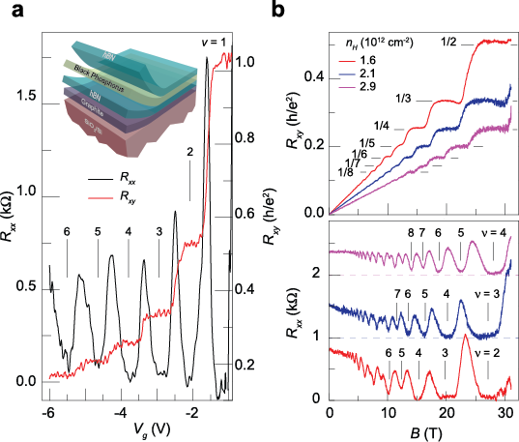
Results and Discussion
The figure on the right displays the magnetoresistance (R_{xx}) and Hall resistance (R_{xy}) measured in high magnetic field at low temperatures. Panel a shows R_{xx} (black) and R_{xy} (red) measured as a function of V_{g} with magnetic field fixed at B = 31 T. Filling factor of each QH state is indicated in the figure. Inset: Schematic three-dimensional view of the device heterostructure. Panel b: Hall resistance (upper panel) and magnetoresistance (lower panel) as a function of magnetic field measured at varying hole doping levels (V_{g} <0). All data were taken at T=300 mK. Additional angle-dependent magneto-transport measurements indicate that Zeeman energy is a significant fraction of the cyclotron energy in black phosphorus 2DHG.

Conclusions
We have achieved exceptionally high carrier mobility in black phosphorus 2DHG, which enabled us, for the first time, to observe the integer QH effect in black phosphorus. The large Zeeman energy relative to cyclotron energy, coupled with black phosphorus’s anisotropic electronic structure, may lead to exotic quantum states in the fractional QH regime.

Acknowledgements
A portion of this work was performed at the National High Magnetic Field Laboratory, which is supported by National Science Foundation Cooperative Agreement No. DMR-1157490 and the State of Florida. L.L., F. Y. and Y.Z. acknowledge financial support from the National Basic Research Program of China (973 Program; grant nos. 2011CB921802 and 2013CB921902), and NSF of China (grant no. 11425415). L.L. and Y.Z. also acknowledge support from Samsung Global Research Outreach (GRO) Program. G.J.Y and X.H.C. acknowledge support from the ‘Strategic Priority Research Program’ of the Chinese Academy of Sciences (grant no. XDB04040100) and the National Basic Research Program of China (973 Program; grant no. 2012CB922002). Z.Z. and Y.W. are supported by Ministry of Science and Technology of China (grant no. 2015CB921000). W.L. and K.C. acknowledge support from NSF of China (grant no. 11434010). K.W. and T.T. acknowledge support from the Elemental Strategy Initiative conducted by the MEXT, Japan. T.T. also acknowledges support by a Grant-in-Aid for Scientific Research on Innovative Areas, “Nano Informatics” (grant nos. 262480621 and 25106006) from JSPS.

References
[1] Li, L. et al. Nature Nanotechnology 9, 372–377 (2014).
[2] Liu, H. et al. ACS Nano 8, 4033–4041 (2014).
[3] Li, L. et al. Nature Nanotechnology 10, 608–613 (2015).

