Giant Photocurrent Generation at van Hove Singularities in Graphene Superlattices

Wu, S.; Aivazian, G. (U. Washington Physics); Lai, Y. (FSU, Physics); Li. Z. (FSU/NHMFL, Physics); Wang, L. (Columbia, EE); Xiao, D. (Carnegie Mellon); Dean, C. (Columbia, Physics); Hone, J. (Columbia, ME) and Xu, X. (U. Washington, Physics)

Introduction
Under external controls, the Fermi surface topology of a conductor can undergo sudden changes at spectral critical points. This electronic topological transition, or Lifshitz transition, usually manifests itself as anomalies in material’s fundamental properties such as thermoelectricity, specific heat and conductivity. For example, the energy spectrum of graphene away from the Dirac point contains topological critical points where Van Hove singularities (VHSs) appear and are predicted to host fascinating phenomena like chiral superconductivity. However, the required extreme doping has prevented the experimental access to these VHSs. Alternatively, the formation of Moiré superlattices in graphene on hexagonal boron-nitride (h-BN) heterostructures^{5–9} generates electronic mini-bands that mimic graphene’s energy spectrum but with reduced energy scale, providing a remarkable opportunity to study a variety of physics previously inaccessible. For example, a fractal quantum structure known as Hofstadter’s butterfly generate secondary Dirac points (sDP) has been demonstrated using graphene/BN superlattice structure.

Experimental
We performed photocurrent measurements with graphene encapsulated between h-BN sheets sitting on a graphite gate using recently developed polymer-free transfer techniques. The CW laser excitation (660 nm) is focused on the sample with about 2 μm beam spot size. While grounding the source and floating all the voltage probes, we collected photocurrent from the drain contact. We used 17.5 T (SCM 3) superconducting magnet in the DC field facility. Staff scientist Zhiqiang Li have provided tremendous help.

Results and Discussion
Figure 1e plots the observed photocurrent as a function of Vg under weak magnetic fields when placing the laser spot at a selected graphene edge. The incident power was set at 1 μW before the objective. We find that the observed photocurrent has a strong dependence on Vg. For a slightly nonzero B (~ 50 mT), greatly enhanced photocurrent, indicated by the red arrows, is observed nearby both electron- and hole-side sDP (e/h-sDP). The observed photocurrent is attributed to the photo-Nernst effect. The enhanced photocurrent is due to the lifshitz transition when the Fermi surface across the VHSs near the minibands. The photoresponsivity as large as 0.3A/W is obtained. This corresponds to the collection of about 20 electrons by absorbing one photon.
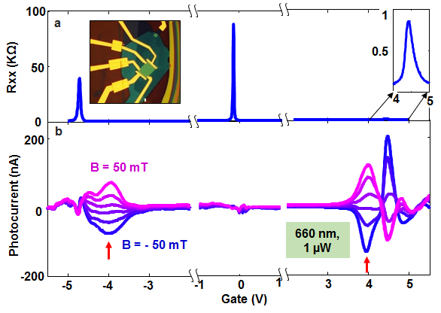Fig.1 a, Longitudinal resistance R_{XX} as a function of gate at 50 mT showing one DP and two sDPs. Inset: Optical micrograph of the device. b, Photocurrent generation as a function of gate under magnetic field varying from -50 to 50 mT with step size of 20 mT.

Conclusions
We demonstrate that the formation of saddle point VHSs in the mini-bands of graphene/h-BN superlattice enables anomalously enhanced photo-Nernst current due to Lifshitz transition. The collection of multiple carriers upon the absorption of one photon in graphene shows the possibility of outperforming the Shockley-Queisser limit using hot-carrier light-harvesting devices [1].

Acknowledgements
A portion of this work was performed at the National High Magnetic Field Laboratory, which is supported by National Science Foundation Cooperative Agreement No. DMR-1157490 and the State of Florida. In addition, this work was supported by AFOSR (FA9550-14-1-0277) and the National Science Foundation (NSF, DMR-1150719).

References
[1] Wu, S., et al., submitted (2015).

