Splitting of the Fermi Contour of Quasi-2D Electrons in Strong Parallel Magnetic Fields

Mueed, M.A.; Kamburov, D.; Pfeiffer, L.N.; West, K.W.; Baldwin, K.W.; Shayegan, M. (Princeton U., Electrical Engineering Department) and Winkler, R. (Northern Illinois University, Physics Department)

Introduction
In a strictly two-dimensional electron system (2DES) with zero layer thickness, the electrons’ in-plane motion is unaffected by a parallel magnetic field (B||). However, for a quasi-2DES, such as electrons in a quantum well (QW) with finite width, B|| can couple to electrons’ out-of-plane motion, thus also affect their in-plane motion. This can have profound consequences. For example, the Fermi contour, which is circular in an isotropic system such as the 2DES in GaAs QWs, becomes severely distorted by B|| and eventually splits into a pair of smaller contours in the presence of a sufficiently large B|| (Fig. 1).

Experimental
We studied 2D electrons confined to GaAs QWs flanked on each side by undoped Al_{0.24}Ga_{0.76}As barrier layers and Si δ-doped layers. The sample is a standard Hall bar covered with periodic gratings of negative electron-beam resist (shown as blue stripes in Fig. 1) which induce a periodic and small density modulation through the piezoelectric effect in GaAs. We used SCM2 for measurements.

Results and Discussion
Through measurements of commensurability oscillations (COs), stemming from the lateral density modulation of the 2DES, we directly and quantitatively probe the evolution of the Fermi contour as B|| causes its distortion and eventual disintegration into two pieces [1]. Here, in Fig. 1, we present the Fourier transform (FT) spectra of the COs as a function of B||. On the right side, we also show four Fermi contours of the majority spin species, calculated for B|| = 0, 6, 12 and 15 T, which quantitatively capture the splitting phenomenon.
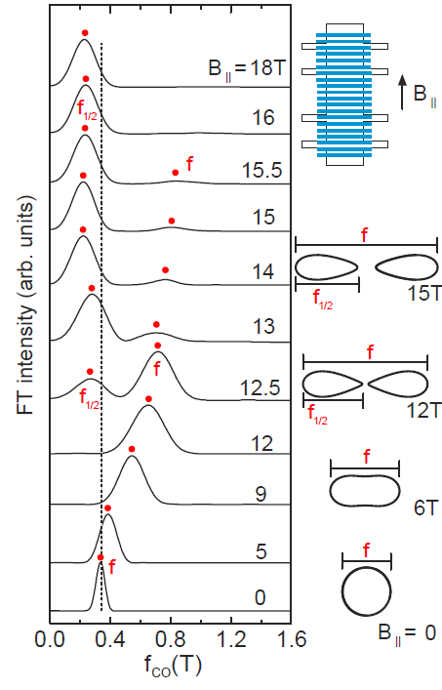
The bottom FT spectrum in Fig. 1 exhibits a single peak (f) whose position (≃0.35 T) is consistent with the commensurability frequency (the dotted line) expected for a circular Fermi contour. With increasing B||, this peak f moves to higher frequencies in the FTs, suggesting that the Fermi contour is getting elongated. However, at B|| ≅ 12.5 T, a new peak f_{1/2} emerges at approximately f/2. This is an indication that the elongated contour has split into two smaller ones. Even after the splitting, we continue to observe both f and f_{1/2} up to B|| ≅ 15.5 T implying a magnetic breakdown between the split contours. As B|| gets larger, the f_{1/2} peak becomes the strongest feature in the FT spectra while the strength of f diminishes progressively. We conclude that the FT data demonstrate the breakdown of the Fermi contour (at B|| ~12 T) consistent with calculations. Note that, since the majority and minority spin contours are similar in size, COs cannot resolve the splitting of both contours.
In our studies, we also probed the warped Fermi contour of 2D holes and hole-flux composite fermions via the COs induced by the surface grating [2]. Similar technique was also used to explore the phase boundary between a composite fermion Fermi sea and fractional quantum Hall liquid state [3]. In these two studies, we used the SCM1, SCM2 and the 31-T-magnet facilities.

Acknowledgements
This work was partly performed at the National High Magnetic Field Laboratory, which is supported by National Science Foundation Cooperative Agreement No. DMR-1157490, the State of Florida, and the U.S. Department of Energy. We thank S. Hannahs, T. Murphy, J. Park, G. Jones and A. Suslov for technical help. Our work was also supported by NSF, DOE, the Gordon and Betty Moore Foundation, and Keck Foundation.
FIG. 1: On the right side, we show a schematic of the Hall bar (top) along with the calculated Fermi contours for B|| = 0, 6, 12 and 15 T. On the left, we show a series of FT spectra as a function of B||.
References
[1] M. A. Mueed et al., Phys. Rev. Lett. 114, 236404 (2015).
[2] M. A. Mueed et al., Phys. Rev. Lett. 114, 176805 (2015).
[3] M. A. Mueed et al., Phys. Rev. Lett. 114, 236406 (2015).

