The Pinning of a Wigner Crystal at the Reentrant Insulating State

Knighton, T.; Wu, Z.; Tarquini, V.; Huang, J. (WSU, Physics); Pfeiffer, L. (Princeton U. EE); Serafin, A.; Xia, J.-S. and Sullivan, N. (UF, Physics)

Introduction
New quantum phenomena emerge in response to strong electron-electron interaction. To probe interaction-driven phenomena, it is crucial to study ultra-dilute electron systems or dilute systems in a magnetic field. The sample must be clean in order to avoid the occurrence of Anderson Localization. We have fabricated undoped high quality two-dimensional hole systems in GaAs/AlGaAs quantum well (grown by Loren Pfeiffer) in which the charge concentration is 4x10¹⁰ cm⁻² with a mobility of ~4x10⁶ cm²/Vs. The goal for this project is to study the reentrant insulating phase near fractional filling 1/3 and verify if genuine pinning modes exist. In addition, by varying the sample temperature, we examine whether quantum melting occurs. This should have direct implications to the onset of a quantum Wigner Crystal.
Experimental – Hall Measurement and temperature dependence of the resistivity
The samples are Hall-bar devices fabricated at Wayne State University. The transport measurement of 2D hole samples are performed at the MicroKelvin Lab High B/T facility with the sample mounted inside a helium-3 emersion cell which is cooled down to 10 mK temperature. Upon condensing 3He gas inside the cell, the sample reaches thermal equilibrium with the liquid 3He bath. Quantum Hall measurement is performed to characterize the charge densities and the mobility. Then, perform detailed ac measurement of the magnetoresistance and the Hall resistance up to 7 Tesla in order to research the reentrant insulating phase (RIP) near fractional filling 1/3. Fixing the B field to the very center of the RIP, dc IV measurement is performed to probe the nonlinear dynamical response in a window of 100 pA and 100 uV. The same DC-VI scan is repeated for several temperatures from 10 mK up to 400 mK.
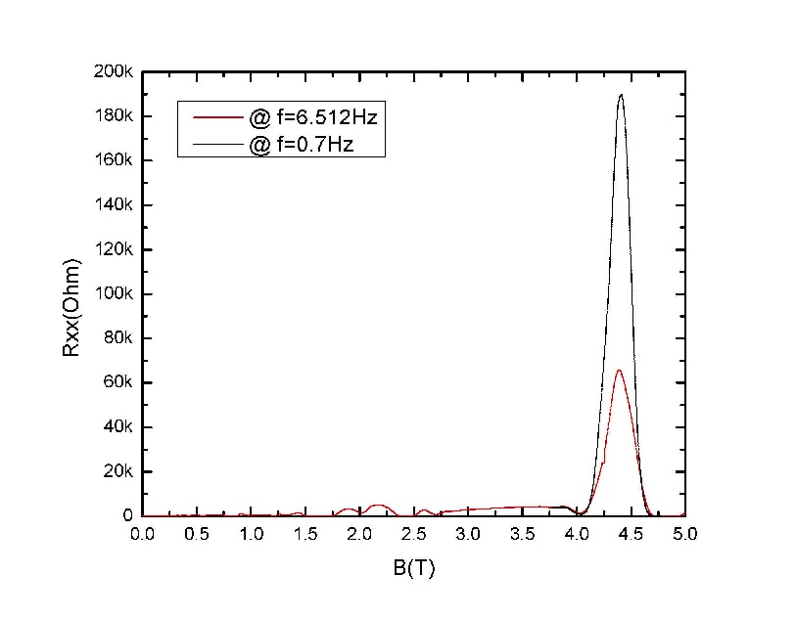
Results and Discussion
Fig. 1 (upper) shows the magetoresistance Rxx as a function of B-field where the reentrant insulating peak is identified near B=4.3 T. Due to the large impedance, driving frequency is reduced to <1Hz in order to avoid coax attenuation. Fig.1 (lower) shows the linear IV scan where a clear threshold is captured. The threshold current is 10 pA and corresponding slope (resistivity) is roughly 100 MOhms which is 100 times larger than previously observed. This result is consistent with our zero-field results obtained from HIGFET with a carrier density of 2x10⁹ cm⁻².

Conclusions
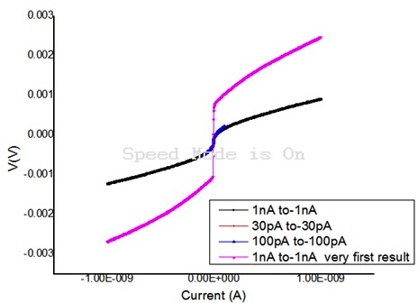
The formation of a Wigner crystal is extremely fragile and is easily influenced by disorder that tends to drive a glass state or an Anderson insulator both of which lack genuine pinning. The enormous pinning observed in the extremely clean limit is more consistently a true many-body pinning as expected for a Wigner Crystal.

Acknowledgements
This work is supported by NSF through DMR- A portion of this work was performed at the National High Magnetic Field Laboratory, which is supported by National Science Foundation Cooperative Agreement No. DMR-1157490, the State of Florida, and the U.S. Department of Energy.
In addition, we acknowledge NSF’s support through DMR-1410302.
Fig.1 (upper) Magnetoresistance vs. B for a carrier density of 4x10¹⁰ cm⁻². (lower) DC-IV threshold behavior.

References
[1] V. J. Goldman, M Santos, M Shayegan, and J. E. Cunningham Phys. Rev. Lett. 65, 2189 (1990)

