Multiple Fermi Surfaces in Superconducting Nb-doped Bi₂Se₃

Lawson, B.J.; Corbae, P.; Asaba, T.; Li, G.; Yu, F.; Tinsman, C.; Li, L. (Univ. Michigan); Qiu, Y. and Hor, Y.S. (Missouri Univ. Science & Tech)

Introduction
Topological insulator Bi₂Se₃ has shown a number of interesting physical properties. Doping B_{i2}Se₃ with copper (Cu) or strontium (Sr) has been demonstrated to make the material superconducting and potentially even a topological superconductor [1]. However, direct experimental confirmation has not been realized and is controversial. The recent discovery of superconducting niobium (Nb) doped Bi₂Se₃ reveals an exciting new physical phenomenon, the coexistence of superconductivity and magnetic ordering. To understand this new phenomenon, a detailed knowledge of the electronic structure is needed. To date, the quantum oscillations needed to reveal this structure have not been reported in Nb-doped Bi₂Se₃. In this letter, we present the first observation of quantum oscillations in the magnetization (the de Haas-van Alphen effect) of Nb-doped Bi₂Se₃. In the fully superconducting crystal, two distinct orbits are observed, in sharp contrast to Bi₂Se₃, Cu-doped
Bi₂Se₃, and Sr-doped Bi₂Se₃. [2].
Experimental
High-resolution torque magnetometry was used to measure the magnetic moment of the samples [3-8]. Torque is measured as the change of the capacitance between the metal cantilever and a nearby metal plate.
Results and Discussion
Our quantum oscillation results provide the map of the Fermi surfaces in Nb-doped Bi₂Se₃. In the superconducting sample, we observe at least two oscillation frequencies as field is in the Bi2Se3 plane.
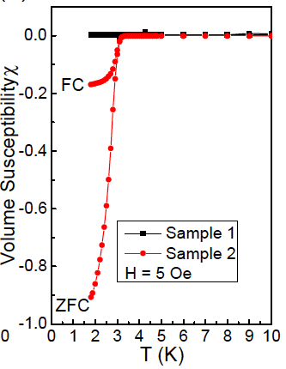
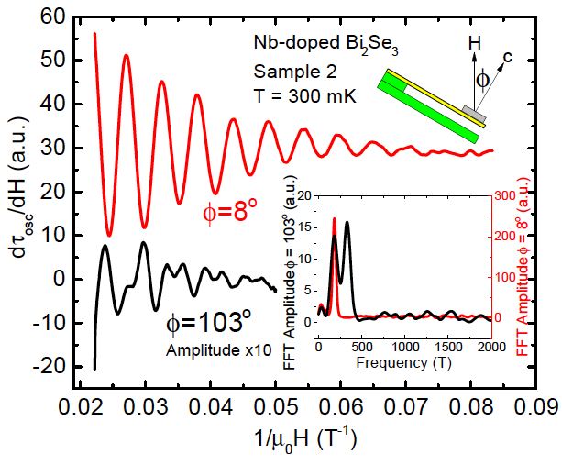

Fig.1 (Left) Volume magnetic susceptibility of Nb-doped Bi₂Se₃crystals, measured in Zero-Field-Cool (ZFC) and Field-Cool (FC) conditions. Sample 1 is non-superconducting. For Sample 2, the Meissner effect in the ZFC condition reaches close to -1, indicating a nearly 100% superconducting volume. (Right) Derivative of oscillatory magnetic torque of superconducting Nb-doped Bi₂Se₃. The top curve in red is taken at tilt angle of magnetic field around 8º and shows one oscillation frequency. The lower curve in black is taken at tilt angle of magnetic field around 103º and shows 2 oscillation frequencies. The inset shows the Fast Fourier Transformation (FFT) traces.

Conclusions
The multiple frequencies observed in our quantum oscillations, combined with our electrical transport studies, indicate the multi-orbit nature of the electronic state of Nb-doped Bi₂Se₃. [2].
Acknowledgements
The material is based on work supported by the Department of Energy under Award number DE-SC0008110. A portion of this work was performed at the National High Magnetic Field Laboratory, which is supported by National Science Foundation Cooperative Agreement No. DMR-1157490 and the State of Florida.
References
[1] L. Fu & E. Berg, PRL 2010.
[2] B. Lawson, et al. to be submitted.
[3] Lu Li, et al., Nature Physics, 3, 311-314 (2007).
[4] Lu Li, et al., Nature Physics, 7, 762-766 (2011).
[5] Lu Li, et al., Science, 321, 547-550 (2008).
[6] B. J. Lawson, Y.S. Hor, Lu Li, Phys. Rev. Lett. 109, 226406 (2012).
[7] B. J. Lawson, et al., Phys. Rev. B 90, 195141 (2014).
[8] G. Li, et al., Science, 346, 1208 (2014).

