Fractional Quantum Hall Effect in a Fractal System

Wang, L.; Gao, Y.; Hone, J. (Columbia U., Mechanical Engineering); Taniguchi, T.; Watanabe, K. (National Institute for Materials Science); Wen, B. and Dean, C.R. (Columbia U., Physics)

Introduction
Coupling to the Moiré super lattice pattern in graphene/h-BN heterostructures yields a highly modified electron bandstructure with a density-dependent, non-linear dispersion, and a band gap at the charge-neutrality point. Under application of a magnetic field, the usual Landau level spectrum develops a rich complexity, exhibiting a fractal order known as Hofstadter’s butterfly[1]. The Hofstadter spectrum arises in a purely single particle picture, and the role of electron-interactions has received only limited theoretical attention. For example it remains unclear whether fractionally filled Hofstadter bands will support Laughlin FQHE states. Does the composite Fermion (CF) picture continue to hold and if so do the composite states also exhibit fractal structure? Studying Moiré -patterned graphene, we observed coexistence of conventional fractional quantum Hall effect (QHE) states together with the integer QHE states associated with the fractal Hofstadter spectrum. To our surprise, at large magnetic field, we observed signatures of another series of states, which appeared at fractional Bloch filling index (red lines in figure 1b, c). The fractional Bloch band QHE states are not anticipated by existing theoretical pictures and may point to a new type of quantum Hall effect in these systems.

Experimental
Single layer graphene on hexagonal boron nitride sample was measured up to 45 tesla in cell 15 at the NHMFL in a sample-in-vapor He³ refrigerator.
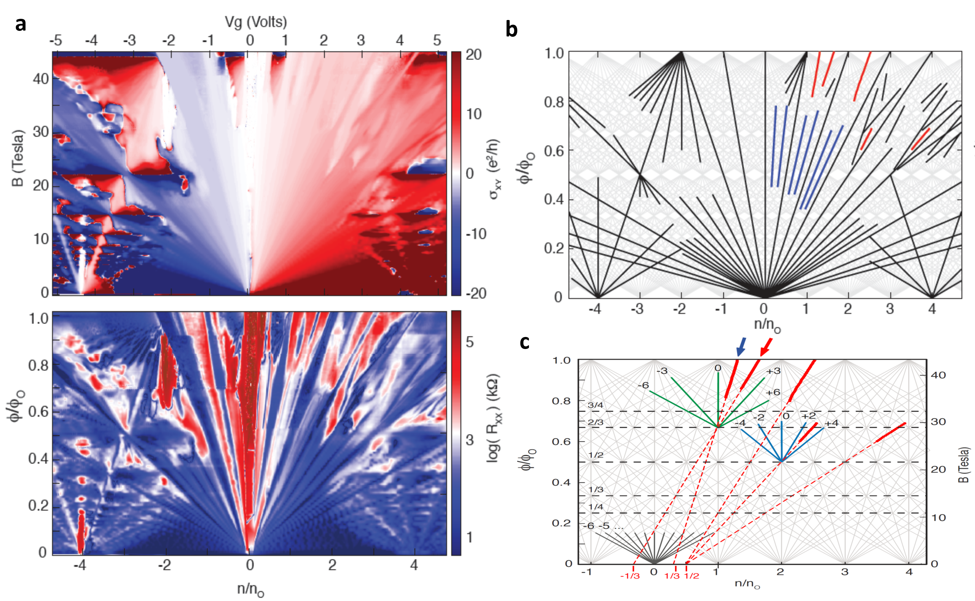
Results and Discussion
Fig.1a shows a plot of Hall conductance and longitudinal resistivity as a function of normalized carrier density and normalized flux. The exceptional device shows clear integer symmetry broken in the main fan and mini-fans. Also in the main fan, we observed clearly fractional quantum Hall minimums. Fig. 1b shows the reduced Wannier diagram, with black, blue and red lines mark the IQHE, FQHE and anomalous features respectively. Fig. 1c shows that the anomalous quantum Hall features have fractional Bloch band intersections. Observed in two separate devices, the Bloch indices cluster around multiples of 1/3 and 1/2. These states appear to be driven by strong interactions, however, further experimental and theoretical work is required to elucidate the precise nature of this phase.
Figure 1: (a) Magnetoresistance in moire-patterned graphene for fields up to 45 T. (c),(d) A sequence of states fall outside of conventional description of the QHE, exhibiting integer Hall quantization, but projecting to non-integer valued Bloch index.

Acknowledgements
A portion of this work was performed at the National High Magnetic Field Laboratory, which is supported by National Science Foundation Cooperative Agreement No. DMR-1157490, the State of Florida, and the U.S. Department of Energy. C.R.D acknowledges support by NSF under grant DMR-1463465.

References
[1] C.R. Dean et al., “Hofstadter’s butterfly and the fractal quantum Hall effect in moire superlattices”, Nature 497, 598-602 (2013)
[2] L. Wang et al., “Evidence of a fractional fractal quantum Hall effect in graphene superlattices”, Science 350, 1231-1234 (2015)

