**Energy Gaps and Layer Polarization of Integer and Fractional Quantum Hall States in Bilayer Graphene**

Shi, Y.; Lee, Y.; Che, S.; Pi, Z.; Espiritu, T.; Stepanov, P.; Lau, C.N.(University of California, Riverside); Smirnov, D.(NHMFL) and Zhang, F. (University of Texas, Dallas)

**Introduction**

Graphene, with its anomalous “half-integer” quantum Hall effect, (QHE) has emerged as a new platform for new physics in low dimensions and special symmetry groups such as SU(4). Bilayer graphene (BLG) and trilayer graphene have also attracted significant attention, as their charge carriers are massive Dirac fermions with many predicted novel phenomena. For BLG, the orbital, spin and valley degrees of freedom give rise to the 8-fold degeneracy in the lowest LL, which can be broken by electronic interactions and/or single-particle perturbations, leading to multicomponent QH ferromagnetic states at intermediate integer filling factors.

**Experiment Results**

Using transport spectroscopy, we investigate the energy gaps of integer and fractional quantum Hall states in bilayer graphene with controlled layer polarization. The state at filling factor **=1 has two distinct phases: a layer polarized state that has a larger energy gap and is stabilized by high electric field, and a hitherto unobserved interlayer coherent state with a smaller gap that is stabilized by large magnetic field. In contrast, the ν=2/3 quantum Hall state and a feature at *=*1/2 are only resolved at finite electric field and large magnetic field. These results underscore the importance of controlling layer polarization in understanding the competing symmetries in the unusual QH system of BLG.

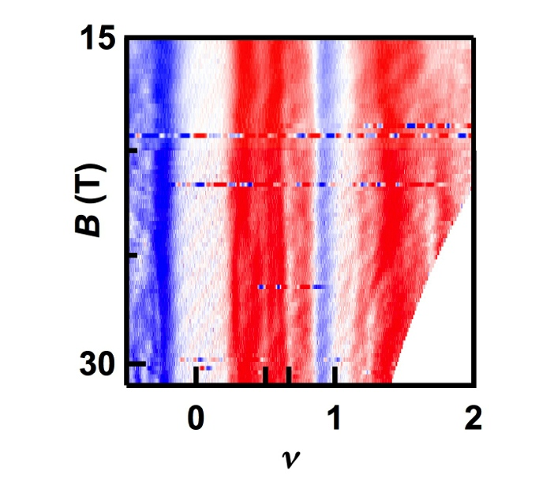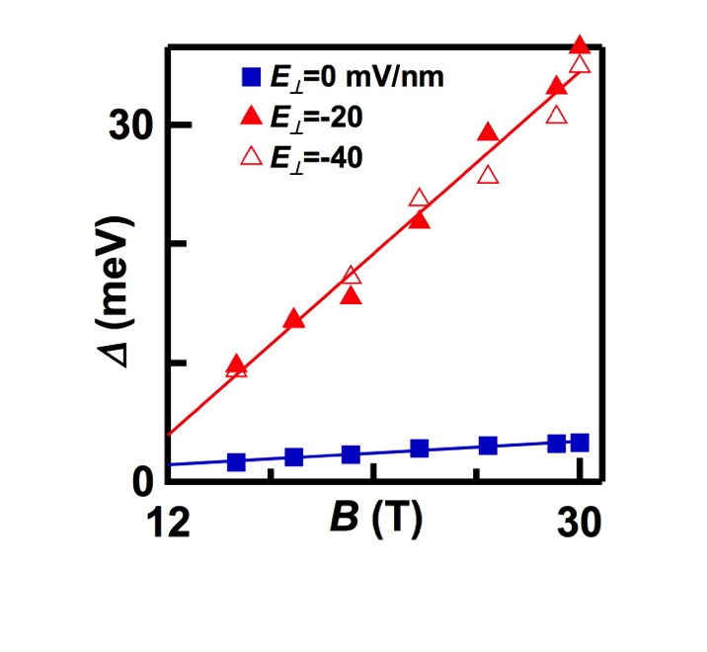

(a)

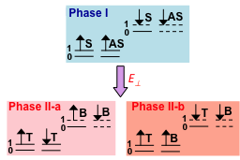

(b)

(c)

Fig. 1. (a) Measured LL gap of BLG *(B)* at *E⊥* = 0 (Blue) and *E⊥* = -20mV/nm and -40mV/nm (Red) respectively. (b). Schematics of electronic configurations of the different **1 phases. T: top layer; B: Bottom layer. S (AS): their symmetric (anti-symmetric) combination. The numbers 0 and 1 are the orbital indices. The solid (dotted) lines represent occupied (empty) levels. (c). *G(B,  * at *E⊥* = 35mV/nm, showing a QH plateau at **=2/3 and a feature at **=1/2.

**Acknowledgements**

This work is supported by DOE BES Division under grant no. ER 46940-DE-SC0010597. A portion of this work was performed at the National High Magnetic Field Laboratory, which is supported by National Science Foundation Cooperative Agreement No. DMR-1157490 and the State of Florida.

**References**

[1] Yanmeng Shi, Yongjin Lee, Shi Che, Ziqi Pi, Timothy Espiritu, Petr Stepanov, Dmitry Smirnov, Chun Ning Lau, Fan Zhang, submitted (2015).