Tunneling between Quantum Hall Edge Modes in Gated Bilayer Graphene

Li, J.; Tupikov, Y.; Hua, W. and Zhu, J. (Penn State University, Department of Physics)

Introduction
This project seeks to investigate the properties of the broken-symmetry quantum Hall (QH) and fractional quantum Hall (FQH) edge states in gated bilayer graphene. We study the tunneling/mixing of two sets of edge states belonging to the N=0 and 1 Landau levels of bilayer graphene, where the influence of a perpendicular electric field E_{z} and a fully rotating magnetic field B_{tot} and B_{perp} induce a rich phase diagram and potentially exotic edge state structures.

Experimental
In year 2015 we used DC Field facility. We spent one week on the 31T magnet in May and completed the study of the kink states. The results are included in a preprint under review at Nature Nanotechnology. In December, we spent one week on the SCM2 18/20T, the results of which are reported here. Using a dual-split-gated structure, we independently control the filling factors -4 < ν_{L}, ν_{R} < 4 of the left and right bilayer graphene regions and measure the tunneling resistances as a result of the backscattering and mixing of the edge states in the junction region. We were able to tune the junction barrier to the fully mixing limit and examined the unipolar as well as the bipolar regimes. We studied the behavior of the edge states at various E_{z} in a 2D map and examined the dependence of phase transition points at various B_{tot} and B_{perp}.

Results and Discussion
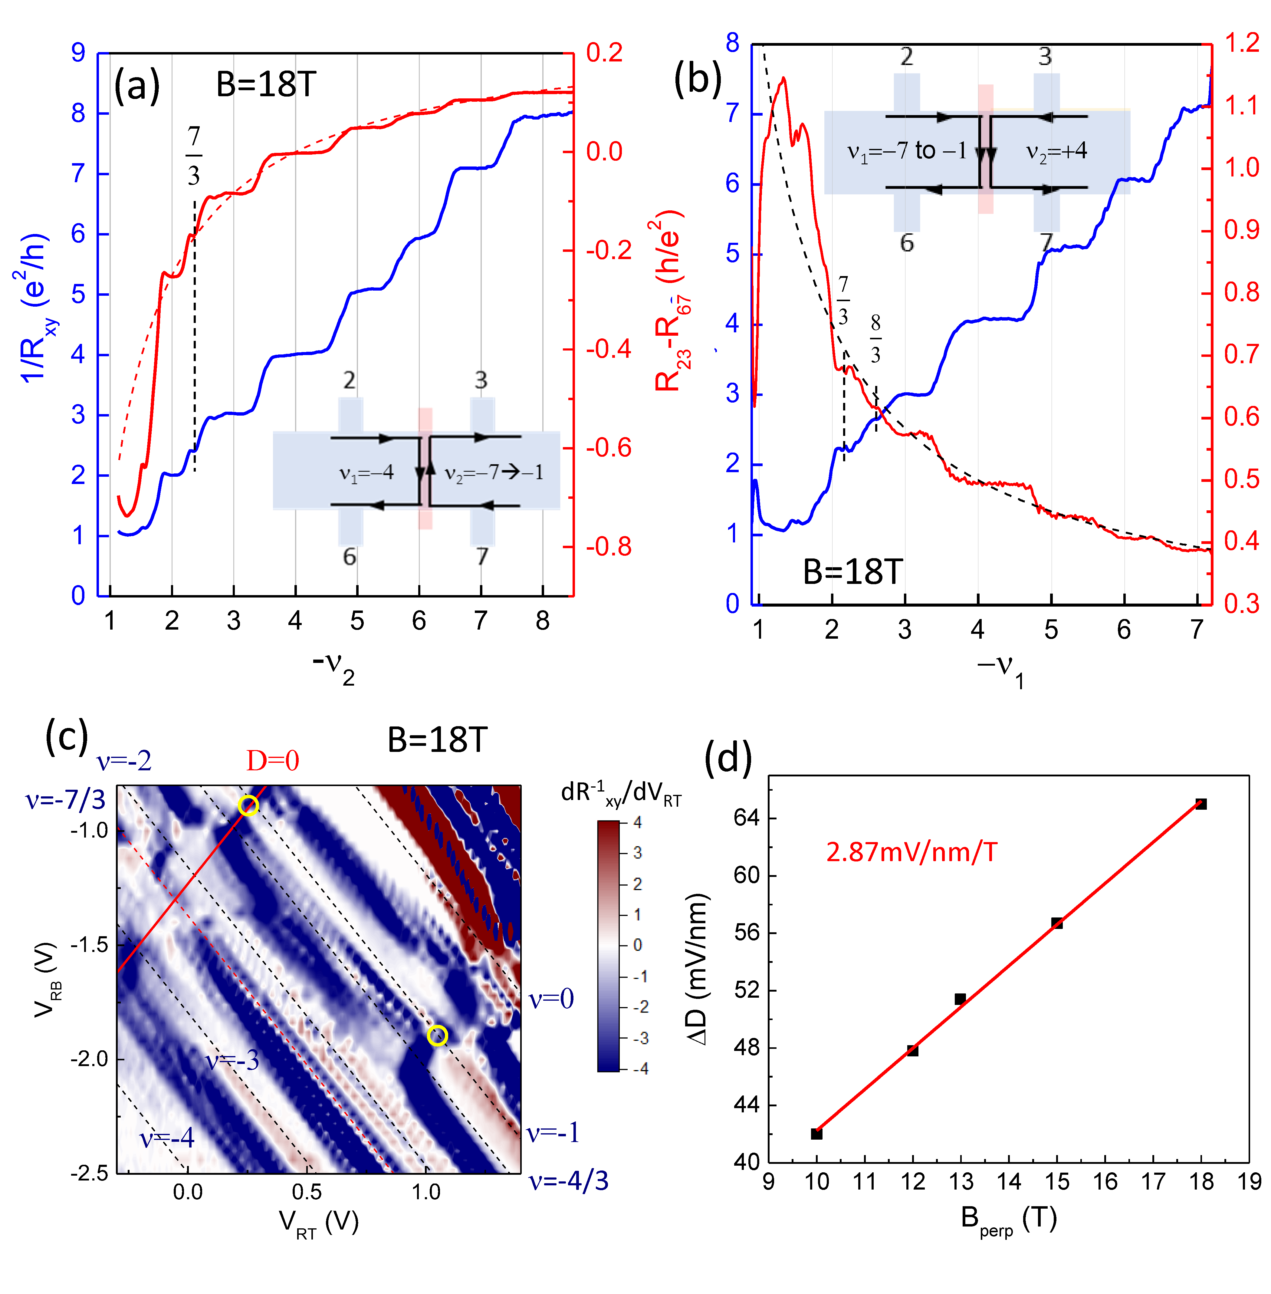
Initial analysis shows exciting features that are indicative of interesting underlying physics. In the limit of full edge mixing, i.e. weak tunnel barrier, we observed the predicted behavior for both the unipolar and the bipolar scenarios. The tunneling resistances are well quantized to the expected values, as shown in Figs. 1(a) and (b). More strikingly, several FQH plateaus are well developed and their edge states appear to follow the same trend as the integers. In addition, we identified the phase transition points of the ν = -1 state on the 2D map shown in Fig. 1(c). Their dependence on B_{perp} is shown in Fig. 1(d).
Fig. 1 (a) Tunneling resistance (solid red curve) and filling factor ν₂ of the right side bilayer (solid blue curve) in a unipolar ν₁/ν₂ junction as illustrated in the inset. ν₁ is fixed at -4. Predicted values in the fully mixing limit (|ν₂|-|ν₁)/|ν₁ν₂| is plotted as dashed red curve. (b) Similar plot corresponding to the bipolar junction as illustrated. Dashed red curve plots the predicted value (|ν₁|+|ν₂|)/|ν₁ν₂| corresponding to the fully mixing limit. (c) dR⁻¹_{xy} / dV_{RT} versus V_{RT} and V_{RB} shown in color scale to study the E_{z} dependence of the QH and FQH states. Lines corresponding to constant filling factors are marked by white dashed lines. The D=0 line is marked by a solid red line. Two phase transition points for ν = -1 are circled. Its dependence is plotted in (d), with a slope of 2.87mV/nm per Tesla.
Conclusions
Edge-edge tunneling studies in a sophisticated dual-split-gated structure are beginning to reveal the underlying edge state structures of the interaction-driven QH and FQH states in bilayer graphene. Following data analysis and modeling will understand the behavior of the FQH states and the field driven phase transitions.

Acknowledgements
A portion of this work was performed at the National High Magnetic Field Laboratory, which is supported by National Science Foundation Cooperative Agreement No. DMR-1157490, the State of Florida, and the U.S. Department of Energy. J. Z., J. L. and H. W. are supported by NSF DMR -1506212.
Publication
J. Li et al, Gate-controlled topological conducting channels in bilayer graphene, submitted to Nature Nanotechnology, (2015).

