Dual Top and Bottom Gated Black Phosphorus Field-Effect Transistors

Tayari, V.; Hemsworth, N. (McGill University, Engineering); Cyr-Choinière, O.; Gervais, G. (McGill University, Physics) and Szkopek, T. (McGill University, Engineering)

Introduction
Black phosphorus (bP) is the second known elemental allotrope with a layered crystal structure that can be mechanically exfoliated down to atomic layer thickness [1-3]. In contrast to graphene, bulk bP is a bona fide semiconductor with an intrinsic direct band gap of 0.3 eV which increases to ~2 eV in the atomic monolayer limit of phosphorene.

Experimental
We have fabricated both single and dual top and bottom gated bP transistors, with thicknesses ranging from 6±1nm to 47±1 nm. Using an Al₂O₃, Au, and a polymer encapsulant (Fig. 1a), we suppress bP oxidation without recourse to the multiple alignment of flakes exfoliated from different 2D materials [1].

Results and Discussion
We observe field effect mobilities up to ~1000 cm²/Vs and on/off current ratios exceeding 10⁵ [4]. The magnetoresistance shows Shubnikov-de Haas (SdH) oscillations in magnetic fields up to 35T and in the temperature range of 300mK-50K (Fig. 1b). These SdH oscillations reveal a 2D hole gas with Schroedinger fermion character (Berry phase $β≈0$) in an accumulation layer formed at the bP/oxide interface. The effective mass for holes m*=0.36±0.03m₀ extracted from the temperature dependence of the SdH oscillations is in excellent agreement with that reported by the Yuanbo Zhang group at Fudan University [5]. We also observe transconductance and mobilities that can be improved up to by 400% and 200%, respectively, as the top gate is set to negative voltages. This suggests that screening of charge impurities can be mitigated by forming a 2D hole gas at the bP/top gate interface (Fig. 1c).

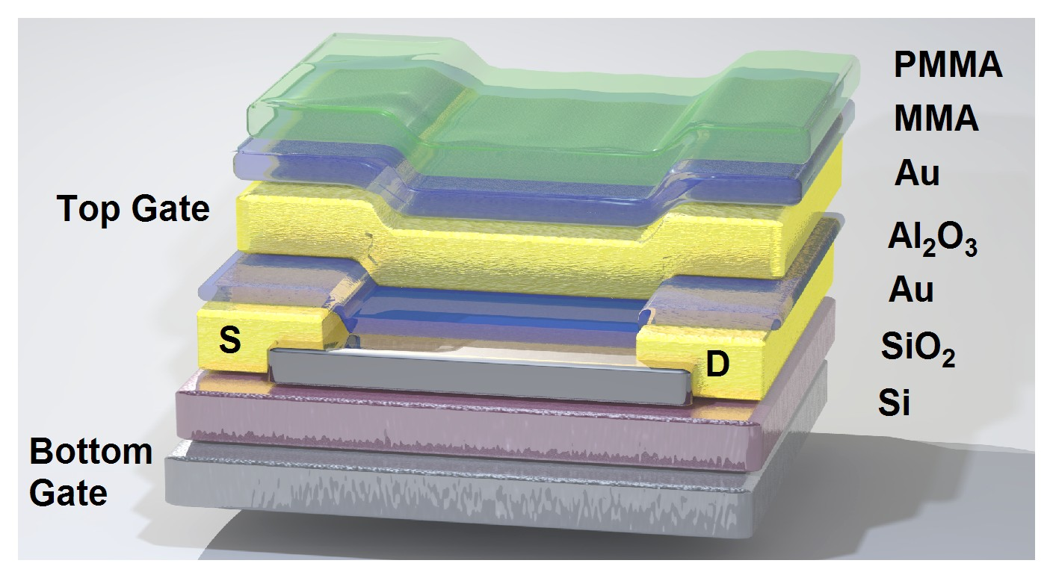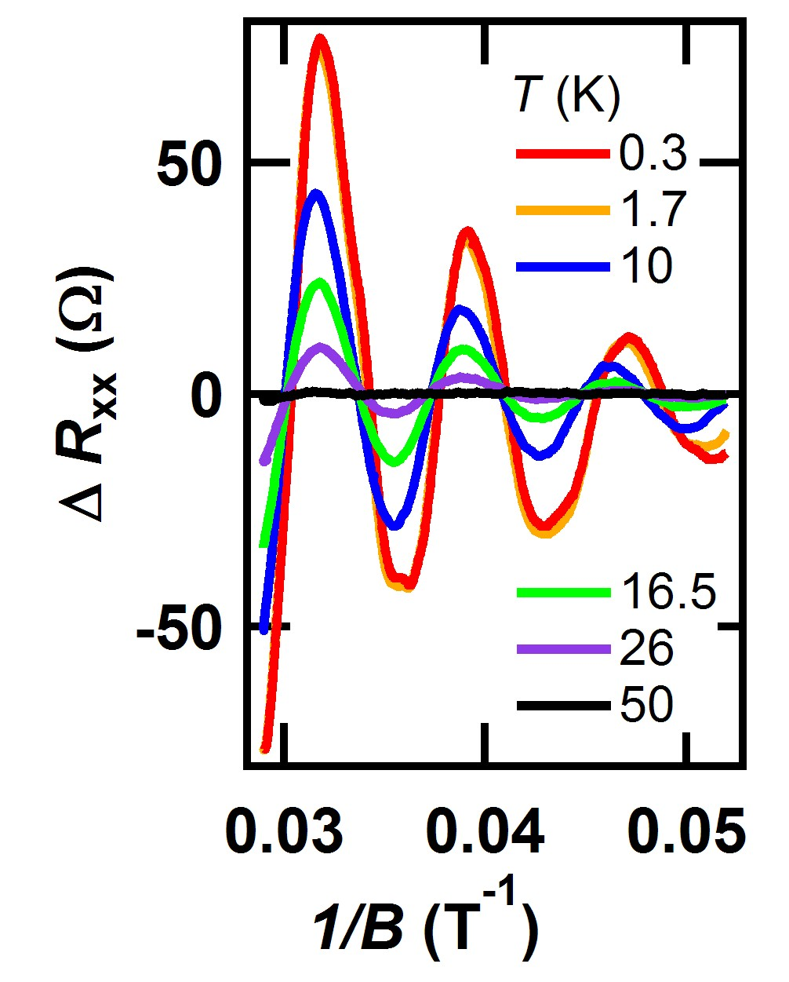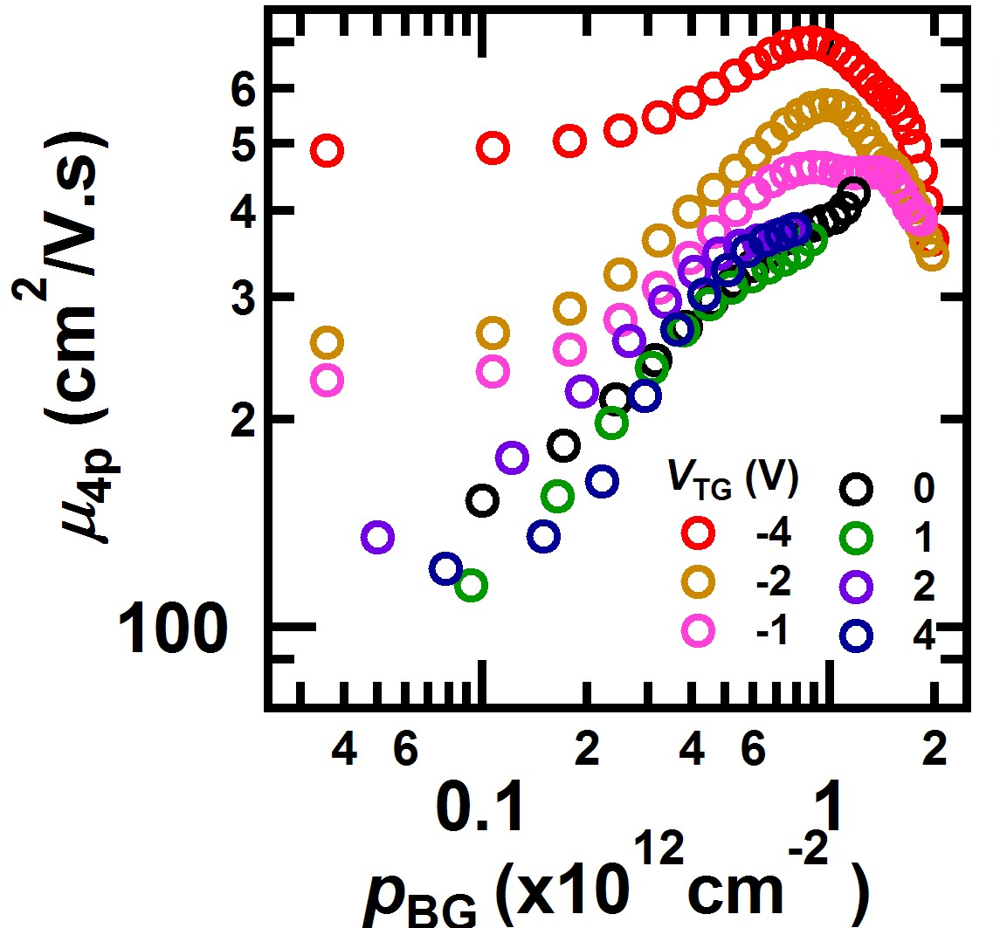
(a)
(b)
(c)
Figure 1: a) A schematic of a dual gated bP FET structure. b) The oscillatory longitudinal resistance ΔR_{XX} versus temperature T. c) Room temperature mobility versus hole density at different top gate voltages indicative of mobility enhancement.
Conclusions
Our work demonstrates that dual-gated bP field-effect devices can be fabricated and act as a canonical 2D semiconducting transistor. The effective mass extracted from the SdH oscillations is in excellent agreement with that reported elsewhere [5]. We also demonstrate a mobility and transconductance enhancement by applying a suitable gate voltage to both gates. This could prove useful in future high-performance electronic devices based on black phosphorus.
Acknowledgements
A portion of this work was performed at the National High Magnetic Field Laboratory, which is supported by National Science Foundation Cooperative Agreement No. DMR-1157490, the State of Florida, and the U.S. DOE. This work was funded by NSERC, CIFAR, FRQNT, RQMP and CRC program.
References
[1] L. Li, et al., Nature Nanotech,9, 372 (2014).
[2] F. Xia, et al., Nature Comm. 5, 4458 (2014).
[3] A. Favron et al., Nature Materials 14, 826 (2015).
[4] V. Tayari, et al., Nature Comm. 6, 7702 (2015).
[5] L. Li, et al., Nature Nanotech. 10, 608 (2015).

