Ultrafast Polarization Phase Selective (PPS) Studies:
Areas of Fundamental Significance to Biochemistry/Biophysics

Rupnik, K. (LSU, Chemistry)
__________________________________________________________________________________________
Introduction
In 2015 we developed and tested four new instrumental configurations including ultrafast (~15fs) pulses and better than 10⁻⁹ sensitive attoscale PPS Spatio-Temporal Electro-Magnetic Processes (STEMP) at 7T and 25T fields that can monitor previously unseen transient correlated electron-spin-hole (ESH) dynamics and couplings processes, even in soft matter systems of our interest. It is expected that experimental studies at this scales could not only identify early ESH events but also image some of their selected trajectories, particularly with the advantage of 25 T fields. Adaptive models needed to image and identify radiation signatures (RS) STEMP of Reaction Controlling Agents (RCA) include our previously developed methods (Rupnik, 1995-on). We are now closer to understanding electron dynamics in our Opto-magnetic (OM) PPS Fe_{x}S_{y} enzymes studies which resulted in another important scientific breakthrough (Rupnik at all, 2014): we observed various steps of a newly found controlled non-enzymatic synthesis. Other recent breakthroughs include a study of reduction-oxidation processes in enzymes where we found significant novel ESH structures in some proteins with Fe₄S₄ clusters and were also able to propose new mechanisms of electron transfers with broad relevance to medicine as well as molecular evolution. We expect that ongoing development of our new techniques and new collaborative measurements at LSU, ETH and NHMFL will provide even more detailed information about fast ESH RS.
Experimental
June 2015 experiment was only the second unique PPS study using well-defined precise ~15fs pulses and reconfigured Split-helix magnet in cell 5 of NHMF lab. We have successfully completed initial measurements of representative Fe- containing compounds in broader spectral region and also at room temperatures. Data and methods using 4 new configurations are available to other users. We hope to complete that work next year.
In the fall of 2015 we tested new instruments for all-photonic STEMP measurements.
Results and Discussion
Our PPS spectra and magnetizations cover important Fe compounds, particularly metal-ligand electron transitions range associated with the complex biophysical processes such as are redox, TO and protein synthesis. Measured broadband ultrafast multidimensional (frequency, field, PPS etc.) data show some familiar OM features, but with new different sub-structures, and indicate novel transient time-domain signatures.
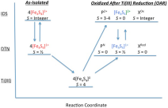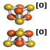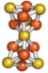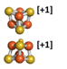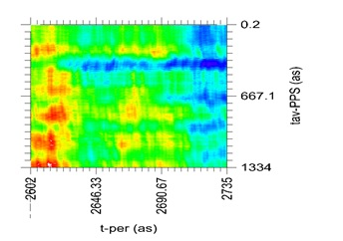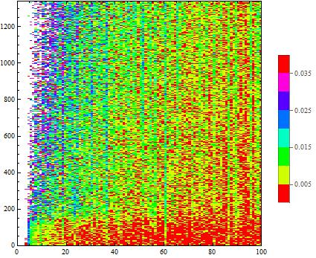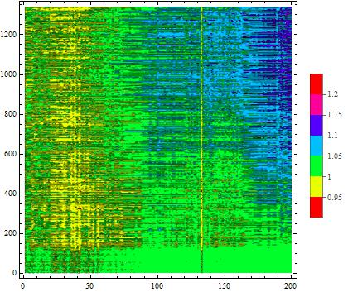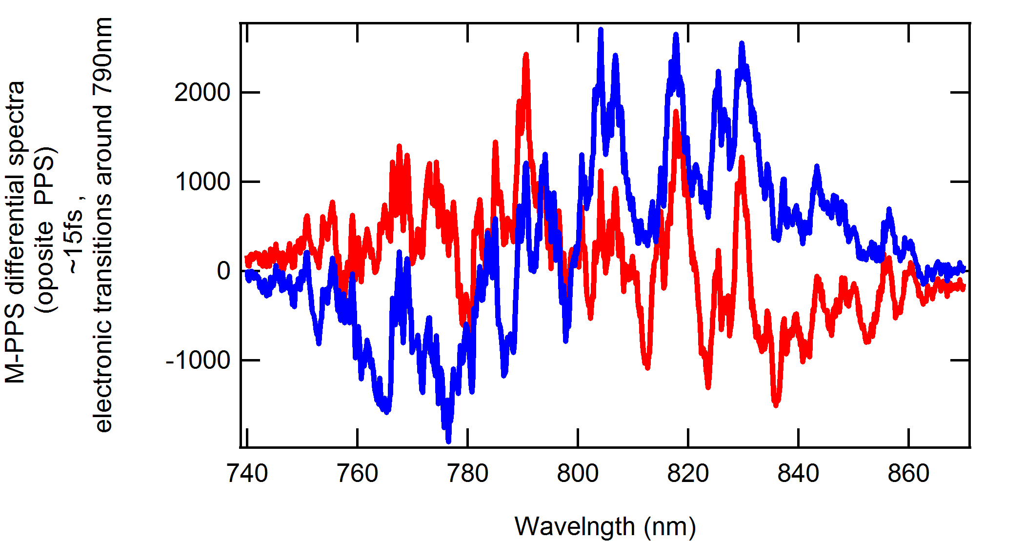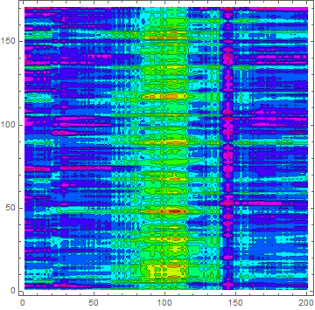

Figures 1a, 1b: Biophysical processes such as this non-enzymatic synthesis depend on ultrafast correlated ESH RCA dynamics (Rupnik at all Biophysics 2014). Figures 2 a, b: Newly observed multidimensional ultrafast transient signatures centered around 400 and 800nm show rich PPS and magnetic field dependent substructures, different from previous narrowband measurements results. Figure 3: Observed oscillatory spectral structures are now investigated: typical UF OM PPS- differential PPS structure - ~15fs , 800nm centered pulse in electronic transitions range.
Conclusions
We have developed, tested and recorded signals using 4 new magnetic PPS configurations in the very important low fs region. These novel results complement well our previous studies. They also indicate feasibility of significantly better measurement techniques, a part of the ongoing work in the fall 2015. We are now requesting additional magnet time to expand the study and complete data for prepared publications.
Acknowledgements
A portion of this work was performed at the National High Magnetic Field Laboratory, which is supported by National Science Foundation Cooperative Agreement No. DMR-1157490 and the State of Florida. NHMF User Collaboration Grants program, Physics/materials division, Award number 227000-520-022742., LSU R&E and students support funds, IAS, NSF Magneto-optics materials and education project (2012-2015).
References
[1] Rupnik K., Proceedings Atto 2015 , July 2015, St-Sauveur, Canada; Rupnik K., Proceedings Ultrafast Dynamic Imaging of Matter. March 8-12, 2015, Grindelwald, Switzerland; Rupnik K., ETH Zurich, Switzerland March 13, 2015, [2] Rupnik K. et al. Biochemistry, 2014, 53 (7) 1108; Rupnik, K. et al., J. Am. Chem. Soc., 134, 13749-13754 (2012); Rupnik K. et al., J. Am. Chem. Soc., 133, 6871-6873 (2011); [3] Rupnik K., APS March Meeting 2014, Denver; Rupnik K., GRC Quantum control August 2015;Rupnik K. GRC Photoionization - Photo-detachment, February 2014; Shafir D., et al. New J. Phys. 12, 073032, 2010.

