Structural and Functional Characterization of ChiZ by Solution and Solid-State NMR
Escobar, C.A. (Florida State U., Institute of Molecular Biophysics, NHMFL) and Cross T.A. (Florida State U., Chemistry & Biochemistry, NHMFL)

Introduction
ChiZ is a 17.3 kDa membrane protein from Mycobacterium tuberculosis, which has been shown to be involved in cell division [1]. This protein has one C-terminal domain (residues 91 to 165) that contains a LysM domain for peptidoglycan binding. The N-terminal cytoplasmatic domain (residues 1 to 64) has been shown to have petidoglycan hydrolysis activity, and it is predicted to be intrinsically disordered [1]. In this study, solid state NMR will be used to characterize the structure of transmembrane region of ChiZ in a membrane-like environment, while solution NMR will be used to characterize the soluble domains independently.
Experimental
Recombinant His-tagged ChiZ N-terminal domains have been over expressed on E. coli and purified using nickel affinity chromatography. The N- terminal domain was assigned using standard experiments at pH 4.0 and pH 7.0. The interaction of ChiZ N-terminal domain with peptidoglycan was evaluated by MAS solid state NMR.
Results and Discussion
2D ¹H-¹⁵N HSQC spectra of ChiZ N-terminal domain at pH 4.0 and 7.0 show significant differences (Fig. 1). For instance, there is a subgroup of amino acids that gave little to no signal in the spectra at pH 7.0 (Fig 1B). This main difference could be due to an increased proton exchange or different dynamics of those residues in the protein. Interestingly, the region with small signal intensities at pH 7 (residues 38 to 64) is also conserved among ChiZ protein from other organism.
MAS ssNMR experiments of the peptidoglycan and CHiZ N-terminal domain mixture show signals corresponding to the protein in the solid pellet. However, the protein can be detected using INEPT type excitation, which indicates the protein is highly mobile even when in contact with the insoluble peptidoglycan.
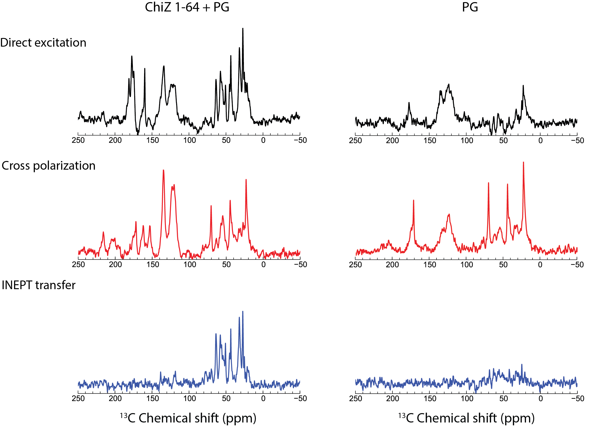
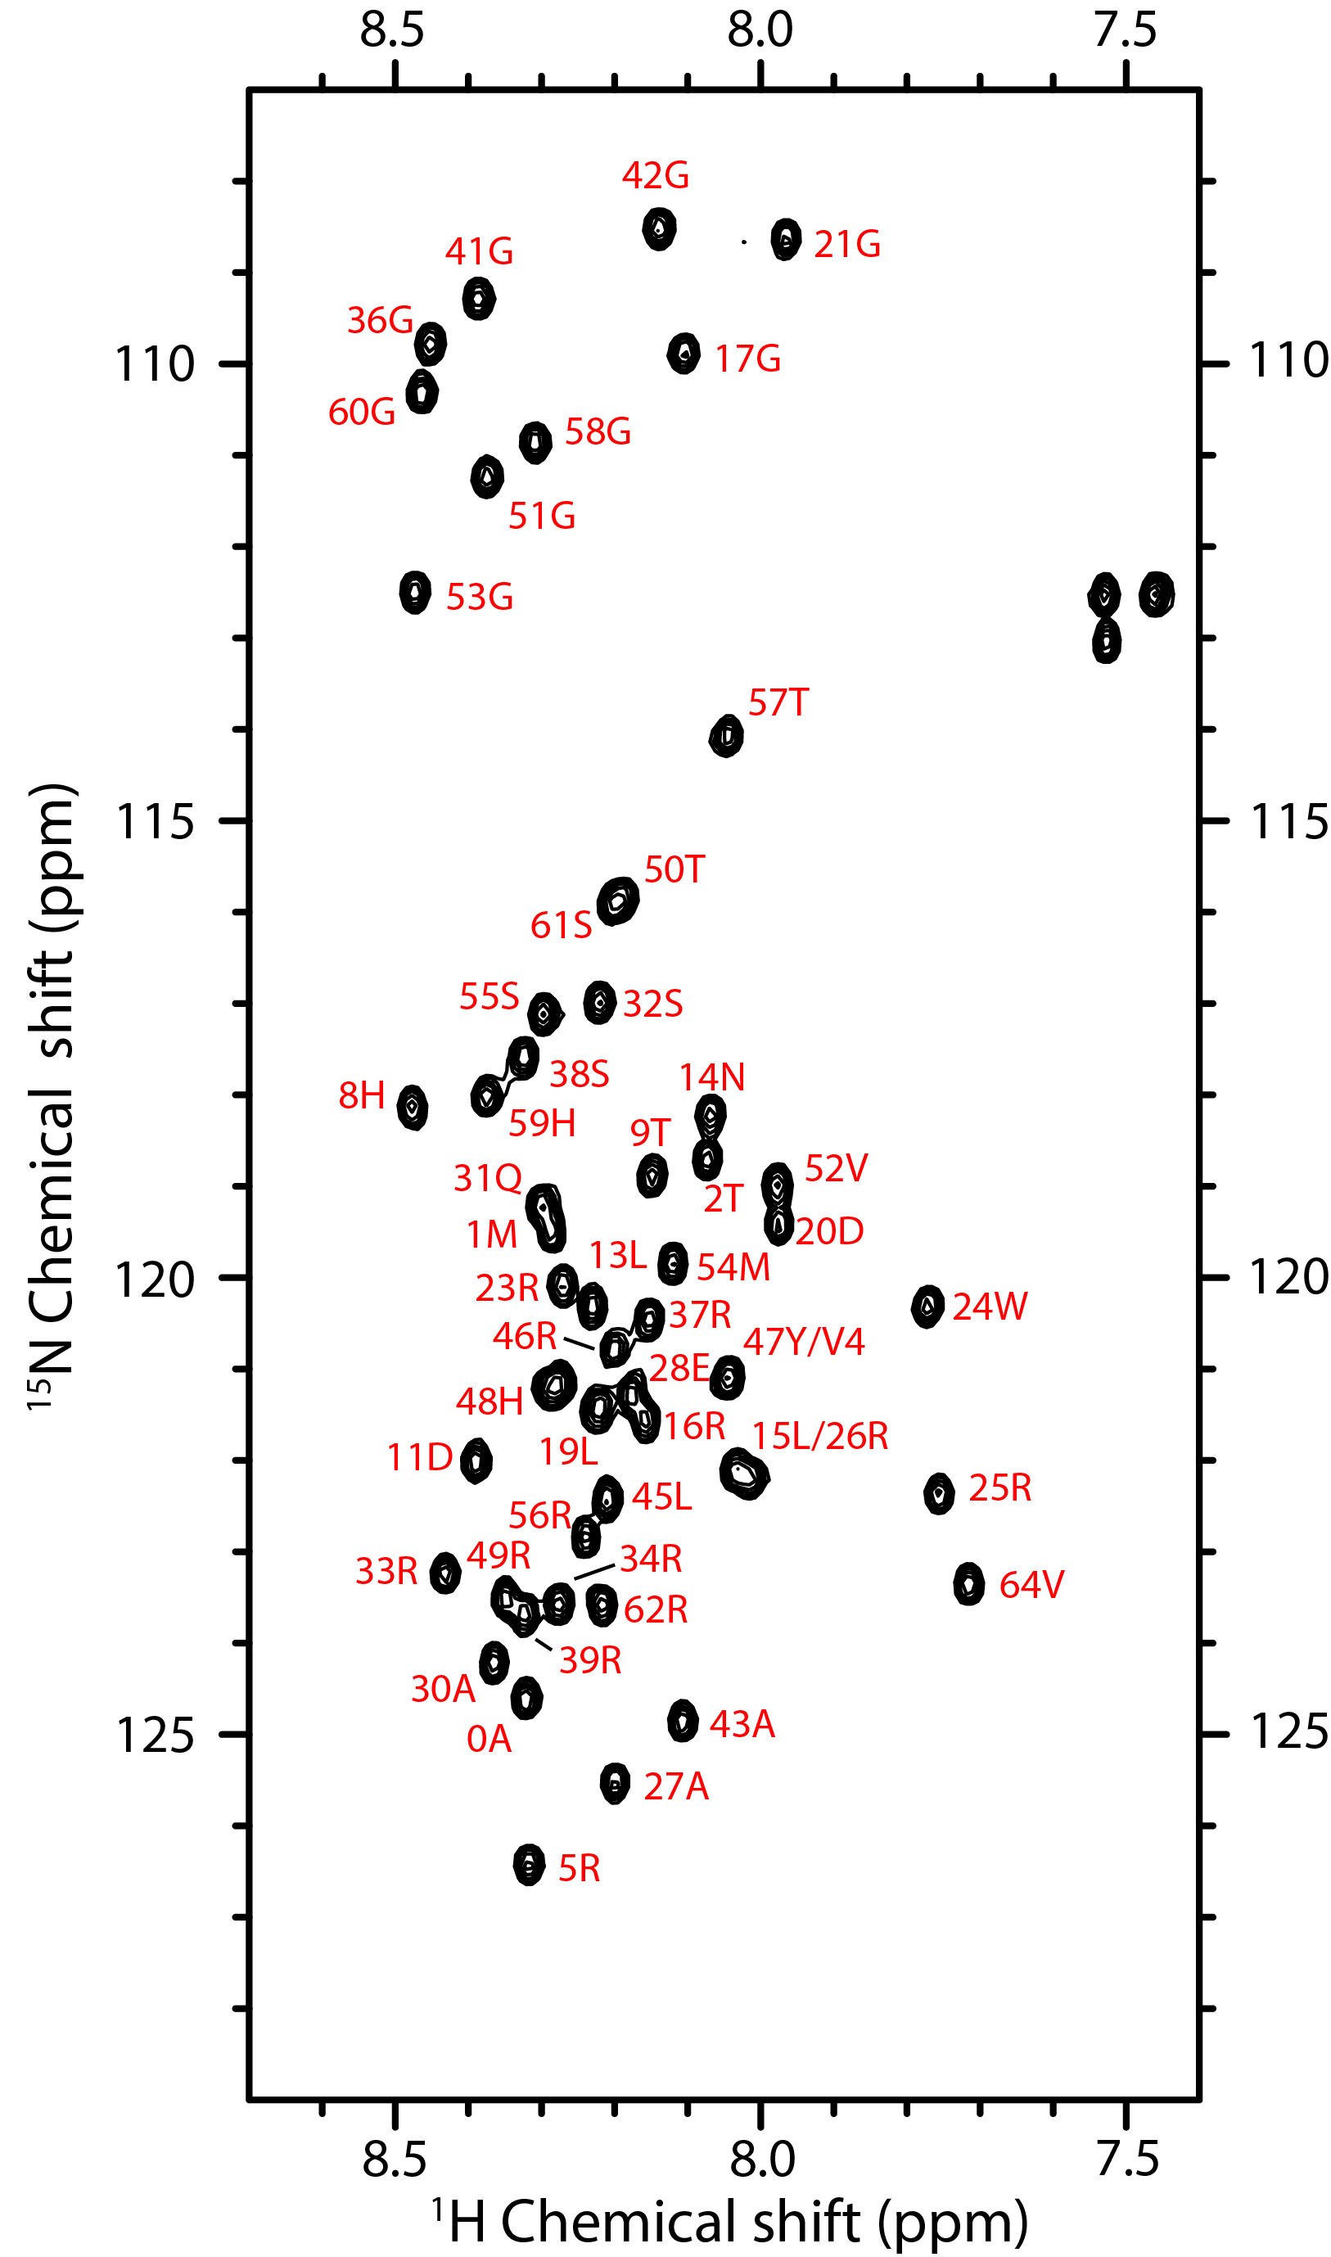
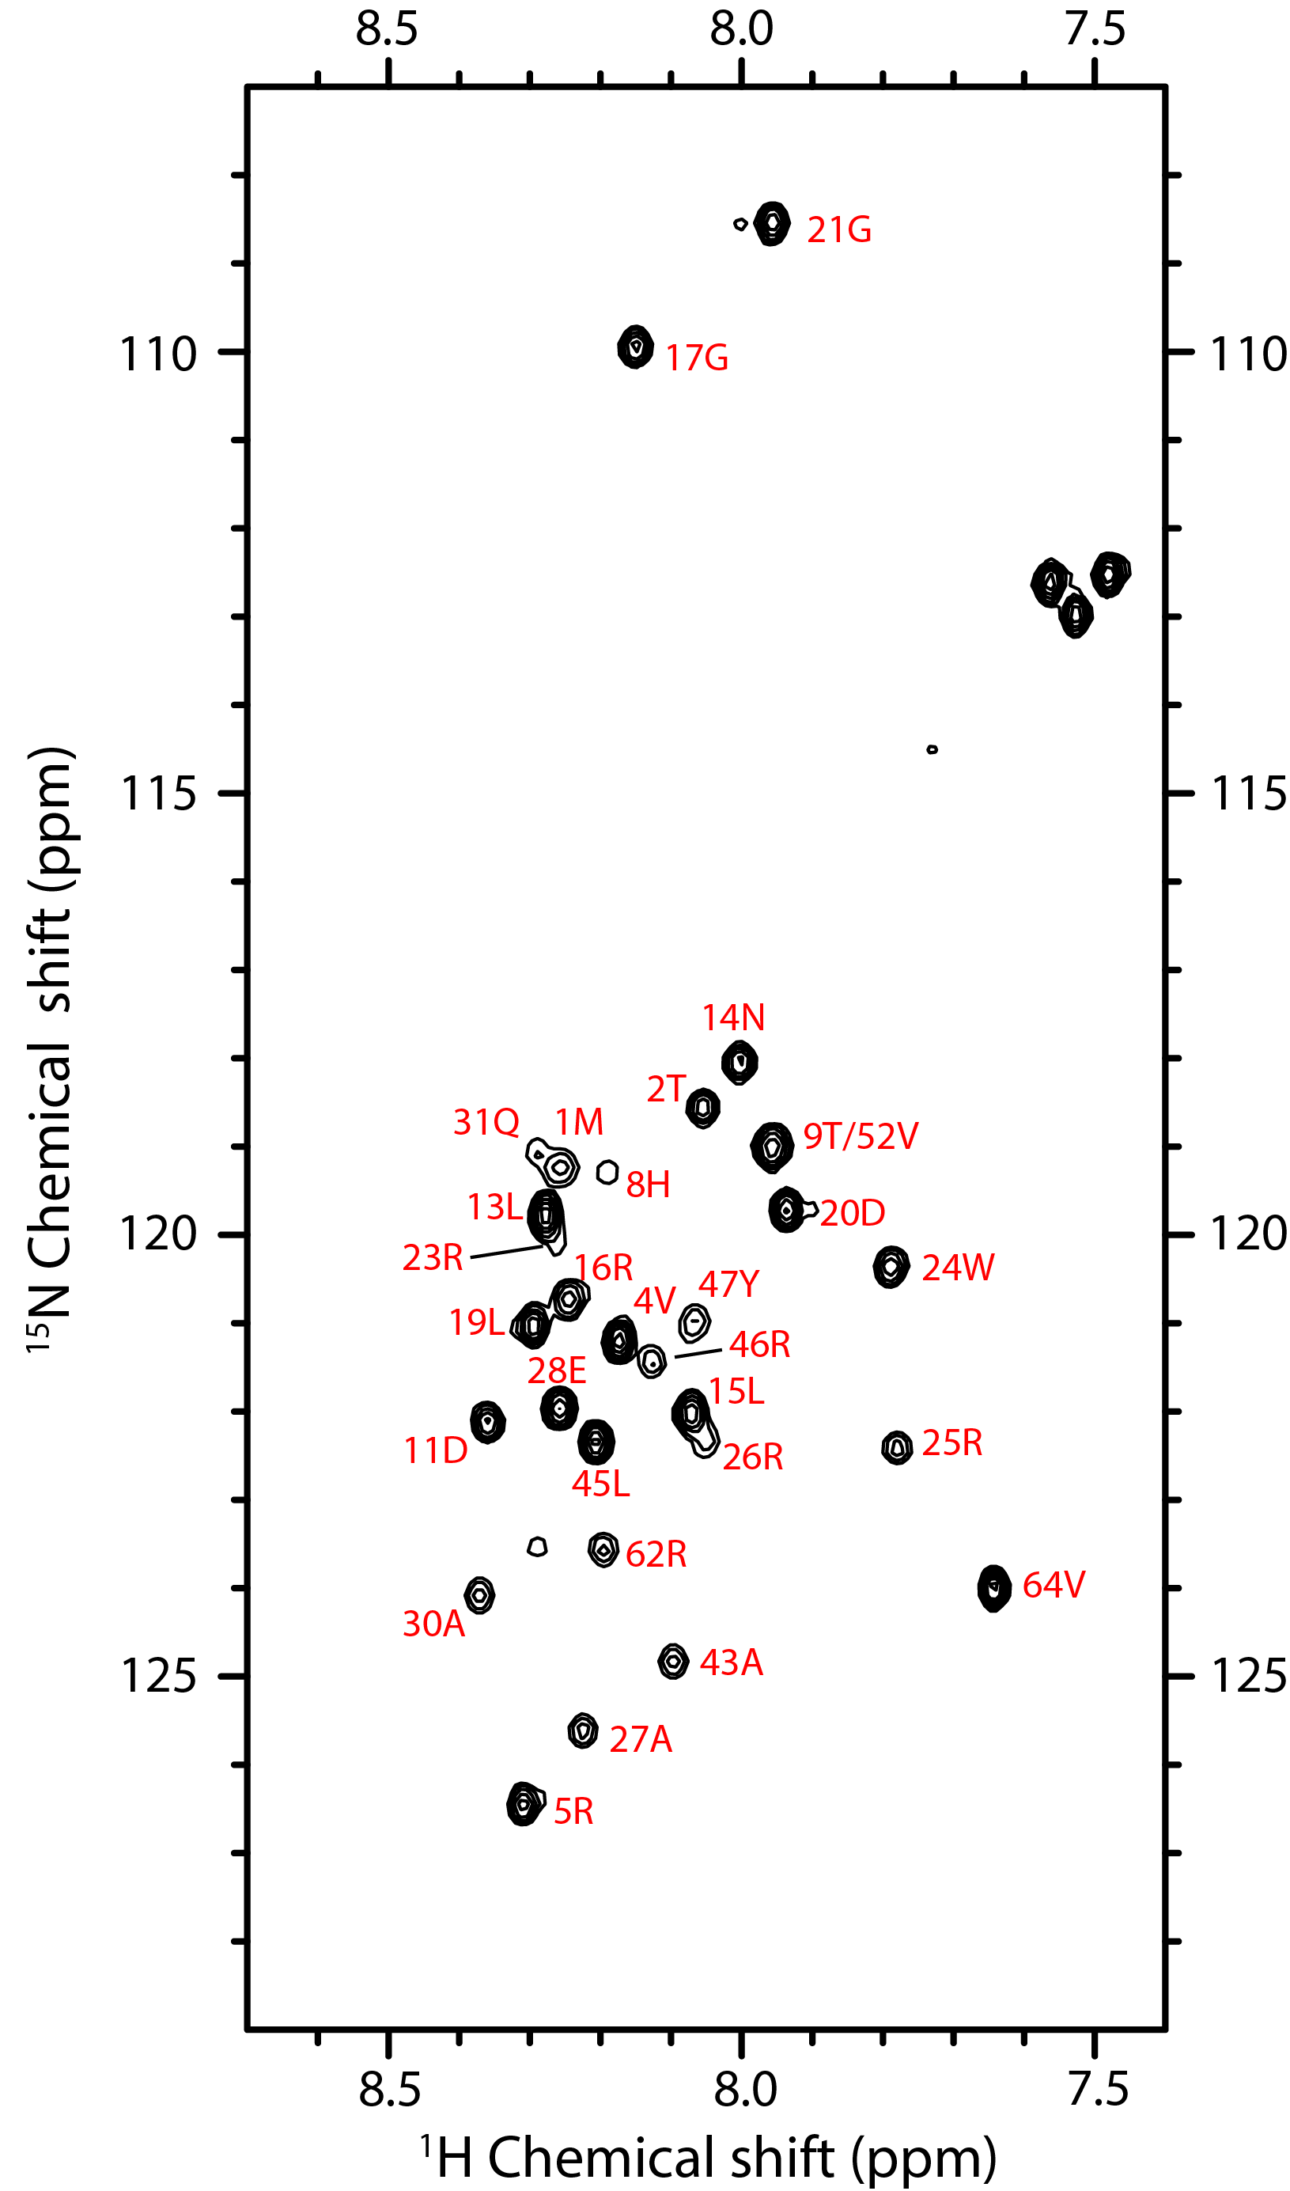
B
A

Fig.2. MAS spectra of ChiZ N-terminal domain with peptidoglycan collected with different excitation methods. A sample with only peptidoglycan was used as control. Experiments were performed at 25°C using 12.2kHz spinning speed.

Fig.1. 2D ¹H-¹⁵N HSQC spectra of ChiZ N-terminal domain at pH 4.0 (A) and 7.0 (B). Spectra were collected at 37°C in a 800 MHz magnet at NHMFL.

Conclusions
ChiZ N-terminal domain has two distinctive spectra depending on the pH used. In addition, ChiZ N-terminal domain is able to bind to peptidoglycan, but it remains highly dynamic. The nature of the binding needs further study.

Acknowledgements
A portion of this work was performed at the NHMFL, which is supported by NSF Cooperative Agreement No. DMR-1157490 and the State of Florida. In addition, funding support by NIH project P01- AI074805.

References
[1] Chauhan, A. , et al., Molecular Microbiology, 62, 132–147 (2006).

