Structure of EmrE by Oriented Solid-State NMR Spectroscopy

Leninger, M. and Traaseth, N.J. (New York U., Chemistry)

Introduction
Oriented solid-state NMR (O-SSNMR) is a powerful technique to probe the structure and dynamics of membrane proteins. One of the most popular experiments for aligned membrane protein samples is the polarization inversion spin exchange at the magic angle (PISEMA) experiment and is commonly used to correlate the ¹H-¹⁵N dipolar coupling with the ¹⁵N anisotropic chemical shift. We have thoroughly optimized the sample preparation of the membrane drug transporter EmrE in order to investigate whether a higher magnetic field would further enhance the spectral quality by reducing ¹⁵N linewidths in ppm. To perform our measurements, we used the protein EmrE that is able to confer drug resistance to bacteria by coupling drug efflux with the proton motive force. Insight into the structure and dynamics would give additional mechanistic insight into one of the broadest defense mechanisms found in multidrug resistant organisms.

Experimental
Uniformly ¹⁵N labeled EmrE was reconstituted into lipid bicelles and flipped by the addition of lanthanide. Two experiments were acquired on this sample using the 900 MHz 105mm NMR magnet at the MagLab in Tallahassee, FL. First a ¹⁵N PISEMA experiment was acquired and followed with a 3D PISEMA/ZZ-mixing experiment with a 500 msec mixing time to correlate the pairs of resonances in exchange. The need for the exchange experiment stems from the asymmetric nature of the monomers within the EmrE dimer that we have previously resolved using O-SSNMR.

Results and Discussion
The PISEMA spectrum shown in Figure 1 was acquired on the EmrE sample with 128 scans and 40 increments giving a total experimental acquisition time of ~5 hr. The sensitivity and resolution was significantly improved compared to previous data collected using a 600 MHz NMR spectrometer including a reduction of the ¹⁵N line widths. In fact, the majority of the linewidths were ~1.5 ppm, which gives a highly resolved spectrum.
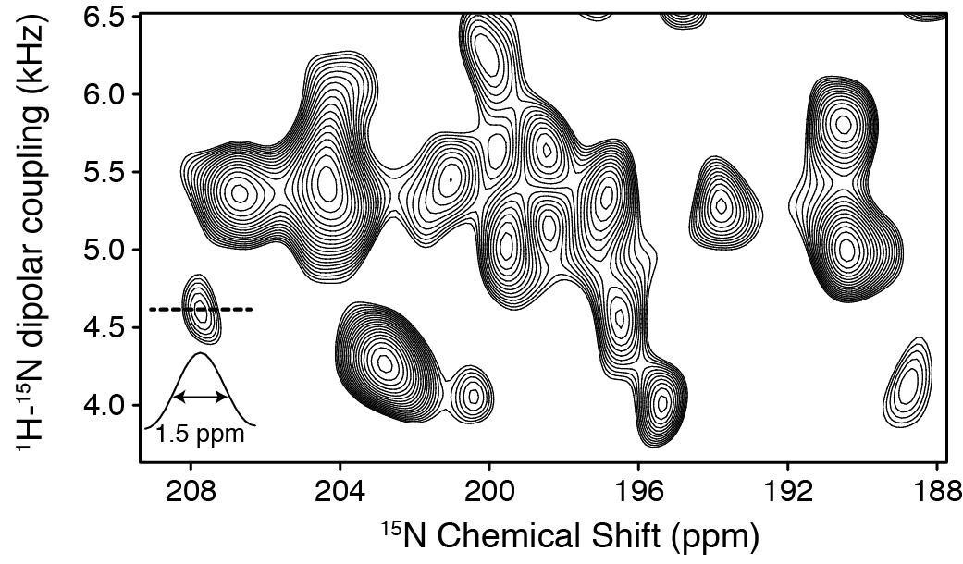

Figure 1. PISEMA acquired with [U-¹⁵N] EmrE at the 900 MHz UWB system at the Maglab. A representative 1D slice is shown for the peak at 208 ppm, which displays the resolution.

Conclusions
These improvements in the spectral resolution at high magnetic field will enable the acquisition of an additional set of complex experiments to gain further insight into the structure and dynamics for large polytopic drug transporters.

Acknowledgements
A portion of this work was performed at the National High Magnetic Field Laboratory, which is supported by National Science Foundation Cooperative Agreement No. DMR-1157490 and the State of Florida. The research project on the multidrug resistant protein EmrE and solid-state methods developments are supported by NIH (R01AI108889) and NSF grants (MCB1506420) to N.J.T. We thank Dr. Ivan Hung for help in setting up the experiment.

