**Using Global Metabolomics to Investigate Metabolic Changes between Late-Gestation Fetal and Neonatal Hearts**

Walejko, J. (UF, Biochemistry & Molecular Biology, SECIM); Keller-Wood, M. (UF, Pharmacodynamics) and Edison, A. (UGA, Genetics & Biochemistry & Molecular Biology)

**Introduction**

During late gestation, the fetal heart relies primarily on glucose and lactate to support rapid growth and development.1 The Keller-Wood laboratory has shown in an ovine model of pregnancy that maternal elevations in cortisol lead to fetal mortality during the peripartum period. Hyperplasia of the fetal heart was observed in fetuses exposed to excess cortisol and transcriptomic analysis revealed alterations in fetal cardiac metabolism.2 Although it is known that the fetal heart undergoes a metabolic switch to utilizing fatty acids as a neonate, little else is known about metabolic changes of the heart during this period.3 Therefore, I proposed to utilize a sheep model of pregnancy to investigate metabolic differences of the fetal heart at labor onset compared to the neonatal heart immediately following birth.

**Experimental**

70 heart samples were collected from the left and right ventricles and intraventricular septum in 14 fetuses following labor onset and 10 neonatal lambs immediately following birth. HR-MAS proton nuclear magnetic resonance (1H-NMR) spectroscopy was conducted on an Avance III 600 MHz spectrometer at the University of Florida Advanced Magnetic Resonance Imaging and Spectroscopy facility to gain metabolic profiles of heart samples. Principal component analysis (PCA) was used to determine differences in metabolites between groups. Significance of metabolites was determined using a student's t-test with a Benjamini-Hochberg false discovery rate (FDR) correction of the area under the metabolite peak(s) of probabilistic quotient normalized spectra.

**Results and Discussion**

PCA reveals separation of heart tissue samples between neonates and fetuses at labor onset. A t-test of normalized spectra revealed that lactate, glutamine, and alanine are significantly increased (p<0.05) in fetal heart tissue while 3-hydroxybutyrate (3HB) and glutamate are significantly increased (p<0.05) in neonatal heart tissue.

**Conclusions**

Elevations of lactate, along with glutamine and alanine, suggest that glycolysis and gluconeogenic pathways are active in the term fetal heart. Increased levels of 3HB and glutamate in the neonatal heart suggests the onset of the switch in substrate utilization occurs during labor and delivery. This provides evidence that labor onset marks a time of rapid metabolic changes in the fetal heart, suggesting that perturbations in this metabolism may contribute to stillbirth during the peripartum period, or later life cardiomyopathies.

**Acknowledgements**

A portion of this work was performed at the National High Magnetic Field Laboratory, which is supported by National Science Foundation Cooperative Agreement No. DMR-1157490 and the State of Florida. In addition, we would like to acknowledge NIH SECIM grant 1U24DK097209-01A1, NIH grants HD057871, and NIH/NCATS TL1 TR000066 and UL1 TR000064.

**References**

[1] Kong B., *et al*., Chin Med J, **121**, 1257-64 (2008).

[2] Richards E., *et al.*, Physiol Genomics, 46, 547-559 (2014).

[3] Fisher D., *et al*., Am J Physiol, 238, H399-405 (1980).

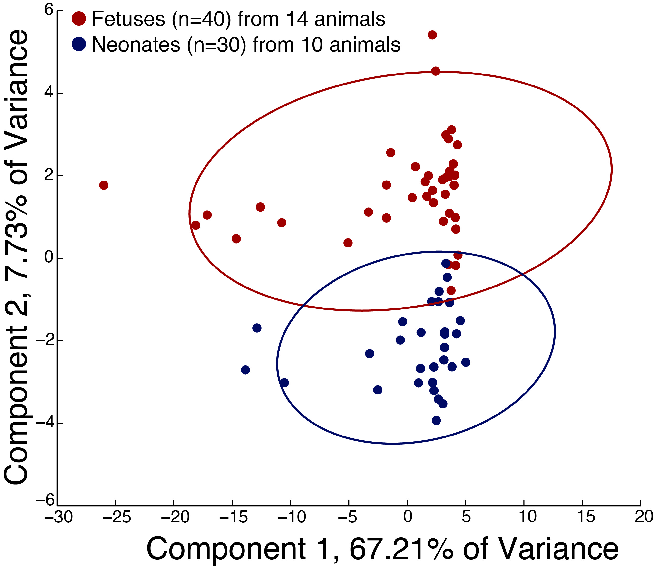

**Fig 1:** PCA scores plot reveals separation of heart samples from fetuses (red, n=40) compared to samples from neonates (blue, n=30).

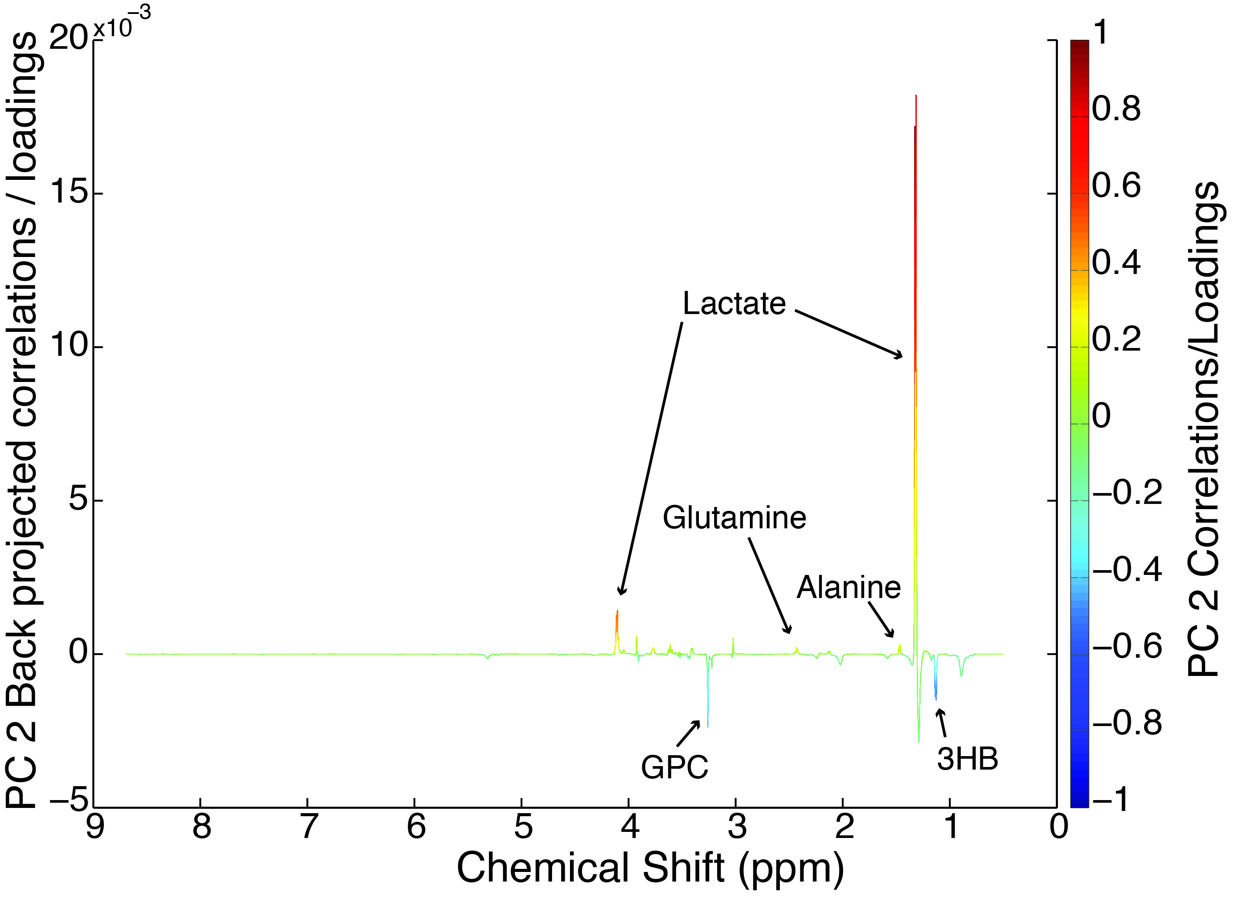

**Fig 2:** PCA component 2 loadings plot was used to find metabolites contributing to this separation (see Table I). Glycerolphosphocholine (GPC) was not found to be statistically significant (p=0.055).

**Table I** Metabolites that differ in fetal and neonatal hearts



*Alanine not significant in LV when analyzed separately

**Lactate overlapped with myo-inositol