NMR Structural Analysis of Sarcoplasmic Reticulum Proteins in Membranes

Veglia, G.; Nelson, S.E.D.; McDonald, L.R.; Vostrikov, V.V. (U. of Minnesota, Chemistry; Biochemistry, Molecular Biology, and Biophysics) and Soller, K.J. (U. of Minnesota, Chemistry)

Introduction
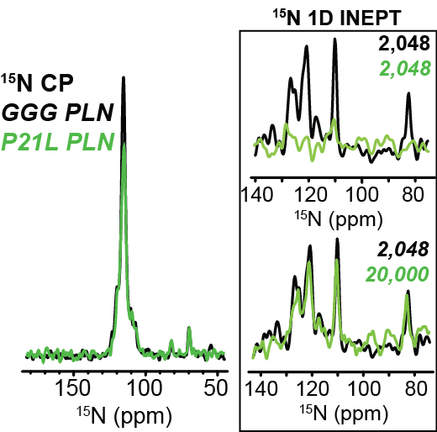
Disruptions in Ca²⁺ transport in muscle tissue can lead to severe dysregulation of contraction and relaxation. Ca²⁺ cycling is controlled by dynamic protein complexes that transport Ca²⁺ through the sarcoplasmic reticulum (SR) membrane. Dysfunctions in Ca²⁺ re-uptake to the SR through the sarco(endo)plasmic reticulum Ca²⁺-ATPase (SERCA) due to mutations in the small, transmembrane regulator phospholamban (PLN) have been identified in a variety of cardiomyopathies. We use NMR to map the structural and dynamic effects of these pathological mutations, as well as designing and testing new mutations in PLN aimed at tuning SERCA activity to restore cardiac function [1]. We are also using NMR to map the binding interface between the calcium sensing regulatory protein, calmodulin (CaM), and the SR Ca²⁺ release channel, ryanodine receptor (RyR). Recently, multiple mutations in CaM were identified in cardiac arrhythmias, and mapping the CaM-RyR binding interaction will provide valuable insights into how these mutations disrupt Ca²⁺ transport and lead to arrhythmia. MAS NMR is an ideal method to investigate both the PLN conformation and CaM-RyR complex due to the variety of available experiments in a biologically relevant lipid environment.

Fig. 1: [¹H,¹⁵N] INEPT reveals a shift in the dynamics of PLN’s cytoplasmic domain. Left, ¹⁵N CP. Right, Overlay of 1D ¹⁵N INEPT spectra for AFA^{GGG} (black) and AFA^{P21L} (green). The number of scans used for each sample is indicated in the top right of each spectrum.
Experimental
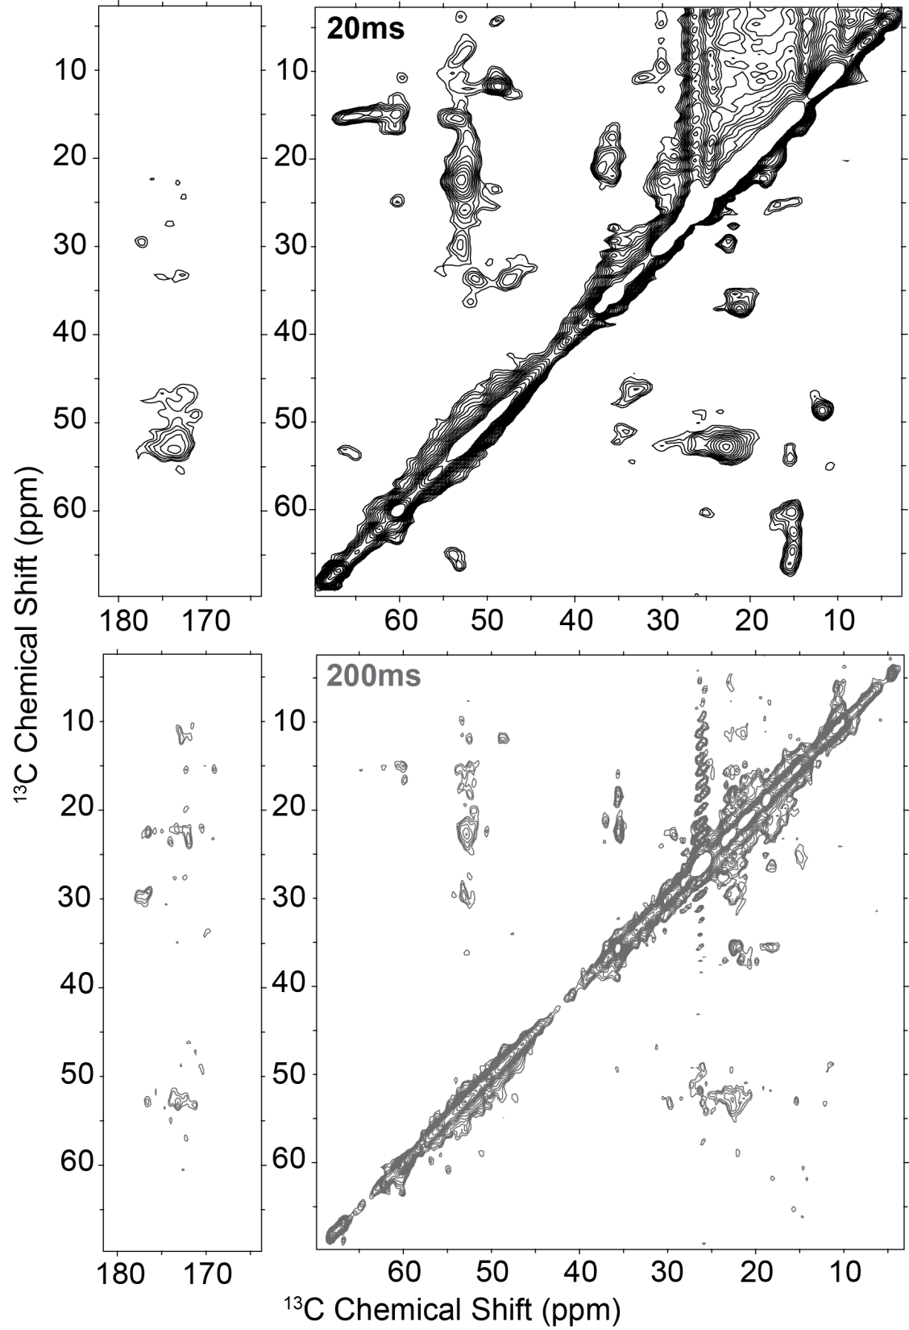
AFA (C36A/C41F/C46A, monomeric) PLN samples for MAS NMR were reconstituted in DMPC [2], while CaM-RyR samples were prepared in SR tissue extracts. [¹H, ¹⁵N] INEPT and [¹³C, ¹³C] DARR spectra were acquired using both uniformly and selectively labeled PLN samples. [¹³C, ¹³C] DARR on uniformly labeled CaM samples were acquired with varied mixing times. All experiments were acquired at NHMFL in Tallahassee, FL using the 800 and 900 MHz solid-state spectrometers.
Figure 2: [¹³C, ¹³C] DARR of CaM bound to the RyR. Top, 20 ms mixing time. Bottom, 200 ms mixing time. Spectra were acquired using the 900 MHz NMR spectrometer at the NHMFL facility in Tallahassee, FL.
Results and Discussion
In the past year, we have acquired spectra on a variety of PLN variants that have provided valuable insights into not only the effects of mutations leading to cardiomyopathy but the overall regulatory mechanism between PLN and SERCA. For example, ¹⁵N and ¹³C acquisition on a selectively labeled sample of AFA^{R9C} PLN allowed us to unambiguously identify the position of Ile residues in both DARR and INEPT spectra [3]. This level of assignment conformation allows us to map changes in chemical shift or conformation to specific sites in the protein. We were also able to acquire spectra of uniformly ¹³C and ¹⁵N samples of specifically designed PLN mutations aimed at tuning SERCA dynamics. Both the phosphomimetic AFA^{T17E} and AFA^{GGG} mutants exhibited highly dynamic behavior relative to AFA PLN, while AFA^{P21L} exhibited a highly rigid cytoplasmic domain (Fig. 1).
The sensitivity of the 900 MHz 105 mm solid-state spectrometer allowed for the acquisition of well resolved [¹³C, ¹³C] DARR spectra of CaM in complex with the RyR at a variety of mixing times (Fig. 2). These spectra indicate that certain regions of CaM may still remain relatively dynamic.
Acknowledgements
The spectra shown were acquired at the NHMFL, which is supported by NSF Cooperative Agreement No. DMR-1157490 and the State of Florida. Research funding for was provided by NIH grant GM64742.
References
[1] Ha, K.N., et al., J. Muscle Res Cell Motil, 33(6), 485-492 (2012).
[2] Gustavsson, M., et al., PNAS, 110(43), 17338-17343 (2013).
[3] Nelson, S.E.D., et al., in preparation.

