Sodium 3D COncentration MApping (COMA 3D) Using ²³Na and Proton MRI

Truong, M.L. (Vanderbilt U., Institute of Imaging Science); Harrington, M.G. (Huntington Medical Research Institutes, Molecular Neurology); Schepkin, V.D. (NHMFL) and Chekmenev, E.Y. (Vanderbilt U., Institute of Imaging Science)

Introduction
Recent development of ultra-high field pre-clinical 21.1 T MRI [1] enabled high-resolution functional MRI studies of live rats [2], with sensitivity sufficient to generate high-resolution maps of dilute nuclei beyond protons and without the use of hyperpolarization techniques. High-resolution 2D ²³Na with sub-millimeter spatial resolution has been demonstrated and successfully used for functional changes of sodium in the rat model of migraine [3]. However, the resolution and sensitivity improvements endowed by high magnetic fields create labor and information intense datasets, e.g. large multi-dimensional matrices that prove cumbersome for quantitative analysis. Combined with the need for examining multiple animals and applying quantitative analytical and statistical tools, an automated image processing is required.

Experimental
Functional changes of sodium 3D MRI signals were converted into millimolar concentration changes using an open-source, fully automated MATLAB toolbox. These concentration changes are visualized via 3D sodium concentration maps, and they are overlaid over conventional 3D proton images to provide high-resolution co-registration for easy correlation of functional changes to anatomical regions. The MATLAB toolbox allows for automated image analysis of the 3D images acquired on the Bruker platform and can be extended to other imaging platforms. The toolbox provides: (a) MATLAB source code for image processing, (b) the detailed processing procedures, (c) description of the code and all sub-routines, (d) example data sets of initial and processed data, and can be downloaded: http://www.vuiis.vanderbilt.edu/~truongm/COMA3D/.

Results and Discussion
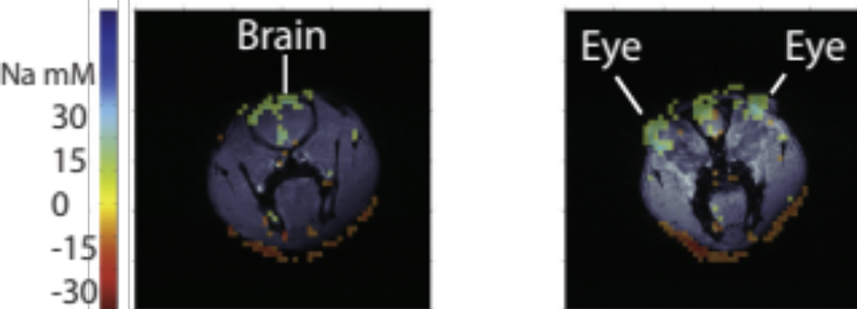
COMA 3D toolbox was applied to process a 3D imaging dataset of a rat migraine model for determining the levels of sodium during central sensitization as a result of migraine, Figure 1 [4]. Nearly 5000/h concentration maps were generated on a personal computer (ca. 2012) using 21.1 T 3D sodium MRI brain images of live rats with spatial resolution of 0.8 × 0.8 × 0.8 mm³ and imaging matrices of 60 × 60 × 60.
Fig.1 Axial slices showing the sodium concentration changes from NTG induced central sensitization in the brain and eyes of a rat migraine model, with the sodium functional changes (induced by NTG) in the range of 10–20 mM through significant sections of rat brain. The field of view for each slice is 48 × 48 mm².

Conclusions
This is the first report of using ²³Na 3D MRI for imaging a change of brain function in this migraine model, and the first report of generating such 3D maps with sub-microliter spatial resolution.

Acknowledgements
Supported by grants from the National Institutes of Health R01 NS-043295, and HMRI. A portion of this work was performed at the NHMFL, which is supported by NSF DMR-1157490 and the State of Florida.

References
[1] Fu, R., et al., J. Magn Reson., 177, 1-8 (2005).
[2] Schepkin, V.D., et al., Magn Reson Med., 67, 1159-1166 (2012).
[3] Harrington, M.G., et al., Cephalalgia., 12, 1254-65 (2011).
[4] Truong, M., et al., J. Magn Reson., 247, 88-95 (2014).

