Antiparallel β-Sheet Structure within Oligomers of the
42-Residue Alzheimer’s β-Amyloid Peptide

Paravastu, A.K.; Huang, D.; Zimmerman, M.I. (Florida State U., Chemical and Biomedical Engineering); Martin, P.K.; Nix, A.J. and Rosenberry, T.L. (Mayo Clinic, Neuroscience)

Introduction
Significant genetic, pathological and biochemical evidence links Alzheimer’s disease (AD) more closely to soluble aggregates (oligomers) of the β-amyloid peptide (Aβ) rather than more stable amyloid fibrils. We recently reported that 150 kDa oligomers (composed of ~30 molecules) of the 42-residue variant Aβ is characterized by β-strand organization that is distinct from that of Aβ fibrils.¹ These oligomers were produced by the Rosenberry Laboratory. The present work is aimed at determining the precise residues involved in the antiparallel β-sheet and comparing NMR structural constraints to proposed oligomer structural models from the literature.

Experimental
We performed solid state NMR measurements on ¹³C labeled 150 kDa oligomer samples. We chose labeled sites that would allow us to test for the presence of a hypothesized antiparallel β-sheet centered at V36.¹ Our measurements included 2D-fpRFDR, for spectral assignments and precise chemical shifts, 2D-DARR to probe inter-residue spatial proximities, and 2D-CHHC to probe for the hypothesized arrangement of α-hydrogens.²⁻⁴ In order to rationalize our NMR-derived experimental constraints with previously proposed oligomer molecular models, we performed constrained molecular dynamics computer simulations.

Results and Discussion
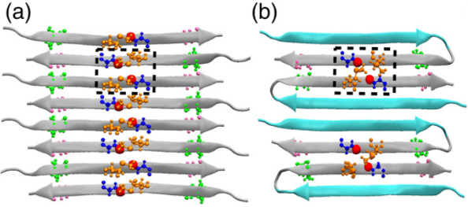
We found experimental evidence supporting our hypothesized antiparallel β-sheet within 150 kDa Aβ(1-42). This interpretation is based on 1) our observation of β-strand secondary chemical shifts at labeled sites between I32 and V40; 2) 2D-CHHC NMR cross-peaks indicating close proximity between M35 H_{α} and G37 H_{α}; and 3) 2D-DARR crosspeaks indicating close intermolecular spatial proximities between I32 and V40 as well as M35 and G37.⁵ Fig. 1 shows molecular models of antiplarallel β-sheets that are consistent with our NMR data.
Fig.1 All-atom models of antiparallel β-shees that are consistent with our NMR data. The atoms drawn correspond to atoms for which NMR data provide direct structural constraints. a) a β-sheet model in which all β-strands are equivalent and composed on residues 32-40. b) a β-sheet model composed on β-hairpins each consisting two inequivalent of β-strands.
Conclusions
The results indicated that the C-terminal β-strands within the Aβ(1-42) peptide are arranged into antiparallel β-sheets when they form the 150kDa oligomer. This result could represent an aggregation pathway, which differs from the fibril formation pathway.

Acknowledgements
This work was supported by the Alzheimer’s Association (grant NIRG-10-173755), the National High Magnetic Field Laboratory User Collaboration Research Grant Program, and the National Institute on Aging of the National Institutes of Health (award number R01AG045703). A portion of this work was performed at the National High Magnetic Field Laboratory, which is supported by National Science Foundation Cooperative Agreement No. DMR-1157490 and the State of Florida.

References
[1] Tay, W.M., et al., J. Mol. Biol., 425, 2494-2508 (2013).
[2] Ishii, Y.J., Chem. Phys., 114, 8473-8483 (2001).
[3] Takegoshi, K., et al., Chem. Phys. Lett., 344, 631-637 (2001).
[4] Tycko, R., et al., J. Am. Chem. Soc., 125, 6606-6607 (2003).
[5] Huang, D., et. al., J. Mol. Biol., 427, 2319-2328 (2015).

