Evaluation of an Intervention using Metabolomics in a
Rat Model of Myocardial Autophagy

Dutta, D. (Howard Hughes Medical Institute, University of Illinois, Urbana, IL) and Plant, D. (McKnight Brain Institute, University of Florida, Gainesville, FL)

Introduction
To investigate whether metabolomics using NMR in a validated rat model can distinguish between a control group and a group receiving a dietary or therapeutic intervention. Preliminary data indicates the ability to detect and identify key lipid, carbohydrate, and amino acid components of the rat serum sample which would make it possible to understand the mechanism of myocardial autophagy. A mild Caloric Restrictive diet regimen and the plant polyphenol resveratrol have shown numerous cardioprotective effects in experimental animal models and in controlled clinical trials. Therefore, combining these two interventions might provide additional cardioprotective effects. Although their exact mechanism is still a matter of debate, our previous results suggest that an induction of myocardial autophagy is at least partially responsible for the beneficial effects (1). Although metabolomics using NMR for understanding mammalian system biology is still being developed, it promises to be not only be useful for detecting biomarkers of disease for early diagnosis and assessment of treatments but may help to understand the mechanisms by which these metabolites are altered.

Experimental
A major goal is to measure critical metabolites known to be altered in mitochondrial dysfunction and to establish a baseline by which to evaluate future interventions. A total of 12 animals for each of the 3 groups will be analyzed. The serum samples have already been collected for a previous study and are stored at -80 C. Standard protocols for sample preparation will be used (2). Proton NMR spectra are acquired on the 600 MHz Bruker Avance III NMR system using a standard 5mm Broadband probe. Proton 1D Pre-saturation-NOESY, 2D TOCSY, J-Resolved and 1H{¹³C} HSQC experiments were collected to assist in identifying the principal components. The data were collected using TopSpin version 3.2.5 (Bruker Biospin) and the spectra are binned using the AMIX 3.9 routines native to TopSpin.
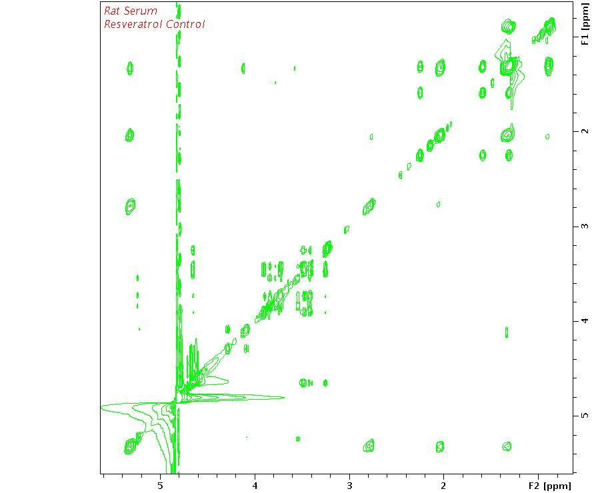
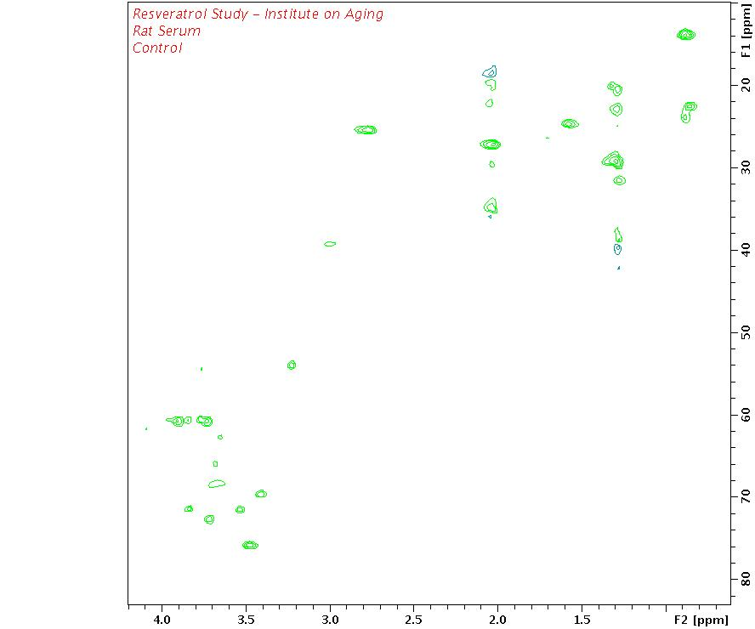
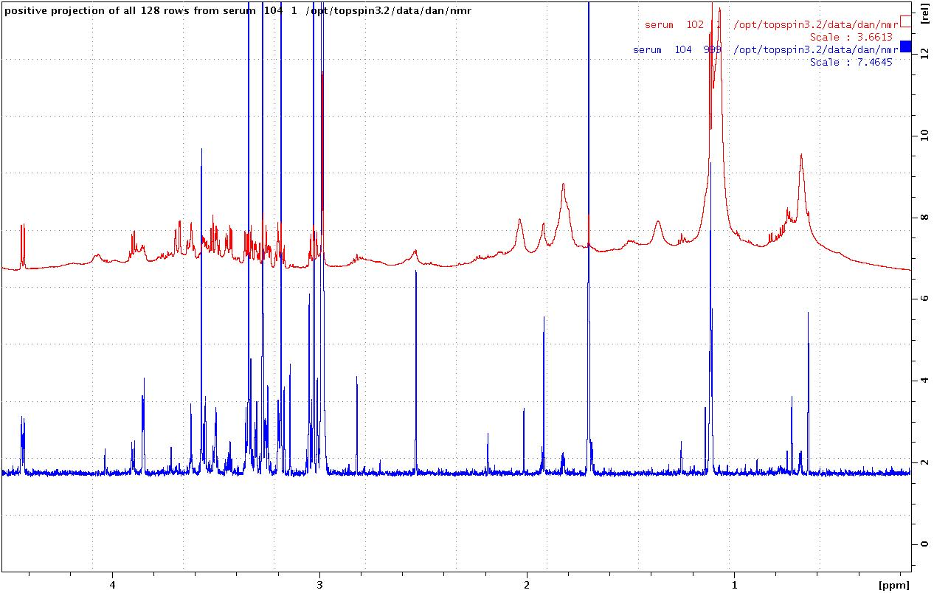
Results and Discussion
Fig.1 (a) ¹H 1D Presaturation/J-Resolved spectrum at 600 MHz (b) a TOCSY spectrum and (c) a 1H{13C} HSQC spectrum
Shown in Figure 1 (a) is a ¹H 1D pre-saturation spectrum (above) and a projection of a 2D J-resolved spectrum (below) of a control sample of rat serum in 10% D2O. Figure 1 (b) is a 2D ¹H TOCSY spectrum using an 80 ms mixing time. Figure 1 (c) is a 2D ¹H{¹³C} HSQC spectrum which provides ¹³C chemical shifts and greatly aids in the identification of the metabolites. The NHMFL recently purchased the AMIX license and we will now be able to evaluate our data with Principal Component Analysis.

Acknowledgements
A portion of this work was performed at the National High Magnetic Field Laboratory, which is supported by National Science Foundation Cooperative Agreement No. DMR-1157490 and the State of Florida.

References
[1] Dutta, D., et al., Free Radical Biol. Med. 74, 252-62 (2014).
[2] Dona, A.C., et al., Anal. Chem., 86, 9887−9894 (2014).

