Sequence Dependence Studies of SP-B₁₋₂₅

Tran, N. (UF, Chemistry); Smith, A.N. (UF, Biochemistry & Molecular Biology); Lukjan, S.F. (Troy University, Chemistry) and Long, J.R. (UF, Biochemistry & Molecular Biology)

Introduction
Pulmonary surfactant (PS) is a lipoprotein mixture found in the alveoli of the lungs and allows for proper lung function by lowering the surface tension at the alveolar air-water interface. It is composed of 80% phospholipids, 10% other lipids (primarily cholesterol), and 10% proteins, namely surfactant proteins A, B, C, and D. Of the four surfactant proteins, surfactant protein B (SP-B) is the only one required for survival. Current models of SP-B suggest its role in trafficking PS lipids from the aqueous hypophase to the air-water interface, however its mechanism of action is poorly understood. Previous ²H and ³¹P NMR experiments have indicated the presence of isotropic phases upon addition of SP-B₁₋₂₅ to varying lipid systems, with pronounced effects in lipid mixtures containing deuterated dipalmitoylphosphatidylcholine (DPPC). This supports the model that SP-B₁₋₂₅ selectively traffics DPPC lipids and may participate in the stabilization of PS at the air-water interface via a lipid fusion mechanism. It has been shown that only the first 25 residues of SP-B (SP-B₁₋₂₅) are required to recapture most of the activity of full length SP-B, suggesting a critical role in the highly conserved N-terminus of SP-B. Point mutations in SP-B₁₋₂₅ reveal different effects on lipid dynamics and morphologies in varying lipid systems. These results have prompted experiments aimed at delineating the sequence dependence on the mechanism of lipid trafficking.

Experimental
Variable temperature ²H NMR spectra of multilamellar vesicles with the indicated amount and variant of SP-B₁₋₂₅ were collected on a 500 MHz Bruker DRX spectrometer utilizing a quadrupolar echo sequence in the AMRIS facility at UF. A 5 mm broadband observe (BBO) probe was used.

Results and Discussion
Previous results suggest that the behavior of SP-B₁₋₂₅ may be sequence dependent as shown by the differences in lipid dynamics induced by the mutant and WT peptide in varying lipid systems. [1] This is shown in Figure 1a,d as the addition of mutant (C8S, C11S, M21I) and wild type (WT) SP-B₁₋₂₅ induces isotropic phases in 4:1 DPPC-d₆₂/POPG, while the isotropic phase is persistent through the temperature range only with addition of WT SP-B₁₋₂₅. This behavior in lipid dynamics differs compared to that observed in calf lung surfactant (CLSE) and a synthetic lipid mixture mimicking CLSE (CLSE^{Syn}). In CLSE, the addition of mutant SP-B₁₋₂₅ induces an isotropic phase in DPPC while WT SP-B₁₋₂₅ does not (Figure 1b,e). In CLSE^{Syn}, addition of mutant and WT SP-B₁₋₂₅ induce line shapes indicative of DPPC lamellar phases, however the line widths are more narrow with addition of mutant SP-B₁₋₂₅, suggesting greater fluidity in DPPC dynamics.
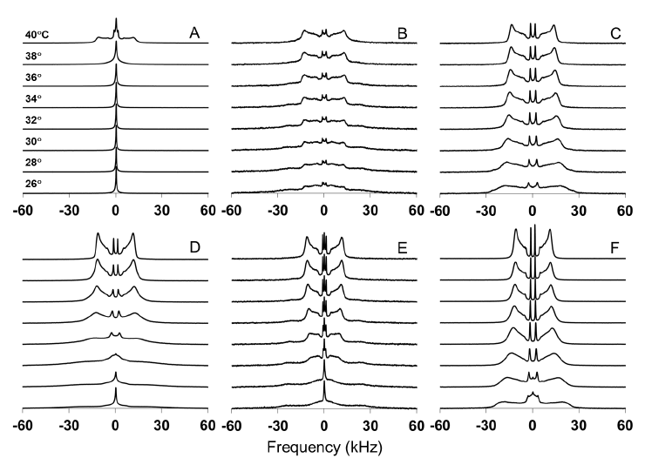
Conclusions
These results suggest that SP-B₁₋₂₅ may be sequence dependent and have prompted the synthesis of additional mutant peptides aimed at delineating functionally significant residues using ²H and ³¹P NMR.

Acknowledgements
A portion of this work was performed at the National High Magnetic Field Laboratory, which is supported by National Science Foundation Cooperative Agreement No. DMR-1157490 and the State of Florida.

References
[1] R. Suzanne Farver. Investigations of Lipid Dynamics and Polymorphisms in Lung Surfactant. Ph.D Dissertation, 2011
Figure 1. Deuterium spectra as a function of temperature for A) 4:1 DPPC-d₆₂/POPG with 5% SP-B₁₋₂₅ (WT), B) CLSE/DPPC-d₆₂ with 5% SP-B₁₋₂₅ (WT), C) CLSE^{Syn}/DPPC-d₆₂ with 5% SP-B₁₋₂₅ (WT), D) 4:1 DPPC-d₆₂/POPG with 5% SP-B₁₋₂₅ (C8S, C11S, M21I), E) CLSE/DPPC-d₆₂ with 5% SP-B₁₋₂₅ (C8S, C11S, M21I), F) CLSE^{Syn} /DPPC-d₆₂ with 5% SP-B₁₋₂₅ (C8S, C11S, M21I)

