Metabolomic Analysis of Mouse Tissues Using 1D and 2D 13C NMR

Clendinen, C.S. (UF, Biochemistry and Molecular Biology); Heumann, H. (Silantes GmbH, Germany); Turck, C.W. (Max Planck Institute, Germany) and Edison, A.S. (UF Department of Biochemistry and Molecular Biology; Southeastern Center for Integrated Metabolomics)

Introduction
Isotopic labeling can greatly increase the signal to noise of ¹³C spectra even in mouse tissue extracts. 1D ¹³C analyses of the mouse tissue extracts, however, were complicated due to large homonuclear couplings. To resolve this issue, we collect 2D ¹³C-¹³C INADEQUATE. Not all tissues were of sufficient mass to perform INADEQUATE, thus only the brain and liver was analyzed using INADEQUATE and the 1D spectra of all tissues annotated using the metabolites found in the liver. We aim to understand the distribution of metabolites across mouse tissues.

Experimental
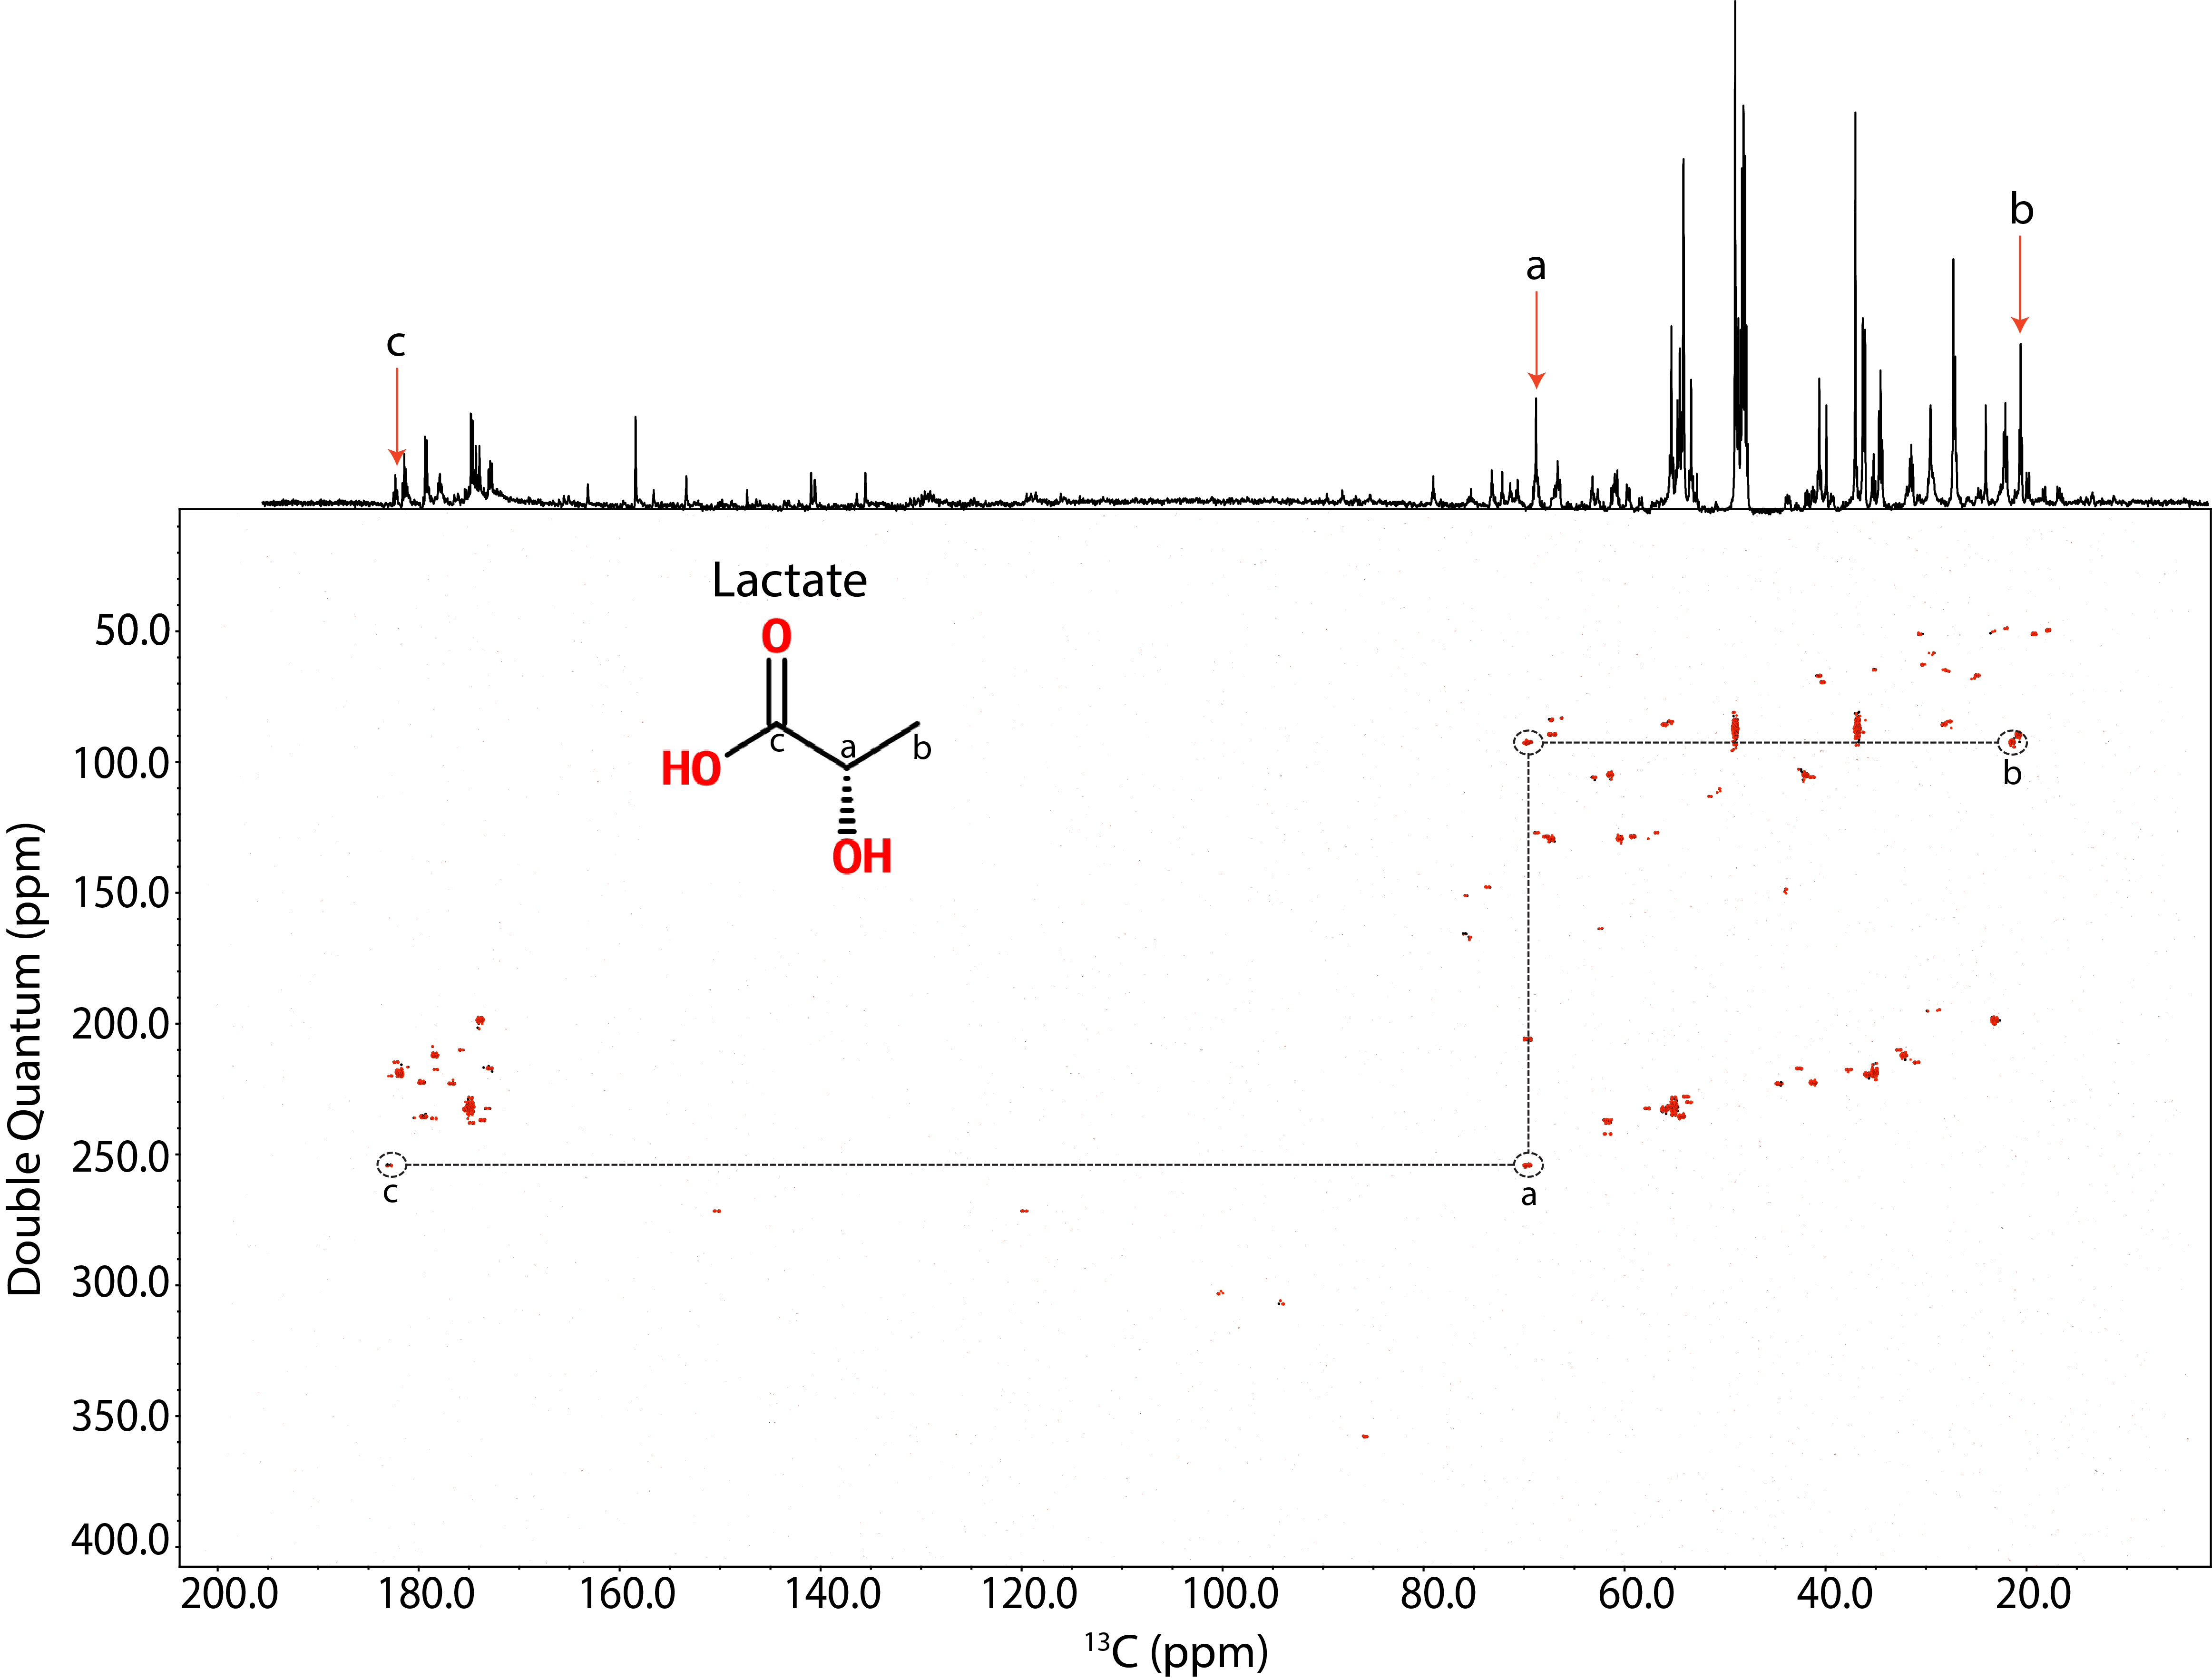
¹³C-enriched mouse tissues are generated by feeding the animals a custom made ¹³C diet for 14 days. Dried extracts from the several of tissues were re-suspended in 40 μL of deuterated solvent. All samples were be analyzed using the 1.5 mm HTS cold probe² in the 600 MHz Agilent spectrometer at the University of Florida. Standard ¹³C 1D spectra were collected for each sample. ¹³C-¹³C INADEQUATE data was acquired for the liver and brain samples.

Results and Discussion
Approximately 30 metabolites in the liver were successfully annotated in the INADEQUATE (Figure above on left) though 75 networks were found. In the brain (Fig 1.) 18 metabolites found out of 21 INADEQUATE networks. ¹³C chemical shifts corresponding to the metabolites annotated in the INADEQUATE was used to annotate the 1D ¹³C spectra (Figure above on right) for all samples. These annotations were used to determine the presence of various metabolites in the other tissues. Sugars such as glucose are predictably present in the liver and the plasma. Due to its need for a constant supply, the brain has no detectable glucose.
Fig.1 Mouse Brain INADEQUATE

Conclusions
Though the mouse tissue data analysis is preliminary, it demonstrates the ability to perform and analyze ¹³C global metabolomics analysis on isotopically labeled mammalian tissue using INADEQUATE.

Acknowledgements
A portion of this work was performed at the National High Magnetic Field Laboratory, which is supported by National Science Foundation Cooperative Agreement No. DMR-1157490, the State of Florida, and the U.S. Department of Energy. In addition, we would like to thank the National Institutes of Health (NIH 1U24DK097209-01A1 and R01EB009772)
Fig.2 Bar plots of the presence and absence of various amino acids

References
[1] Bax, A. et al. JACS. 1981
[2] Ramaswamy,V. et al. eMagRes. 2013

