³¹P NMR of the P301L Mouse Model of Frontotemporal Dementia and AD

Briggs, R.W. (U Fla, Department of Aging and Geriatric Research); Febo, M.V. (U Fla, Department of Psychiatry) and Plant, H.D. (U Fla, McKnight Brain Institute)

Introduction
The focus of this study was to characterize the cerebral phospholipid profile related to AD pathology. The in vitro ³¹P NMR spectroscopy of Alzheimer’s disease tissue has historically shown changes in phosphomonoester (PME) and phosphodiester (PDE) ratios (1). The use of 2D NMR to identify individual esters may eventually provide a causal link between tau overexpression in forebrain structures and altered phospholipid profiles in mouse models of cognitive decline.

Experimental
The 2D ¹H{³¹P} HMBC in vitro spectra were collected on the 600 MHz Avance III system using a 5mm broadband probe. The in vivo ³¹P spectra were obtained on the 17.6 T wide bore with a 6-mm x 9-mm surface coil (Doty Scientific Inc.) centered over the frontal cortex of the mouse.

Results and Discussion
The data reported here demonstrate the ability to obtain surface-coil-localized ³¹P spectra from mouse brain in vivo and the potential for identifying individual phosphoesters using 2D ³¹P-¹H NMR. Figure 1 shows an overlay of two 2D HMBC spectra of glycerophosphocholine (GPC) and phosphocholine (PC). These and other PMEs and PDEs will be used in spiking experiments to identify ceramide and sphingosine phosphates.

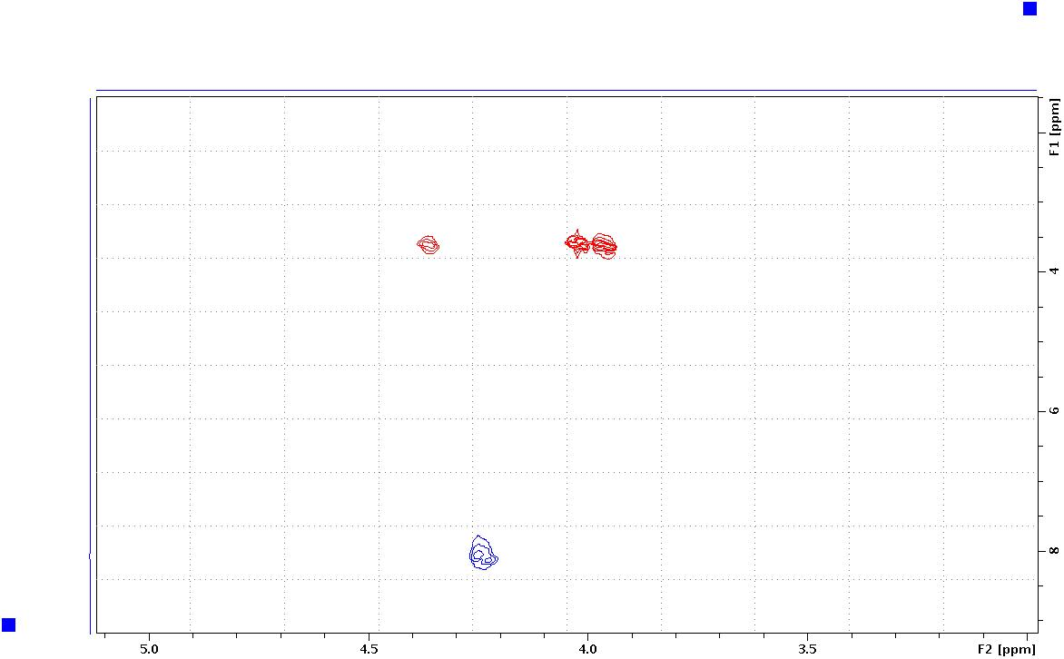

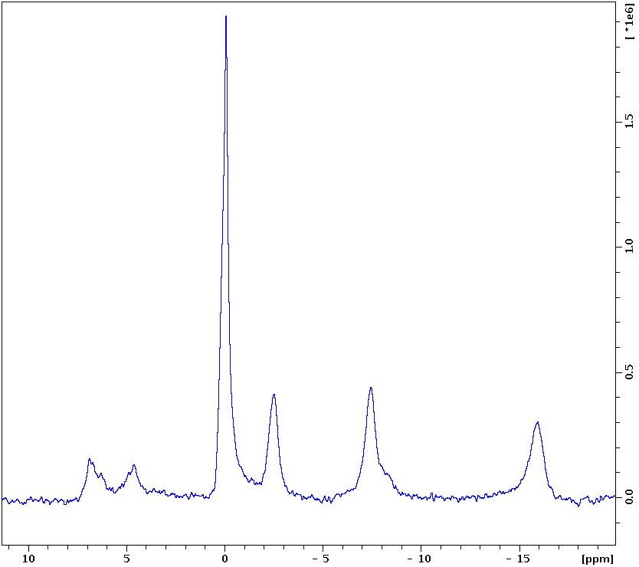

Fig.1 The overlay of two 2D HMBC spectra. The red is glycerophosphocholine and the blue is phosphocholine.
Fig.2 The in vivo ³¹P spectrum of mouse brain frontal cortex processed with 5 Hz exponential line broadening.

Conclusions
Previous attempts to implement the 2D HMBC experiment at 17T were unsuccessful. However, new coils are now available with improved performance which will hopefully allow us to translate the 2D in vitro work at 14T to the 17T in vivo.

Acknowledgements
A portion of this work was performed at the National High Magnetic Field Laboratory, which is supported by National Science Foundation Cooperative Agreement No. DMR-1157490 and the State of Florida.

References
[1] Miatto, O., et al., Canadian Journal of Neurological Science, 13 (4 Suppl), 535-539 (1986).

