Magneto-Optical Features of the Ferric Horse-Heart Cytochrome Complex Revealed by Differential Absorption Spectroscopy

Bishop, M.M. (NHMFL) and McGill, S.A. (NHMFL)

Introduction
The cytochrome complex (Cyt c) plays an integral role in electron transfer within mitochondrial cell membranes of all known plants and animals. The heme group in the cytochrome complex consists of an iron center (Fe²⁺ or Fe³⁺) surrounded by a porphyrin molecule. Out-of-plane distortions of the heme porphyrin are known to correlate with its electron-transfer function.^{1, 2} These types distortions affect orbital overlap from the $π$-states of the porphyrin and the d$π$-symmetric orbitals. A high magnetic field should be able to shift the energies of these orbitals in the ferromagnetic iron center, and change absorption coefficients corresponding to particular transitions. This approach allows for a systematic, perturbative study of this system, which has previously only been attainable through selective or coincidental (natural) protein mutations that change the spatial and electronic properties of the heme/protein complex.

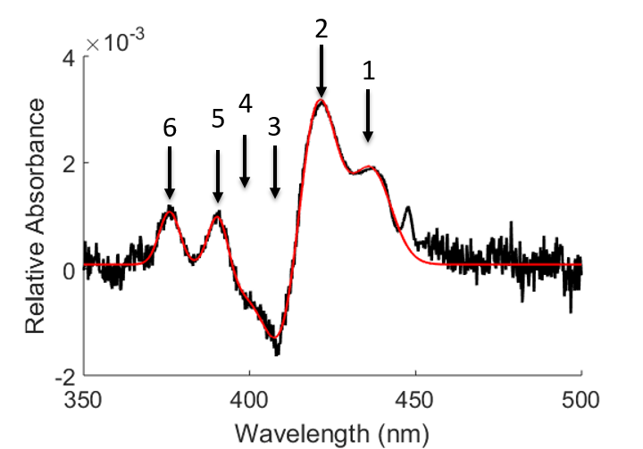Experimental
Horse heart cytochrome c was dissolved in pH 7.0, 50 mM phosphate buffer and mixed with ethylene glycol to achieve a 70:30 ethylene glycol:phosphate buffer solution. This mixture allowed for a clear glass, free of cracks, upon cooling. The sample mixture was flame sealed in a custom made quartz cuvette with a 3 mm path-length and cooled in the cold finger of a cryostat to 75 K. The light from a quartz tungsten halogen lamp was collimated, passed through the sample and then dispersed onto a CCD camera using a spectrometer. The intensity of the transmitted spectrum was monitored as the 25 T Split-Florida Helix magnet was cycled from 0 T to 25 T. The intensity at each pixel (frequency) was Fourier transferred and windowed with respect the field oscillation frequency to reveal small relative absorbance (A) corresponding the change in field, defined as
Figure 1. The relative absorbance spectrum of ferric Cyt c at 75 K, calculated using Equation 1 (black) and the fit of experimental data to a sum of six Gaussian curves (red).
$A=-log⁡(I_{25T}/I_{0T})$, [1] where $I_{25T}$ and $I_{0T}$ is the transmitted intensity at 25 T and 0 T respectively.

Results and Discussion
The relative absorbance spectra of ferric (Fe³⁺) Cyt c (Figure 1) can be fit to a sum of six Gaussian features, two of which are negative in sign. The positions of the four lowest energy peaks match well with so-called “anomalous features” first observed when subtracting the absorption spectrum of ferrous (Fe²⁺) cytochrome c at 14 K from a similar absorption spectrum near room temperature (270 K).³ Interestingly, the anomalous temperature features only appear in the reduced (ferrous) Cyt c, but similar transitions are clearly visible in our magnetic data for the ferric form. This magnetic activity strongly suggests that the origin of these features likely involve the iron atom in the heme cofactor. These changes in transition strength likely correspond to iron-to-porphyrin charge-transfer transitions that are thought to exist in this spectral region.⁴

Acknowledgements
This work was supported by (DMR-1229217). A portion of this work was performed at the National High Magnetic Field Laboratory, which is supported by National Science Foundation Cooperative Agreement No. DMR-1157490, the State of Florida, and the U.S. Department of Energy.

References
1. Karunakaran, V., J. Phys. Chem. B. 118, 6062-6070 (2014).
2. Sun, Y., Proc. Natl. Acad. Sci. 111 (18), 6570-6575 (2014).
3. Schomacker, K.T., and Champion, P. M., J. Chem. Phys. 84 (10), 5314-5325 (1986).
4. Galinato, M. G. I., Biochemistry 50 (6), 1053-1069 (2011).

