Ultrafast Vibrational Coherence Spectroscopy of the Ferric Cytochrome Complex in a 25 T Magnetic Field

Bishop, M.M. (NHMFL); Garcia, C.G.; Holleman, J.F. (NHMFL-FSU) and McGill, S.A. (NHMFL)

Introduction
The iron cytochrome complex (Cyt c) is a small globular heme protein which acts as an electron donor and acceptor in the electron transport membranes of mitochondria. The structure of this protein is highly conserved among species, which suggests that it is highly optimized. Ruffling coordinates, which describe an out-of-plane distortion of the heme cofactor appear to be particularly conserved among species, and are correlated to electron transfer function.^{1, 2} These ruffling coordinates/motions in Cyt c have been the subject of intense study and this ruffling activity is thought to involve iron d$π$-symmetric orbitals.¹⁻³ Recently, femtosecond time-resolved vibrational coherence spectroscopy (VCS) has identified a low-frequency mode (~55 cm^{–1}) that is assigned to this ruffling motion on the excited-state potential surface.³ The present experiment utilizes a similar VCS experiment in the 25 T Split-Florida Helix to observe changes the in the ruffling coordinates/motion with applied magnetic field.

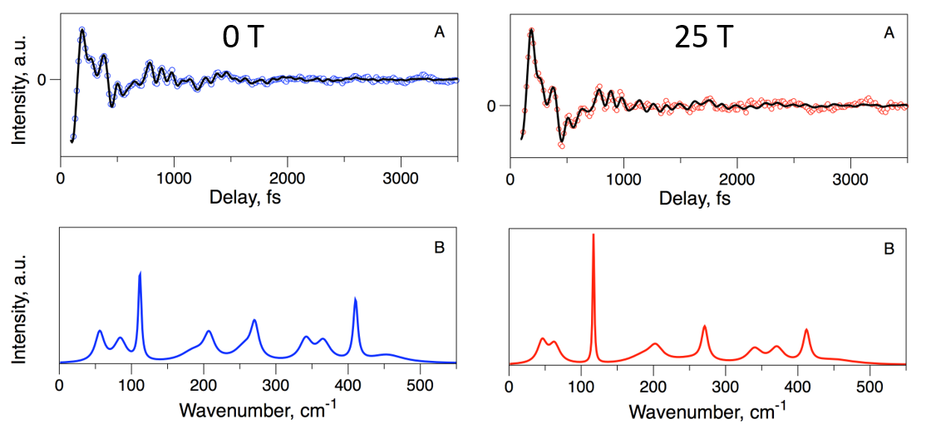Experimental
The ultrafast laser pulses utilized in this experiment (~35 fs, 432 nm, 1 kHz repetition rate) were generated by a Coherent Opera Solo optical parametric amplifier, which is pumped by a Coherent Legend Elite (5 mJ) regenerative amplifier. The pulse train was split into pump and probe pulses using a beam-splitter and the pump pulses were variably delayed utilizing an optical delay line before both pulses were focused onto the sample with a small angle between the beams. A photodiode measured the pump-induced change in intensity of the probe using a lock-in amplifier as the pump delay-time was scanned. Intensity oscillations in the time-resolved transients were fit using a linear predictive, singular value decomposition (LPSVD) routine. The Fe(II) Cyt c was pumped and probed with 432 nm light to excite the Soret ($π$→$π$*) transition of the heme cofactor.
Figure 1. The oscillatory components of the VCS transients of Fe(II) Cyt c (top), fit using an LPSVD algorithm (black lines) at 0 T (blue) and 25 T (red). The Fourier transforms of the LPSVD fit (black lines) are shown in the bottom panels.

Results and Discussion
The oscillatory frequencies measured at 0 T (Figure 1, blue curves) compare well to previous VCS and resonance Raman experiments on this same system. The transient data reveal different dynamics at 25 T as compared to 0 T. In particular, the lowest two frequencies at 84 and 56 cm^{–1} shift significantly in field to 63 and 46 cm^{–1} (∆ = –21 and –10 cm^{–1}) respectively, while all other frequencies shift less than ±5 cm^{–1}. In addition, the overall signal decay timescale, which is thought to monitor vibrational cooling, increases in the 25 T field from 4.3 ps to 5.3 ps. This increase in the cooling timescale is consistent with a more displaced excited-state structure at 25 T. The softening of the 56 cm^{–1} mode is consistent with a more ruffled heme, which leads to the plausible conclusion that the field induces a structural change in the in the excited state heme cofactor, which tends to increase the ruffling distortion. The likely mechanism for this structural change is a disruption of the iron d$π$ and heme-$π$ orbital overlap, perhaps through Zeeman splitting of the d$π$ orbitals in field.

Acknowledgements
This work was supported by (DMR-1229217). A portion of this work was performed at the National High Magnetic Field Laboratory, which is supported by National Science Foundation Cooperative Agreement No. DMR-1157490, the State of Florida, and the U.S. Department of Energy.

References
[1] Kubo, M. et al., J. Am. Chem. Soc. 130 (30), 9800-9811 (2008).
[2] Sun, Y. et al., Proc. Natl. Acad. Sci. 111 (18), 6570-6575 (2014).
[3]. Karunakaran, V. et al., J. Phys. Chem. B. 118, 6062-6070 (2014).

