Structure of a Full-Length E. Coli Integral Membrane Sulfurtransferase and its Structural Transition upon SCN⁻ Binding Defined by an EPR-Based Hybrid Method

Ling, S.; Tian, C. (U. of Science and Technology of China, Anhui, China); Hayati, Z. and Song, L. (NHMFL)

Introduction
Dimeric YgaP is an E. coli integral membrane sulfurtransferase. Each monomer contains a cytosolic catalytic rhodanese domain and a transmembrane domain. The cytosolic rhodanese domain was reported to catalyze the transfer of a sulfur atom (S) from thiosulfate (−S=SO₃²⁻) to the toxic cyanide (CN) group, resulting in non-toxic thiocyanate (SCN) and sulfite (−SO₃²⁻). Recently, the structures of YgaP rhodanese domain and TM domain have been determined separately by solution NMR [1]. However, the tertiary fold of full-length YgaP is still unknown. EPR is becoming a powerful and effective method used to study structure, dynamics and even functions of membrane proteins. Here, an EPR-based hybrid approach using experimental and computational methods was applied to determine the three-dimensional structure of full-length dimeric YgaP and its structural transition upon SCN⁻ binding in DPC micelles.
Experimental
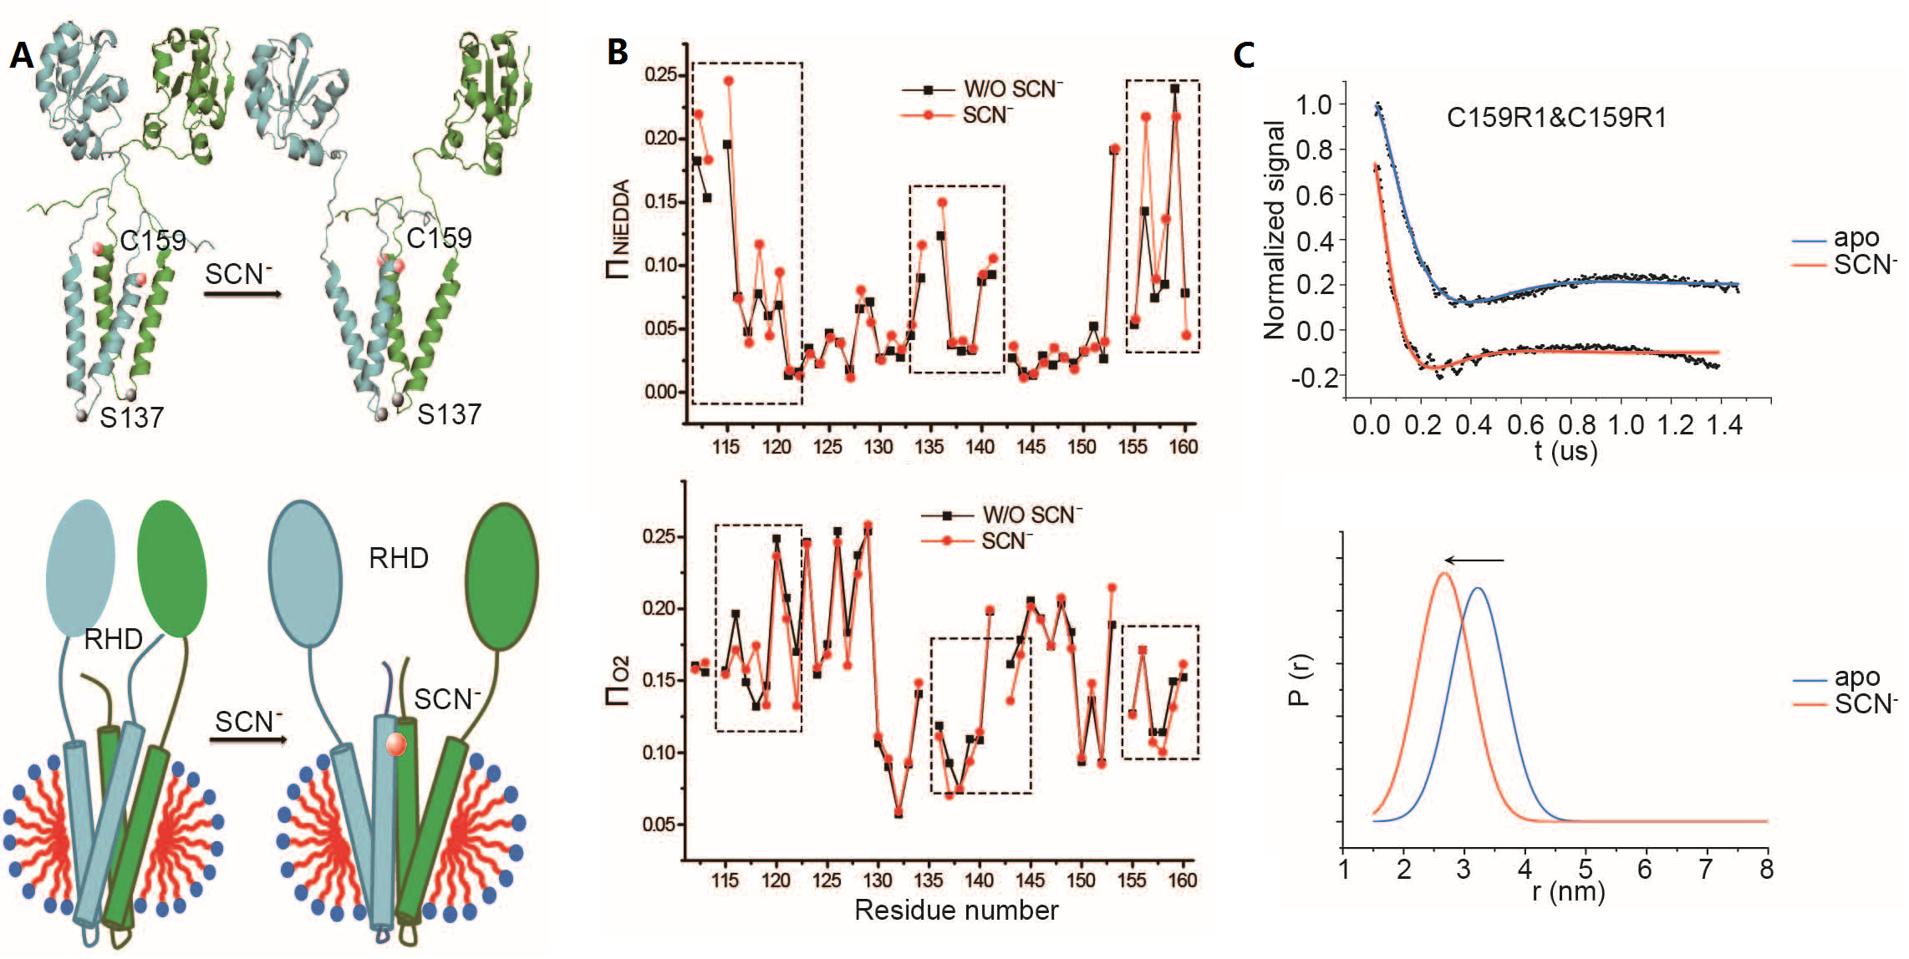
Fig. 1. (A) Conformational changes of YgaP upon SCN⁻ binding. (B) Deviation analysis of accessibility parameters Π_{NiEDDA} and Π_{O2} between the YgaP samples in the absence or presence of NaSCN. (C) DEER spectra (upper panel) and distance distributions (lower panel) of YgaP C159R1 in the absence and presence of NaSCN.
Single cysteine or double cysteines substituted YgaP variants were constructed, over-expressed and purified in DPC detergent micelles. The prepared YgaP proteins were then spin labeled with Maleimide Spin Label (MTSL) for EPR studies. 40% Glycerol was supplemented as cryo-protectant prior to snap freezing in liquid nitrogen for Double Electron-Electron Resonance (DEER) measurements, while CW-EPR distance measurements were performed at 150 K. DEER data were collected on a Bruker E680 spectrometer at the NHMFL.

Results and Discussion
To characterize the structure of YgaP in detergent micelles, systematic site-specific EPR mobility and accessibility analyses were conducted to derive the secondary structures of the YgaP-TMD. The dimeric YgaP-TMDs structure determined by EPR distance restraints illustrated that the two transmembrane helices formed the interface of the homodimer. Additionally, long-distance restraints measured by DEER demonstrated that the YgaP rhodanese domain was connected to the TMDs by a long flexible linker, forming a dimeric full-length YgaP structure (Fig. 1A, upper panel). Moreover, the aqueous solvent exposure increase caused by SCN⁻ binding was also observed in the first half of YgaP-TMH1, which is likely because the TMH1 regions are moving away from one another (Fig. 1A, lower panel). DEER experiments were then performed to analyze conformational changes of YgaP upon SCN⁻ binding. Significant changes of distance distribution were observed for YgaP C159R1, with the average distance between two spins decreased from 3.22 nm to 2.67 nm (Fig. 1C). Taken together, the accessibility data and the EPR-derived distance information demonstrated an SCN⁻ induced conformational change in the second half of YgaP-TMH2. Because of the decreased distance between the two C159 residues and the increased solvent accessibility in this area, the second half of YgaP-TMH2 from each monomer may pack together upon SCN⁻ binding.

Acknowledgements
This work was supported by National Natural Science Foundation of China (to C.T.), and an UCGP grant 5080 (to L.S.). A portion of this work was performed at the National High Magnetic Field Laboratory, which is supported by National Science Foundation Cooperative Agreement No. DMR-1157490 and the State of Florida.

References
[1] Wang, W.; Zhou, P.; He, Y.; Yu, L.; Xiong, Y.; Tian, C. and Wu, F., Biochem. Biophys. Res. Commun., 452, 817-821 (2014).

