Role and Site of Cholesterol Binding in Full-length Influenza A M2 (M2FL) Protein by Solid-State NMR Experiments

Ekanayake, E.V. (Florida State U., Chemistry & Biochemistry) and Cross, T.A. (Florida State U., Chemistry & Biochemistry, NHMFL)

Introduction
Influenza A M2 protein is an essential protein for this virus and a drug target for the treatment of this infectious disease. Even though cholesterol is known to bind to M2 protein, to date, neither the location nor the role for cholesterol binding to M2 is known. Here, we use ¹³C isotopically labelled cholesterol/M2FL samples to obtain information for cholesterol binding location. Antiviral drug amantadine, a ligand known to distort C-terminus of M2 protein, was used to seek the functional role of cholesterol binding.
Experimental
Isotopically labeled M2FL is expressed in E. coli followed by IMAC purification. Then ¹³C-Phe labeled M2FL was reconstituted into lipid bilayers containing ~20% ¹³C labelled cholesterol (mol/mol). (Two samples; ¹³C-2,3,4- Cholesterol/M2FL and ¹³C-25,26,27- Cholesterol/M2FL). Unambiguous, Phe-Leu distances of M2FL provide TM and amphipathic helix distance restraints and these restraints were obtained in the presence of amantadine with and without cholesterol in the bilayer. 600 MHz wide bore NMR Magnet #2 in NMR facility and an in house built 3.2 mm ¹H-¹³C-¹⁵N CPMAS probe were used to carry out DARR (Dipolar Assisted Rotational Resonance) solid-state NMR experiments on these M2FL samples. All samples were prepared at pH 7.5.
Results and Discussion
Distance restraints for cholesterol head and tail groups to Phe-ring carbons of M2 protein provide M2FL channel to cholesterol distance information as well as orientation of cholesterol in the bilayer (Fig. 1A). Cholesterol-M2FL distance information taken together with the known palmitoylation/acylation site at Cys50 provide a clear picture of the cholesterol binding pocket in the M2FL protein (Fig. 1B). In the absence of cholesterol in the bilayer, amantadine distorts the amphipathic helix but when cholesterol is present the drug does not distort the amphipathic helix indicating a role for cholesterol, which is to stabilize the amphipathic helix.
Conclusions
Here, we established the distance measurements of M2FL and cholesterol and also the cholesterol binding site. Most importantly, we discovered a role for cholesterol binding. The Amphipathic helix is known to induce membrane curvature during viral budding and stabilization of it by cholesterol is essential for viral budding.
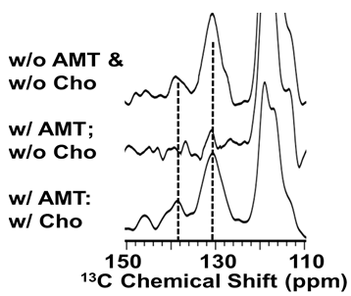
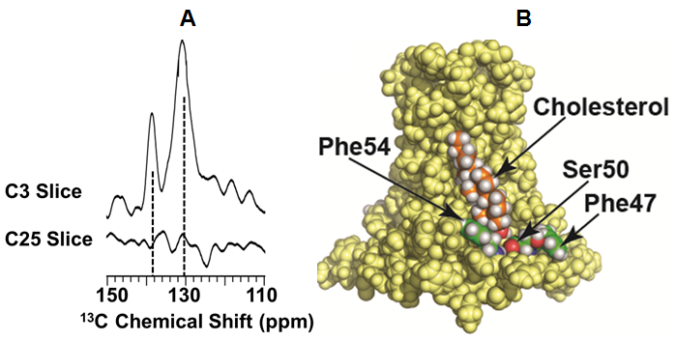

Figure 2: Influence of cholesterol on AMT bound M2FL at pH 7.5. Slices from 2D DARR spectra of ¹³C Phe:¹³C Leu mixed sample of M2FL in lipid bilayers Leu-Cγ at 26.6 ppm. Dashed lines are at Phe Cγ (~138 ppm) and Phe Cδε (130 ppm).

Figure 1: Cholesterol binding to the amphipathic helix of M2FL. A) DARR spectral slices through C3 and C25 of cholesterol in ¹³C Phe labeled M2 B) Likely cholesterol binding site modeled on the M2 CD structure (2L0J).

Acknowledgements
A portion of this work was performed at the National High Magnetic Field Laboratory, which is supported by National Science Foundation Cooperative Agreement No. DMR-1157490 and the State of Florida. Additional financial support for this project provided by National Institute of Health, AI 023007.
References
[1] Ekanayake, E.V., et al., Biophysical Journal, In Press.

