Tetrameric Structural Heterogeneity Revealed by Dynamic Short Hydrogen Bonds in the Histidine Tetrad of the M2 Proton Channel

Miao, Y. (Florida State U., Chemistry & Biochemistry, NHMFL); Fu, R. (NHMFL); Zhou, H.-X. (Florida State U., Institute of Molecular Biophysics) and Cross, T.A. (Florida State U., Chemistry & Biochemistry, NHMFL)

Introduction
The tetrameric M2 protein from Influenza A conducts protons into the virus upon acid activation of its His37 tetrad and is a proven drug target. In this project, we study the side chain conformational transitions during pH titrations and the pKas of selectively H37-labeled tetrad in M2 full-length (M2FL) in hydrated lipid environment. Our solid-state NMR results indicate the complexity of the H37 tetrad in M2FL. In particular, two-dimensional ¹H-¹⁵N correlation spectra show distinct groups of conformations that are in exchange on the millisecond-to-second timescales, implying the tetrameric structural heterogeneity of the H37 tetrad while taking on charges.
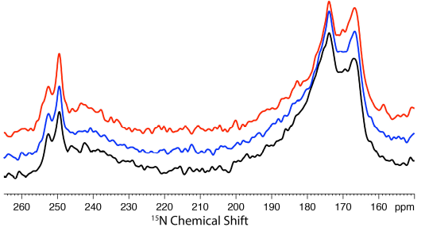
Fig. 1. ¹⁵N CPMAS spectra of ¹⁵N H37 labeled M2FL protein at pH 6.2 obtained using the spin echo sequence with echo times of 167 us (black), 2.5 ms (blue), and 5.0 ms (red).

Experimental
High-resolution solid-state MAS NMR spectra were acquired on a Bruker Avance 600 MHz NMR spectrometer using a NHMFL low-E double-resonance ¹H-¹⁵N biosolids MAS probe. The reversely labeled ¹³C,¹⁵N H37-labeled M2 mutant (H57,93Y) was reconstituted in liposomes. ¹H-¹⁵N heteronuclear correlation (HETCOR) spectra were recorded on samples at various pHs.

Results and Discussion
Fig. 1 shows the spin echo spectra for the ¹⁵N H37 labeled M2FL at pH 6.2 using different spin echo times. Apparently the broad band between 245 and 180 ppm decays at the same rate as narrow peaks such as at 252.5 and 249.5 ppm, indicating that the broad components between 245 and 180 ppm are heterogeneously broadened resonances. Fig. 2 shows the 2D ¹H-¹⁵N HETCOR spectra of the H37 labeled M2FL at pH 6.2 at different temperatures. The ¹⁵N chemical shifts that range up to 193 ppm are coupled to multiple ¹H frequencies that range up to 18.5 ppm. Such a linear correlation between the high ¹H and ¹⁵N frequencies reflect multiple short hydrogen bonded states between imidazole and imidazolium. The ¹H resonance intensities at higher temperature (e.g. +23°C) are greatly reduced due to a loss of sensitivity, but high ¹⁵N frequencies are present indicating that the imidazole-imidazolium hydrogen bonded states are present. The ~ 5 ppm ¹H resonances reflect water protons and the resonances ~ 13 ppm are the NH protons hydrogen bonded to water.
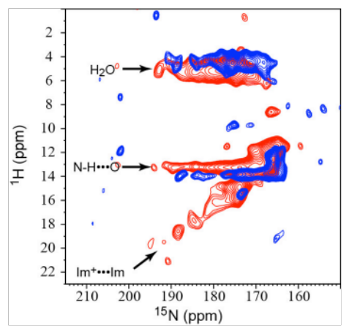
Fig. 2. 2D ¹H-¹⁵N HETCOR spectra of the H37 labeled M2FL at pH 6.2 at -10°C (red) and +23°C (blue).

Conclusions
Our M2FL NMR spectra reveal significant conformational heterogeneity, especially under acid pH conditions whereby the channel becomes active. Such heterogeneous conformational states have considerable lifetimes, suggesting that the conformational heterogeneity originates from side-chain rotameric states in the oligomeric helix packing. Proton conductance occurs following many futile proton transfers between the H37 tetrad and the surrounding water molecules and rare productive shuttling of protons to the viral interior [1].

Acknowledgements
A portion of this work was performed at the National High Magnetic Field Laboratory, which is supported by National Science Foundation Cooperative Agreement No. DMR-1157490 and the State of Florida. Additional funding support by NIH AI074805 and NIH AI023007.

Reference
[1] Miao, Y., et al., Structure, 23, 2300-2308 (2015).

