Selective Membrane Disruption Mechanism of an Antibacterial γ-AApeptide Defined by Multi-Frequency EPR

Kaur, P.; Song, L. (NHMFL); Li, Y. and Cai, J. (U. of South Florida, Chemistry)

Introduction
γ-AApeptides are a new class of antibacterial peptidomimetics that are not prone to antibiotic resistance and are highly resistant to protease degradation. Understanding how γ-AApeptides interact with bacterial membranes and alter lipid assembly is essential to understanding their antimicrobial activities and guiding future design of more potent and specific antimicrobial agents. Using electron paramagnetic resonance (EPR) techniques at 9 and 94 GHz, we characterized the membrane interaction and destabilizing mechanism of a lipo-cyclic-γ-AApeptide (AA1), which has broad-spectrum antibacterial activities. Our findings suggest that AA1 interacts and disrupts bacterial membranes through a “carpet-like” mechanism.
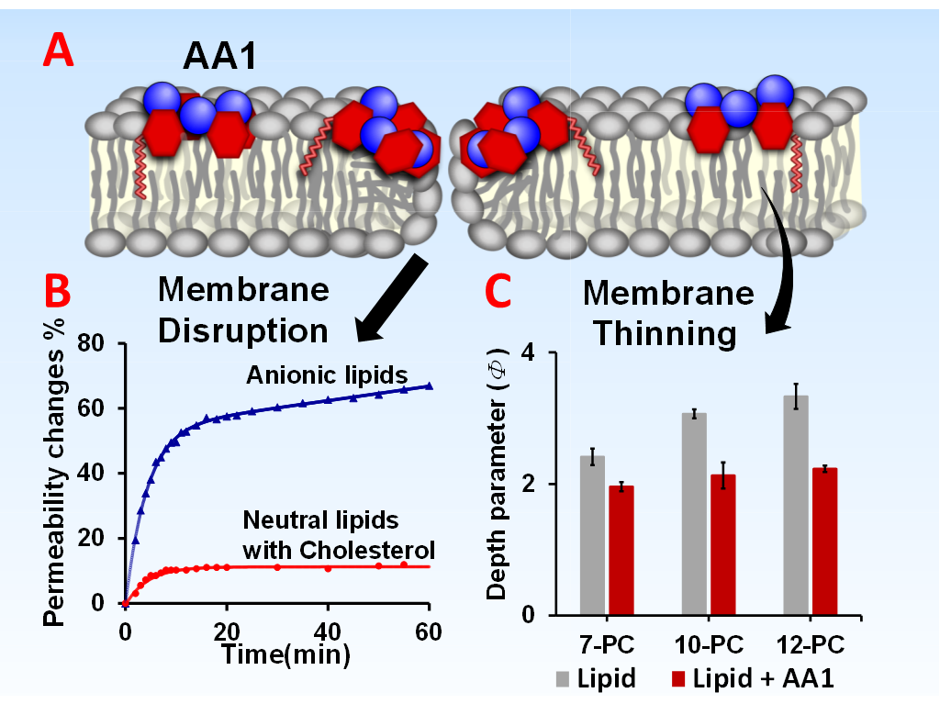
Fig. 1. (A) AA1 binds to the bacterial membrane through electrostatic and hydrophobic interactions and disrupts the membrane; (B) Membrane disruption releases the inner contents of bacterial-mimic anionic liposomes; (C) AA1 binding induced membrane thinning is suggested by the EPR depth parameter changes of 7-PC, 10-PC. and 12-PC in POPC/POPG liposomes.

Experimental
Liposomes formed from a mixture of neutral lipids (POPC) with anionic lipids (POPG) were used to mimic bacterial membranes. Eukaryotic-membrane-mimic liposomes contain POPC with cholesterol. Trace amounts of spin labeled lipids at different bilayer positions (N-TP, T-PC, 5-PC, 7-PC, 10-PC, 12-PC and 5-SASL) were used to probe membrane property changes. The measurements were carried out on a Bruker E680 X-/W-band continuous wave (CW) and pulsed EPR spectrometer and W-band 94 GHz CW and pulsed EPR spectrometer (HiPER) at the NHMFL. The sample holder for HiPER was fabricated in house by the NHMFL machine shop.

Results and Discussion
The analyses revealed that AA1 binding increases the membrane permeability of POPC/POPG liposomes (Fig. 1). AA1 binding also inhibits membrane fluidity and reduces solvent accessibility around the lipid head-group region. Moreover, AA1 interacts strongly with POPC/POPG liposomes, inducing significant lipid lateral-ordering and membrane thinning. In contrast, minimal membrane property changes were observed upon AA1 binding for liposomes mimicking mammalian cell membranes with neutral lipids and cholesterol. The results suggest that the binding of AA1 is initiated by the electrostatic interactions between the cationic side chains of the peptides and the anionic groups in bacterial membranes. The strong AA1-membrane interactions decrease the membrane fluidity and increase the ordering of the lipid molecules, resulting in reduced accessibility of lipid head-groups to both polar and nonpolar molecules in the solvent. In addition, the insertion of the bulky hydrophobic groups of the peptide into the membrane may lead to increased lateral pressure, thereby inducing lateral expansion and membrane thinning (Fig. 1). Furthermore, peptide penetration also creates transient membrane disruption or local disorder, subsequently causing the leakage of cellular content and cell death.

Conclusions
γ-AApeptide selectively permeates and structurally modifies negatively charged bacterial-mimic membranes. In contrast, cholesterol-containing neutral membranes mimicking mammalian cells were minimally affected by the molecule. Based on combined analyses of membrane permeability, dynamics, membrane thinning, and accessibility, we proposed a “carpet-like” mechanism for the antimicrobial activities of AA1. The results provide implications for the development of effective AMPs with robust antibacterial activities against antibiotic-resistant microbes.

Acknowledgements
L.S. acknowledges the NHMFL User Collaboration Grants Program Award No. 5080. J.C. acknowledges the support from NSF 1351265 and NIH GM112652-01A1. This work was performed at the NHMFL, which is supported by National Science Foundation Cooperative Agreement No. DMR-1157490 and the State of Florida.

