Intra-arterial Injected Adipose Derived Stem Cells for Stroke Therapy Cause Lacunar Strokes in Rats

Rosenberg, J.T. (NHMFL); Yuan, X.; Ma, T. (Florida State U., Chemical & Biomedical Engineering) and Grant, S.C. (Florida State U., Chemical & Biomedical Engineering, NHMFL)

Introduction
Human adipose derived stem cells (ASC) have been identified as a potential and alternative source of adult stem cells with therapeutic properties to treat stroke^{1,2}. Compared to the more commonly used human mesenchymal stem cells (hMSC), ASC are more abundant, reproducible and accessible. In this study, we investigated the therapeutic properties of ASC and resultant lesion size in a stroke animal model evaluated at 21.1 T to track the migration and retention of the cells using a micron-sized particle of iron oxide (MPIO).

Experimental
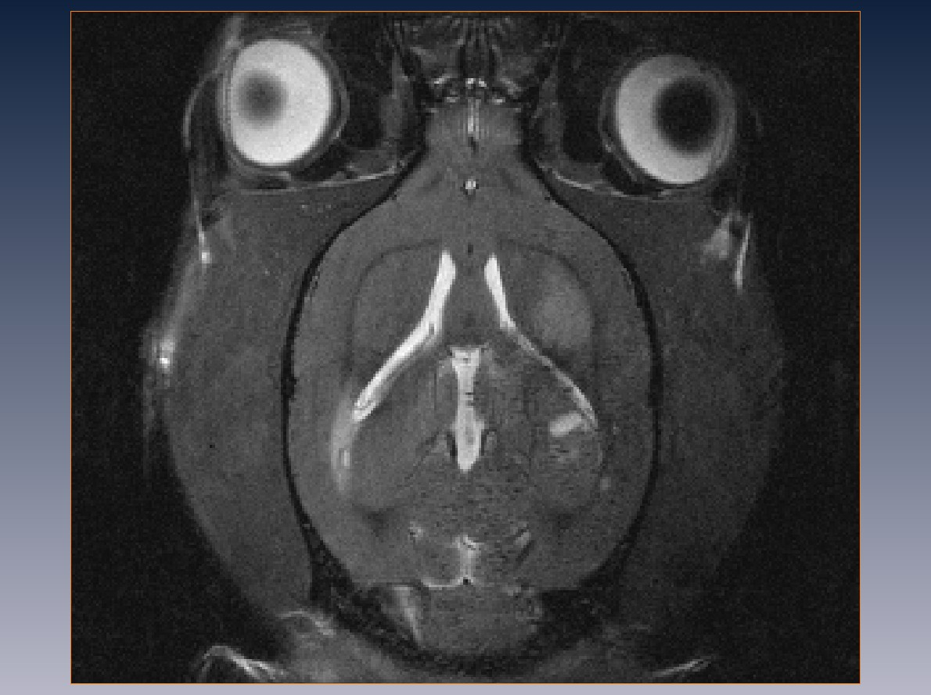
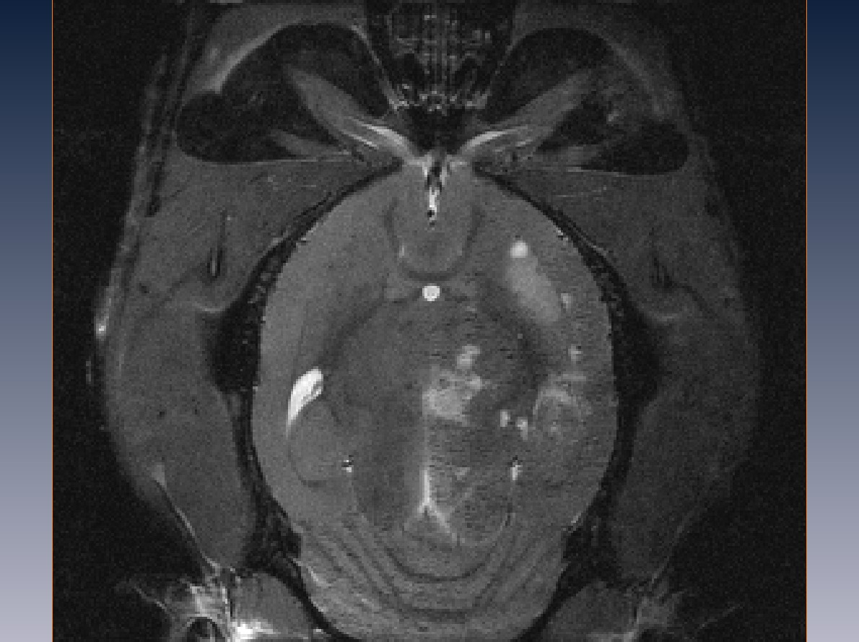
ASC were cultured with standard cell culture methods. Cells were transfected with 0.86-μm MPIO (Bangs Laboratory) for 12 h. Immediately following a 1-h transient middle cerebral artery occlusion (MCAO)³, 1×10⁶ cells were injected intra-arterially through the exposed common carotid artery (CCA) of Sprague-Dawley rats. All injections were made with a 31-G micro-needle to promote single cell delivery and prevent initial aggregation. In vivo MRI was performed using the 21.1-T (900-MHz) ultra-wide bore magnet at NHMFL. Images were acquired 24 h, 72 h and 7 days after surgery utilizing high resolution, T₂-weighted (T₂W) spin echo, gradient recalled echo (GRE) and 3D ²³Na GRE sequences. After scanning, animals were sacrificed by transcardial perfusion using 4% paraformaldehyde. Correlative histology was performed on 10-μm brain sections.
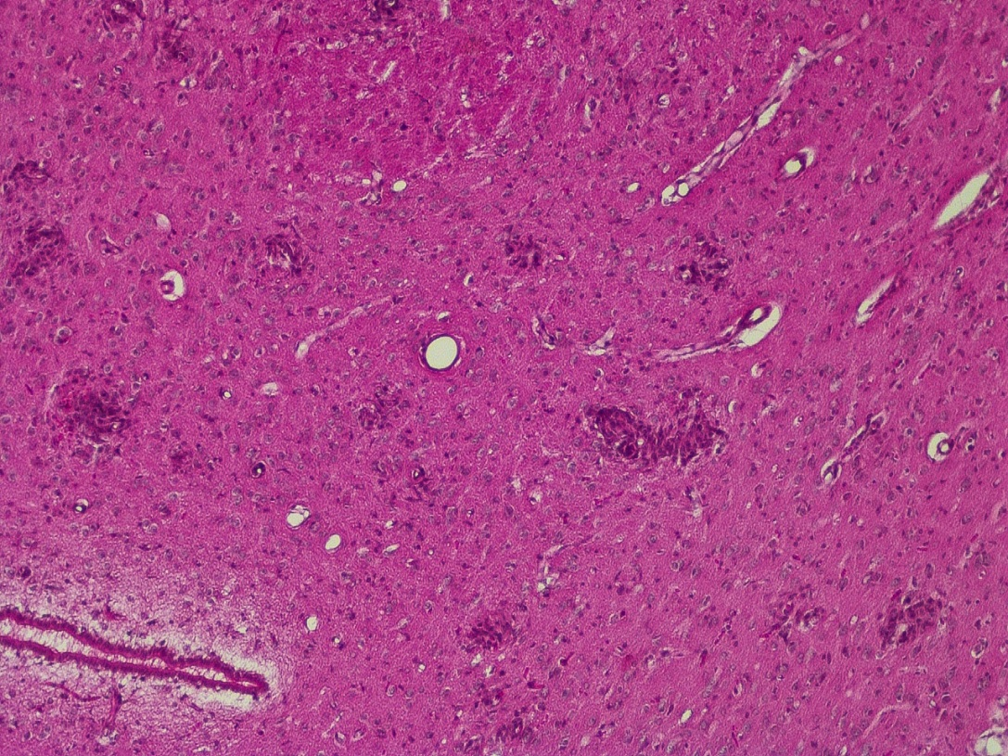
Results and Discussion
Fig. 1a shows a representative T₂-weighted image with the expected stroke lesion (yellow circle) from the MCAO. Ventral to this lesion (Fig. 1b), smaller hyperintense areas can be seen (yellow arrows). GRE images (not shown) reveal a high delivery of the iron labeled cells to the brain with apparent longer retention compared to hMSC^{4,5}. Histological H&E staining show areas of increased cell density in the same region. In
Fig. 2 H&E stain showing high cell density regions.
Fig. 1 T₂-weighted images showing the stroke (yellow circle) & lacunar strokes (yellow arrows).
a b
addition, in vitro experiments show increased aggregation of ASC compared to hMSC. The lacunar strokes seen in Fig. 1b and areas of higher cell density (Fig. 2) are likely caused by the occlusion of penetrating arteries by the injected ASC, which are prone to aggregate both in vitro and vivo.

Conclusions
This project aimed at investigating the potential therapeutic properties of ASC has revealed increased lacunar strokes in the parenchyma once injected through the carotid artery. The occurrence of lacunar strokes are a detrimental side effect for cell therapies, which negate most of the therapeutics properties these cells might have. More work is needed to confirm presence of ASC cells with histology and the cause of the increased aggregation before disqualifying these cells for stroke treatment.

Acknowledgements
This work was supported by the UCGP at the National High Magnetic Field Laboratory, which is funded by National Science Foundation Cooperative Agreement No. DMR-1157490 and the State of Florida. Additional funding was provided by the American Heart Association Grant-in-Aid (10GRNT3860040). All work has been conducted in accordance with FSU Animal Care and User Committee.

References
1. Zuk, P.A., et al., Tissue Eng, 7, (2001).
2. Ikegame, Y., et al., 13 (2011).
3. Longa, E.Z., et al., Stroke, 20 (1989).
4. Rosenberg, J.T., et al., ISMRM (2014).
5. Rosenberg, J.T., et al., WMIS (2013).

