Small World Network Analysis of DTI-based Connectivity in Isolated Neural Ganglia

Ould Ismail, A. (Florida State U., Chemical & Biomedical Engineering); Amouzandeh, G. (Florida State U., Physics); Cain, U. (Florida State U., Chemical & Biomedical Engineering) and Grant, S.C. (Florida State U., Chemical & Biomedical Engineering, NHMFL)

Introduction
Diffusion Tensor Imaging (DTI) tractography can be used to characterize and quantify the structural connectivity within neural tissue (Figure 1). Here, DTI-based connectivity within isolated abdominal ganglia (ABG) of aplysia Californica is analyzed using network theory. For ABG, findings demonstrate preferential specific small-world properties when compared to simulated equivalent lattice and random networks.
Methods
DTI was acquired at 50x50x150 μm using four unweighted images and 18 diffusion weighted directions at 11.75 T. The graph properties [1] of experimental data (EXP) were extracted to obtain the clustering coefficients, local and global efficiency (Figure 2) of the binary adjacency matrices corresponding to unweighted, undirectional graphs. These properties were averaged for the structural networks of N=10 fixed ganglia.
Results and Discussion
In addition to a short characteristic path length compared to the lattice network (Figure 1c), EXP networks showed high clustering in closed neighborhoods and high total clustering when compared to random graphs (512 nodes) equivalent in degree (Figure 1d). These properties meet the definition of small-world networks [2]. Finally, the novel small-world metric (ω) [1] verifies that ABG structural connectivity exhibits small-world properties (ω=0.12) between the continuum of lattice (ideal ω=-1) and random (ω=+1) networks (Table 1).
Conclusions
Network analysis of DTI tractography potentially can provide biomarkers for the neural connectome.

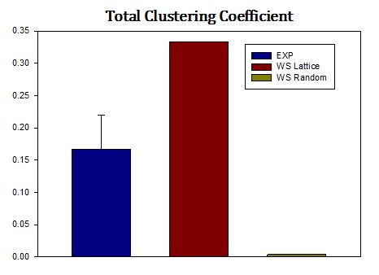
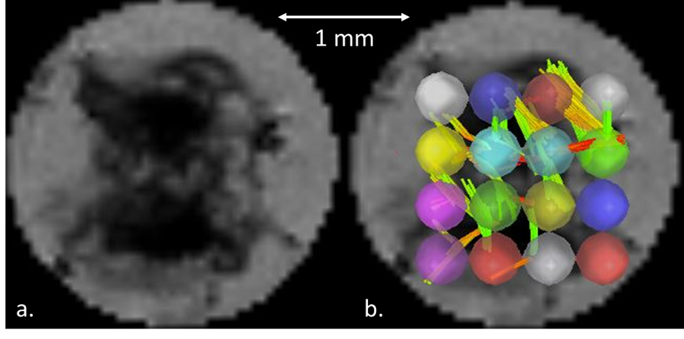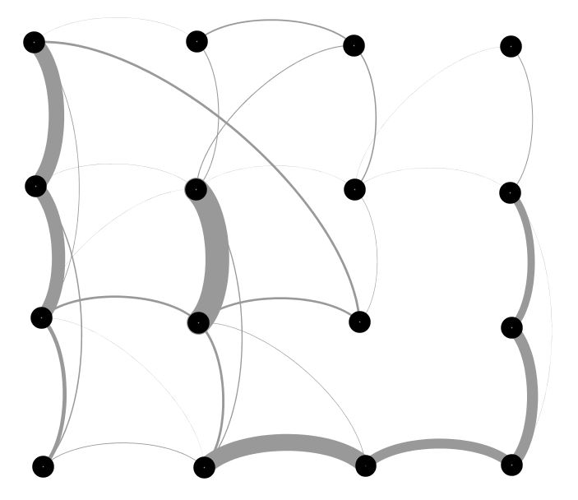
c. d.
Fig. 1 (a Mean ADC map of an example aplysia ganglion; b & c) Inner-connections in the network; d) Clustering Coefficient

Local Efficiency Global Efficiency
Table 1: Novel Small-World Metric

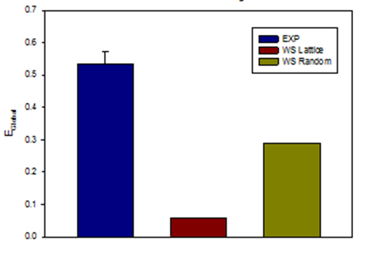
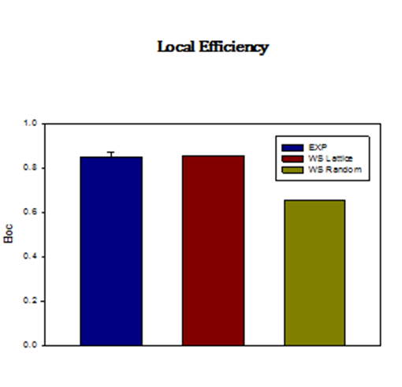
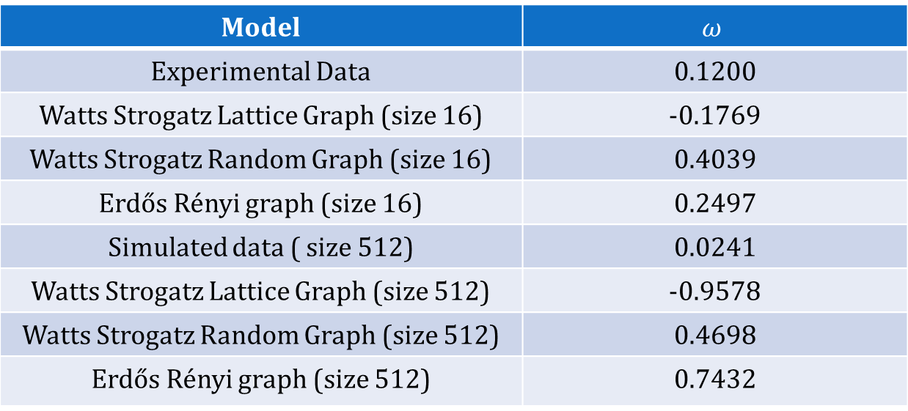
a. b.
Fig. 2 a) The efficiency of the experimental graphs was high locally (as in the Watts-Strogatz (WS) lattice) and (b) globally as in a WS random network), which indicates an impressive balance between the transfer of information on both local and universal scales.

Acknowledgements
This work was supported by the UCGP program at the National High Magnetic Field Laboratory, which is funded by the National Science Foundation (DMR-1157490) and the State of Florida.
References
[1] Telesford, Q.K., et al., Brain Connectivity, 1 (5), 367-375 (2011).
[2] Watts, D.J., et al., Nature, 393, 440-442 (1998).

