Structural Study of the Full-Length M2 Proton Channel in Membrane Bilayers

Tang, T. (NHMFL); Qin, H. (Florida State U., Chemistry & Biochemistry); Fu, R. (NHMFL) and Cross, T.A. (Florida State U., Chemistry & Biochemistry, NHMFL)

Introduction
M2 protein, a homo-tetrameric proton channel in bilayers, is essential in Influenza A virus pathogenicity, including virion assembly, replication and budding from its host cells ^{[1]}. The channel forms a pore for proton passage built by tetrameric transmembane (TM) helices and the following amphipathic domain (AH) has been anticipated to influence proton conductance. Here, PISEMA (Polarization Inversion of Spin Exchange at Magic Angle) is used to investigate the orientation of the TM helix, such as the tilt angles of the helix and peptide planes relative to the bilayer normal ^{[2]}. Accordingly, the focus of this study will be on the structure of the full-length M2, a native form with physiological relevance in different lipid compositions during the virus life cycle.
Experimental
Full-length M2 proteins are overexpressed, purified and reconstituted into planar bilayers. ³¹P experiments ae performed on a Bruker 400 MHz magnet to verify the degree of bilayer alignment. The Low-E static ¹HN probes are used to study the tilt angle of M2 transmembrane helix relative to bilayers. ¹⁵N 1D CP (cross polarization) and ¹⁵N, ¹⁵N-¹H 2D SAMPI4 spectra are performed on a 720 MHz magnet (52 mm bore) with a VARIAN Inova console.
Results and Discussion
Several parameters have been found to influence the alignment of membrane proteins in bilayers ^{[3]}. Such as the lipid composition, and lipid-to-protein ratio can affect the homogeneity of proteins in this 2D bilayer matrix. For membrane proteins with a larger soluble portion, such as 78% in the M2 proton channel, more optimization for the stabilization of extra- or intracellular domains is needed. 1D CP ³¹P and ¹⁵N spectra of U-¹⁵N M2 in POPC: POPG bilayers (Figure A-C) indicate the effect of higher hydration level leads to increased alignment (stronger aligned peaks ~160-225 ppm) but with lower alignment of lipids. To further improve the alignment of lipids or protein and the physiological-relevant environments, the ¹⁵N Ile M2 protein is reconstituted into the 10% cholesterol-doped bilayers and larger aligned portion has been observed (Figure D).
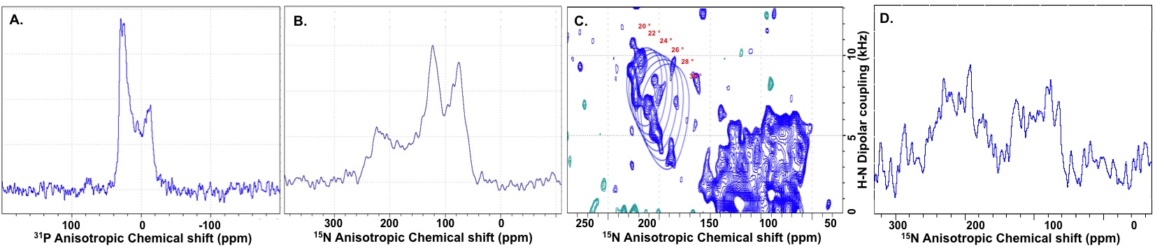
Figure A-D: Alignment of lipid bilayer and TM helix of M2 protein. Fig. A represents the ³¹P 1D CP spectrum. Lipids are partially aligned. Figs. B and C show 1D and 2D spectrum of U ¹⁵N M2 in POPC: POPG bilayers. In Fig. C, the ratio of aligned and non-TM portion (90-150 ppm) approximately reflects 5 Ile in TM and 3 Ile outside TM in 10% cholesterol.

Conclusions
Our results show improvement in homogeneity and alignment of transmembrane helices of M2 proton channel in bilayers. However, a certain level of powder pattern and isotropic portion also hinder structure characterization in bilayers. With the better cholesterol-doped lipid composition, more effort will be put on the improvement of lipid alignment without losing protein alignment.
Acknowledgements
A portion of this work was performed at the National High Magnetic Field Laboratory, which is supported by National Science Foundation Cooperative Agreement No. DMR-1157490 and the State of Florida. In addition, this work was supported by NIH grant R01AI023007.
References
[1] Rossman, J.S., et al., Virology, 411(2), 229-236 (2011).
[2] Sharma, M., et al., Science, 330(6003), 509-512 (2010).
[3] Das, N., et al., Nat. Protoc., 8(11), 2256-2270 (2013).

