Membrane Interaction of Virus-Mimicking Polymer Molecular Brushes
Studied by Multi-Frequency EPR
Hayati, Z.; Song L. (FSU Biology, NHMFL) and Liang, H. (Texas Tech. U., Cell Physiology & Molecular Biophysics)

Introduction
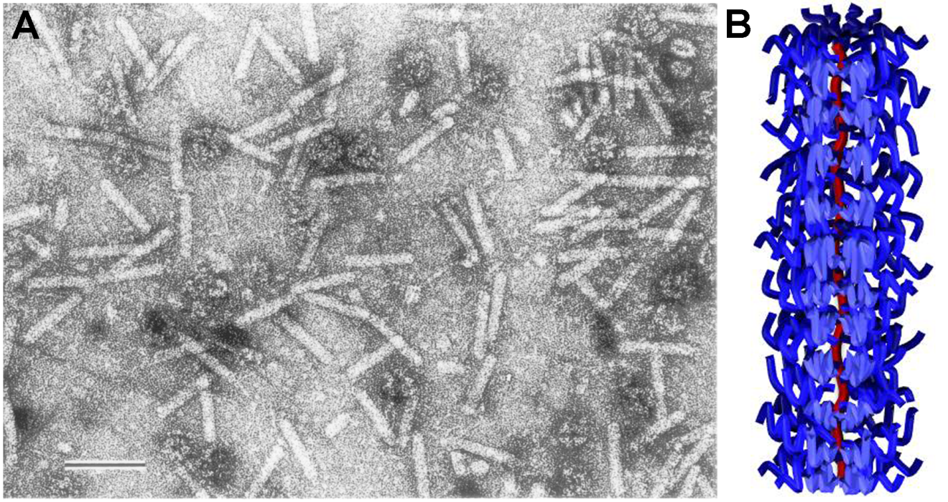
Evolution of antibiotic-resisting pathogens has become one of the greatest challenges in the battle against bacterial infection. We propose to address this challenge from a biomimetic approach. Bacteriophages use proteinaceous devices that are first and foremost recognized by their unique nanoscale architectures (Fig. 1A) to selectively remodel host membranes and gain entrance or egress. Polymer Molecular Brushes (PMBs) are well-defined block copolymers consisting of a main polymer backbone covalently linked with brush-like polymer side-chains (Fig. 1B), via controlled “living” polymerization. We hypothesize that the nanoscale architecture is an essential structural determinant in designing new family of antimicrobials with potent activity and selectivity. We have used electron paramagnetic resonance (EPR) spectroscopy to study the interactions between PMBs and membranes. Specifically, we characterized membrane property changes upon PMB binding.
Fig. 1. (A) Rod-shaped L51 phage observed under TEM (scale bar: 50 nm); (B) Rod-like PMBs.
Experimental
Liposomes with two different lipid compositions were prepared with the extrusion method, i.e. DOPE/DOPG (80:20 mol/mol) to mimic E.coli membranes and DOPC/DOPG (80:20) to mimic mammalian cell membranes. To study mobility and permeability changes, 5-Stearic Acid Spin Label (5-SASL), 4-phosphonooxy-TEMPO (4-PT) and Vitamin C (VC) have been used. The spectra were collected on a Bruker E680 at the NHMFL. A 4-PT/VC quenching assay was performed to determine membrane permeability. The quenching of 4-PT signal by VC was used to access membrane leakage after PMB binding.

Results and Discussion
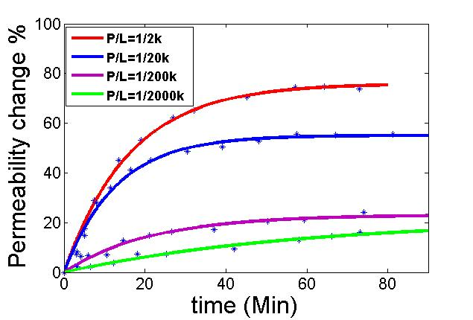
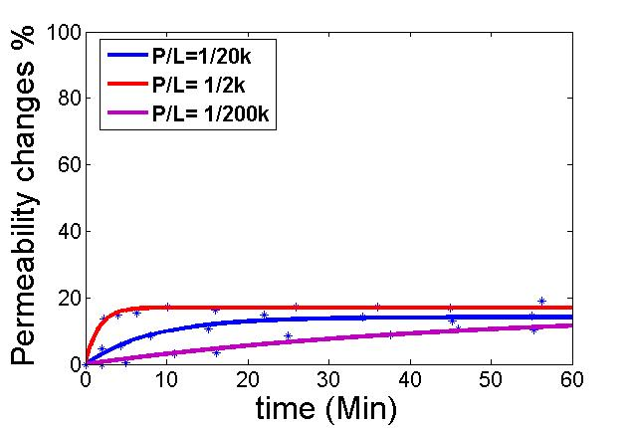
EPR spectra at room temperature were collected to study membrane mobility changes after binding of PMBs. The comparison of bacterial membranes vs. mammalian membranes indicate that PMBs are capable of binding to DOPE/DOPG liposomes much stronger than DOPC/DOPG especially in the case of 1/2000 peptide to lipid ratio (data not shown). To get insight into PMB-induced membrane disruption, lipid permeability measurements were performed for different PMB to lipid (P/L) ratios as shown in Fig. 2. The data suggest that PMBs induce more permeability changes on DOPE/DOPG liposomes than DOPC/DOPG liposomes. Specifically, ~70% permeablility changes were observed for DOPE/DOPG liposomes upon PMB binding at a 1:2000 P/L ratio, whereas only ~20% membrane permeablility changes were shown for DOPC/DOPG liposomes under similar conditions.
A.
B.
Fig. 2. Permeability changes of DOPE/DOPG (A) and DOPC/DOPG (B) liposomes at different PMB to lipid (P/L) ratios.
Conclusions
The EPR mobility and permeability data highlight the selective bacterial membrane disruption capability of PMBs, which suggests its potential application as an antimicrobial reagent.

Acknowledgements
This work was supported by NSF (DMR1410825 to H.L.), and UCGP grant 5080 (to L.S.) and performed at the NHMFL, which is supported by NSF Cooperative Agreement No. DMR-1157490 and the State of Florida.

