Immune Responses to Autologous Schwann Cell Grafts in a Minipig Spinal Cord Injury Hemicontusion Model

Santamaria, A.J.; Benavides, F.D.; Nunez, Y.; Brooks, A.; Solano, J.P. (U. of Miami, The Miami Project to Cure Paralysis); Rosenberg, J.T. (NHMFL); Grant, S.C. (Florida State U., Chemical & Biomedical Engineering, NHMFL) and Guest, J.D. (U. of Miami, Neurological Surgery and The Miami Project to Cure Paralysis)

Fig. 1 Ex-vivo MRI show left-sided distribution of injuries, and area quantification.
Introduction
Autologous Schwann cells (aSC) from sural nerves are expanded, and purified for testing in a Phase 1 human clinical trial after SCI (ClinicalTrials.gov Identifier: NCT01739023). Observations from preclinical pivotal studies in minipigs included a robust lymphocytic response related to transplanted GFP-transfected cells. Formation of lymphoid follicular structures has been reported before in a mouse model after SCI through B cell activation as a systemic autoimmune response, with enhanced lymphopoiesis in bone marrow and spleen, higher circulation of IgG and IgM antibodies^{[1]}, and declines in locomotor function^{[2]}. This has never been reported after cell transplantation for SCI. It is naive to assume that transplantation of artificially manufactured autologous cells into a site different from that of origin will not elicit an immune response. A triple-hemicontusion minipig model was used to assess these responses and their association with SCI and viral cell transfection.
Fig. 2 Visualization of injury and transplant sites through MRI shows faithful histological comparison.
Methods
5 Female Yucatan minipigs underwent 3 left hemi-contusion injuries at T6, T9 and T12. A nerve was extracted to derive aSC, and preparations were divided into a GFP-transfected and non-transfected products. After 52 ± 2.1 days transplants were delivered through myelotomy directly into the injury cavities (100,000 cells/μl) until extrusion was observed. Animals survived for additional 70 days before perfusion. Spinal cords were dissected and submitted to the NHMFL Tallahassee facility for ex-vivo MRI scanning with the 11.75 T magnet. High resolution 3D gradient recalled echo (GRE) sequence was used for assessment. Specimens were then returned for histological analysis to The Miami Project.
Fig. 3 Quantification of lymphocytic populations within groups.
Results
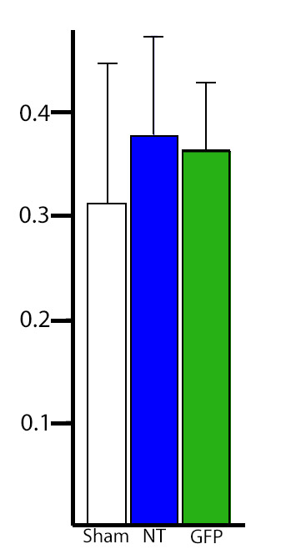
The triple injury hemicontusion paradigm allowed an animal number reduction by preserving uninjured right sided parenchyma in all epicenters assessed Fig. 1, identification of the transplants and lymphocytic reaction through MRI as a faithful histologic comparison Fig. 2, quantification of greater quantities of inflammatory cells within GFP transfected transplants Fig. 3, and visualization of smallest injury cavities in non-transfected transplants though Fractional anisotropy evaluation Fig. 4.
Fig. 4 Fractional anisotropy differences between groups.
Conclusions
Detection of prominent lymphocytic responses in aSC transplanted sites was higher, additionally non-transfected transplants showed better integration with axonal and astrocytic elements. Fractional anisotropy was similar between transplanted groups and higher as compared to sham injuries. High field ex-vivo MRI showed excellent correlation to the injury histological outcomes with unexpected identification of cellular transplants location and distribution.
Acknowledgements
Funded by The Miami Project to cure Paralysis Clinical Trials Initiative and the State of Florida. A portion of this work was performed at the NHMFL, which is supported by the NSF (DMR-1157490). The authors wish to thank funding from the NHMFL UCGP (to SCG).
References
[1] Ankeny, D.P., et al., J Neurochem, 99, 1073-87 (2006). [2] Ankeny, D.P., et al., J Clin Invest, 119, 2990-9 (2009).

