Gold Covered Iron Oxide Nanoparticles as MRI Contrast Agents at 11.75 T

Wi, L. (NHMFL); Carnevale, K.; Strouse, G.F. (Florida State U., Chemistry & Biochemistry); Grant, S.C. (Florida State U., Chemical and Biomedical Engineering, NHMFL) and Rosenberg, J.T. (NHMFL)

Introduction
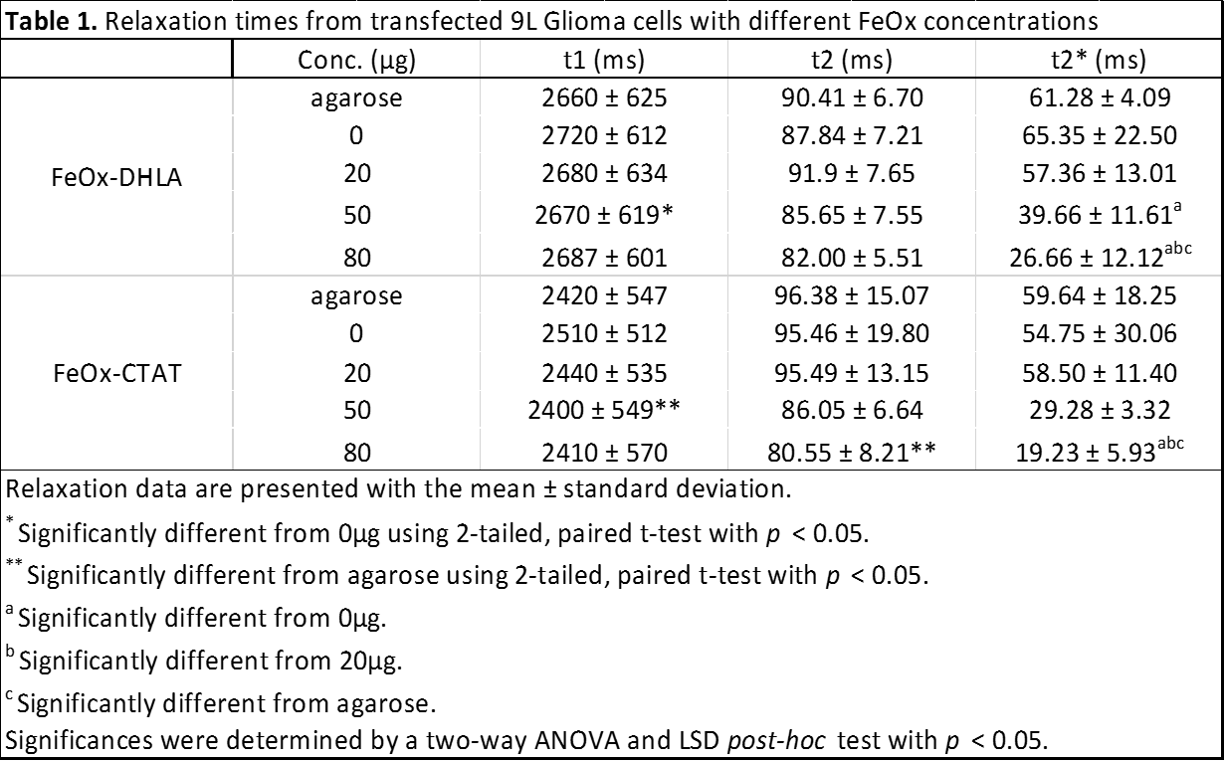
Iron oxide magnetic resonance imaging (MRI) contrast agents are commonly used for MRI based cell tracking. Superparamagnetic iron oxide nanoparticles (SPIO) shorten the T₂ relaxation time by susceptibility induced contrast. MRI cell detectability will depend on the mass of iron taken up by the cells. The uptake can be facilitated by surface coating of the particle [1]. Here, we investigate in a novel gold (Au) [2] coated iron oxide nanoparticles at different weight concentrations, conjugated with iron oxide dihydrolipoic acid (FeOx-DHLA) and iron oxide TAT peptide (FeOx-CTAT) protein for increased uptake and contrast. This nanoparticle formulation will allow for binding of additional cell targeting and therapeutic agents in which cell uptake and MRI contrast are important factors to evaluate.

Experimental
9L Glioma cells were cultured with standard cell culture methods [3]. The two iron oxide nanoparticles were added to the cell culture media at 0, 20, 50, and 80 μg for 24 hours. Cells were washed prior to trypsination to eliminate particles from the cell surface. Labeled cells were placed in a 1% agarose layer with 150,000 cells to make a 4-layer tissue mimicking agarose sample. Each sample was scanned with a 11.75 T magnet at the FSU-FAMU College of Engineering. For T₁ and T₂ measurements, a single-slice 2D spin-echo (SE) sequence was used with varied TRs and TEs, respectively. For T₂* measurements, TEs were varied in repeated acquisitions of a single-slice 2D gradient-recalled echo (GRE). A high resolution (50x50x50μm) 3D GRE was also acquired. Results were statistically compared with t-test, two-way ANOVA, and LSD post-hoc tests.
Table 1: Relaxation times from transfected 9L Glioma cells with different nanoparticle concentrations.

Results and Discussion
Table 1 shows the average T₁, T₂, and T₂* relaxation times for each conjugated iron oxide nanoparticle and respective concentration (N=3). Fig. 1 shows a representative MRI of cells labeled with FeOx-CTAT layered in agarose. A negative correlation was observed between increasing particle concentrations and T₂ and T₂* relaxation times. CTAT conjugated SPIO appears to show increased contrast for the highest concentrations indicating in increased uptakes by the cells, however no significant difference was observed. T₂* contrast is seen with statistical differences between the highest concentration and the control and lowest concentration.
Fig.1 T₂* (left) and 3D-GRE (right) MR images of SPIO-CTAT labeled 9L glioma cells in 1% agarose. Top row are cells with 80 μg, followed by 50, 20 and 0 μg nanoparticle.

Conclusions
This project aimed at investigating MRI contrast of the transfected Au-FeOx nanoparticles show that both contrast agents are taken up by the cells. Increasing the nanoparticle concentration exposed to the cells increased the MRI contrast. The higher concentration of FeOx-CTAT particle show a slight increase in T₂ and T₂* contrast compared to FeOx-DHLA, indicting in increased uptake with the CTAT peptide. Further work is needed to compare the contrast from iron oxides attached with no peptide, with transfecting agent and also to quantify the mass of Fe taken up by the cells and correlate that with the MRI contrast.

Acknowledgements
This work was performed at the NHMFL, which is supported by NSF (DMR-1157490) and the State of Florida. In addition, funding was provided by The NHMFL UCGP (to SCG). The authors wish to thank Prof. Cathy Levenson for providing the cells.

References
[1] Rosenberg, J.T., et al., Magn Reson Med, 64 (2010). [3] Schepkin, V.D., et al., Magn Reson Med, 67 (2012).
[2] Muroski, M.E., et al., J. Am. Chem. Soc. (2014).

