Towards Increased Concentration Sensitivity for Continuous Wave EPR
Investigations of Spin-Labeled Biological Macromolecules at High Fields
Song, L.; Kaur, P. (FSU, Biology and NHMFL); Hill, S. (FSU, Physics and NHMFL); Hunter R.I.; Smith G.M. (U. of St. Andrews, U.K.); Liu, Z.; Esquiaqui, J.M. and Fanucci, G.E. (UF, Chemistry)

Introduction
High-field, high-frequency electron paramagnetic resonance (EPR) spectroscopy at W- (~95 GHz) and D-band (~140 GHz) is important for investigating the conformational dynamics of flexible biological macromolecules because this frequency range has increased spectral sensitivity to nitroxide motion over the 1 ps to 2 ns regime. However, low concentration sensitivity remains a roadblock for studying aqueous samples at high magnetic fields. Here, we examine the sensitivity of a non-resonant thin-layer cylindrical sample holder, coupled to a quasi-optical induction-mode W-band EPR spectrometer (HiPER), for continuous wave (CW) EPR analyses of spin-labeled biological macromolecules.

Experimental
High-field EPR experiments were carried out on HiPER and a Bruker E680 W-band spectrometer (Billerica, MA) at the National High Magnetic Field Laboratory (NHMFL). The thin-layer sample holders made by Rexolite® (cross-linked polystyrene) were fabricated in-house by the NHMFL machine shop. A cysteine mutant of IA₃ protein (E10C) was expressed in E.coli and subsequently purified and labeled with IAP spin label (E10P1).

Results and Discussion
Several newly developed thin-layer sample holders were designed and tested for signal sensitivity (Fig. 1A). We first assessed the sensitivities of these holders using the radical TEMPO as a standard. We then evaluated the performance of an optimized sample holder, with a ~50 μL sample volume, by collecting W-band EPR spectra reflective of the unstructured to helical transition of an intrinsically disordered protein IA_{3.} We also demonstrated a second application involving characterization of the base dynamics in large RNAs. A concentration sensitivity of 2 µM was achieved for a TEMPO standard and 20-30 µM for the biological samples (Fig. 1B). A ~10-fold enhancement in concentration sensitivity was achieved using these thin-layer sample holders with HiPER compared to a TE₀₁₁ cylindrical cavity on a commercial Bruker W-band spectrometer (Fig. 1C).
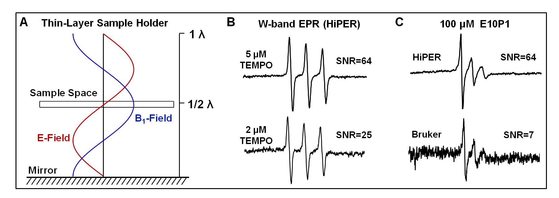
Conclusions
Fig. 1. (A) Schematic diagram of the sample position of a thin-layer holder in the electromagnetic field. The sample is placed at half wavelength (λ) from the mirror, where the B₁-field component of the reflected microwave radiation from the mirror is at a local maximum while the E-field is at a minimum. (B) Spectra of 2 µM and 5 µM TEMPO using an optimized sample holder H2. (C) Comparison of concentration sensitivity of the H2 holder in HiPER and a TE₀₁₁ cylindrical cavity in a Bruker E680 spectrometer.
These results highlight the sensitivity of the thin-layer sample holders employed in HiPER for spin-labeling studies of biological macromolecules at high fields, where applications can extend to other systems that are facilitated by the modest sample volumes and ease of sample loading and geometry.

Acknowledgements
G.E.F. acknowledges support from the National Science Foundation (MCB-1329467) and the National Institutes of Health (GM105409 and S10RR031603). This work was performed at the NHMFL, which is supported by NSF Cooperative Agreement No. DMR-1157490, the State of Florida, and the DOE.

