Three-Dimensional MRM of the Drosophila Brain at High Resolution

Fernandez-Funez, P.; Heon Lee, C. (Neuroscience, UF); Hansen, B. (Aarhus University, Denmark) and Blackband, S.J. (Neuroscience, UF)

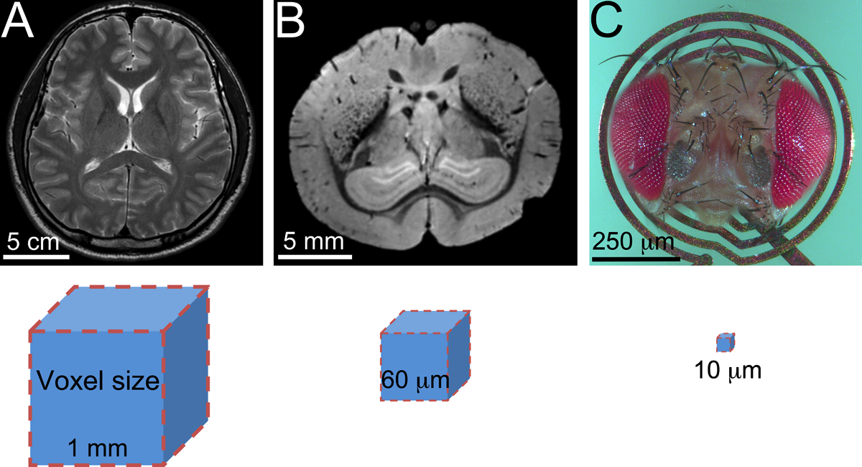
Introduction
We have not done additional new work during 2015 under this project because we could not secure funds to support the work of CH Lee, who left in the summer. However, the work that we completed the year before was finally published in the spring of 2015
[1]. The small fruit fly Drosophila melanogaster has many advantages for genetic studies, including evolutionarily conserved neuronal function and innate behaviors [2]. The fruit fly brain is also an ideal model for developing imaging technologies because it combines a small size (600 x 300 x 100 µm) with high complexity (10⁵ neurons). Two recent publications failed to reveal details of the microarchitecture of the Drosophila brain using MRM [3,4].
Figure 1. MRI specimens and voxel size. A, Human brain imaged at 1 mm resolution. B, Mouse brain imaged at 60 µm. C, Drosophila head mounted on a 500 µm planar microcoil for imaging at 10 µm. Voxels not at scale.

Experimental
We imaged a complete brain at the highest possible resolution by MR. We selected Drosophila because they have the smallest fully organized brain among the laboratory models and has the additional advantage of introducing genetic modifications of brain anatomy and/or function. We selected a planar 1 mm diameter RF microcoil optimized to the Drosophila head (Fig. 1) and two complementary sequences, FLASH and DWI. We imaged the heads at 10 µm isotropic resolution, 8-times higher than previous MRM in fruit flies (Fig. 2A) [3,4].
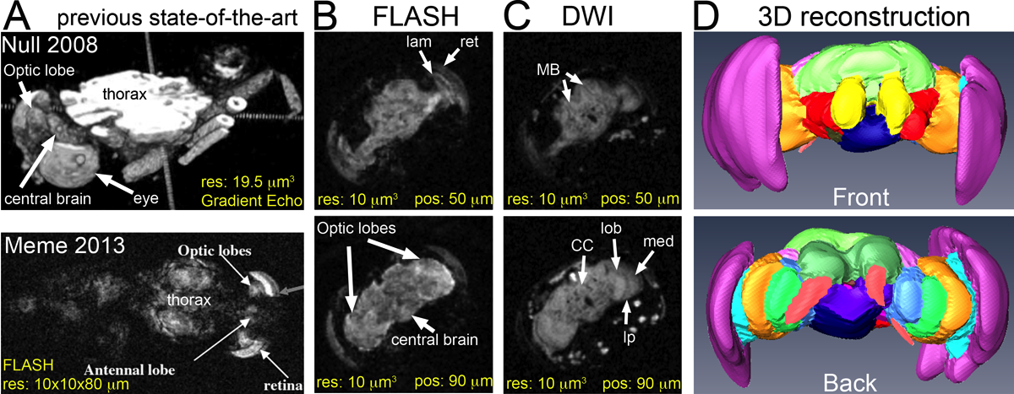
Figure 2. 3D MRM reveals the anatomy of the Drosophila brain. A, Published MRM images of Drosophila. Note the lack of anatomic details in the brain. res: resolution; pos: position along the A-P axis. B, FLASH reveals the retina (ret, pink) and lamina (lam, cyan). C, DWI generates exquisite contrast in the neuropil: mushroom bodies (MB), central complex (CC), medulla (med, orange), lobula (lob, blue), and lobula plate (lp, green). D, 3D brain model.
Results and Discussion
FLASH produced high signal of most internal head structures, including the retina, the lamina, and the brain, but the neuropil showed homogeneous signal (Fig. 2B). The DWI signal was weak in the retina and the lamina, but the contrast within the neuropil was extraordinary, allowing the identification of several known microdomains, including the central complex, the pedunculus, the suboesophageal ganglion, the medulla, and the lobula (Fig. 2C). The images produced by FLASH and DWI were almost complementary, allowing the segmentation and 3D reconstruction of the Drosophila brain (Fig. 2D). This MRM model closely mimicked widely used models generated by optical microscopy despite the difference in resolution and z-step.

Conclusions
Overall, these images reflect the highest resolution and contrast of any complete brain by non-invasive microscopy reported so far. We believe we can push for higher resolution by taking advantage of the AMRIS facilities and identify structural and tractography signatures associated with brain pathologies.

Acknowledgements
A portion of this work was performed at the National High Magnetic Field Laboratory, which is supported by National Science Foundation Cooperative Agreement No. DMR-1157490, the State of Florida, and the U.S. Department of Energy. This work was also funded by the NIH 1R01EB012874-01 award to SB, a McKnight Brain Institute Research Development Award (UF 00112640) and Start-up funding from the dept. of Neurology to PFF.

References: 1. Lee CH, et al. (2015). Sci Rep 5:8990; 2. Bellen HJ, et al. (2010) Nat Rev Neurosci 11: 514-522; 3. Meme S, et al. (2013) Magn Reson Imaging 31: 109-119; 4. Null B, et al. (2008) PLoS One 3: e2817.

