Characterizing Blood Brain Barrier Breakdown with Status Epilepticus Brain Injury

Magdoom, K.N. (UF, Mechanical Eng); Mareci, T.H. (UF, Biochemistry & Mol. Biol.); Carney, P.F. (UF, Pediatrics); Delgado, F. (UF, Biomedical Eng.); Lonser, R. (OSU, Neurosurgery) and Sarntinoranont, M. (UF, Mechanical Eng)

Introduction
Our objective was to use new engineering and imaging tools to quantify BBB breakdown and better understand the effect of neuropathological changes on extravasation and interstitial transport. Status epilepticus brain injury was chosen as a model for BBB breakdown. In the previous report, we discussed changing the BBB disruption model to pontine glioma which is currently incurable with very high mortality rate in humans. 9L tumor cells were infused into the rat pons and the tumor was allowed to grow for a set period of time before it was imaged.

Experimental
In-vivo MR measurements were performed at the AMRIS 4.7T horizontal bore magnet. Nine rats were imaged ten days post implantation of tumor cells using the following imaging protocol. Axially oriented slices of 1 mm thickness were acquired with a field of view of 24 mm x 24 mm and matrix size of 96 x 96. T₁ quantification was made using variable inversion time RARE sequence using the following imaging parameters: TR = 10,000 ms, TE_{eff} = 8.51 ms, RARE factor = 4, TI = 100, 500, 1000, 1500, 2000 and 4000 ms, and NA = 1. T₂ weighted images were acquired using RARE sequence with TR = 10,000 ms, TE_{eff} = 120 ms, RARE factor = 4 and NA = 3. HARDI diffusion data was acquired using fat suppressed diffusion weighted EPI sequence under a spin echo envelope with TR = 5,000 ms, TE_{eff} = 40 ms, number of shots = 3 and NA = 8 for 24 directions (6 with b-value ~ 80 s/mm² and 18 with b-value ~ 800 s/mm²). Serial T₁ weighted spoiled gradient echo sequence with TR = 100 ms, TE = 2.39 ms, flip angle = 90⁰ and NA = 3 was used for dynamic contrast enhanced (DCE) imaging.

Results and Discussion
The pontine tumor showed reduced fractional anisotropy, however average diffusivity did not change much perhaps due to the disoriented fibers indicated by reduced FA. BBB breakdown in the tumor was clearly visible in the DCE scan (Figure 1).

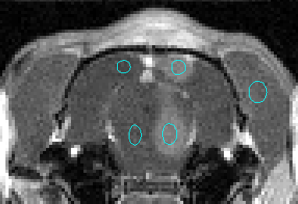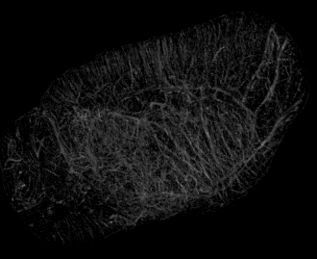
a

Fig. 1. Structural and BBB changes with pontine glioma from left to right; T₂-weighted image, average diffusivity image, fractional anisotropy (FA) image, T₁-weighted image approximately 38 minutes after injecting the contrast agent, Gd-DTPA-BMA, and 47 $μ$m isotropic resolution 3D cerebral angiography image.

Conclusions
Initial experiments were successful in characterizing the BBB breakdown in pontine glioma. However further experiments are warranted to better understand the extravasation and interstitial transport in the brain. We are working towards acquiring high resolution images of tracer distribution (Gd-albumin) at 17.6T magnet ex-vivo after infusing the tracer into the lateral ventricles. We are combining it with high resolution angiography images (rubber was injected into the heart after perfusion to identify vessels ex-vivo, figure 1) to reconstruct the perivascular spaces through which the tracer extravasates in 3D for the first time. The challenge is to remove the susceptibility artifact from the polymer in the T1w image which will be the focus. This study sustains a continuum of research directed toward development of innovative pharmacologic strategies that will allow treatment in the injured brain.

Acknowledgements
A portion of this work was performed at the National High Magnetic Field Laboratory, which is supported by National Science Foundation Cooperative Agreement No. DMR-1157490 and the State of Florida.

