Effects of PDE5A Inhibition on Skeletal Muscle ¹H₂O T₂ after Exercise in Dystrophic Mice

Batra, A. (UF, Physical Therapy); Vohra, R.; Chrzanowski, S. (UF, Physiology and Functional Genomics); Lott, D. (UF, Physical Therapy); Walter, G.A. (UF, Physiology and Functional Genomics); Vandenborne, K. (UF, Physical Therapy) and Forbes, S.C. (UF, Physical Therapy)

Introduction
Dystrophic muscle is characterized by increased susceptibility to muscle damage, inflammation, reduced blood flow, and fatigue. These impairments may be enhanced by lack of sarcolemma-localized neuronal nitric oxide synthase (nNOS) (1, 2). In this study, we examined whether a phosphodiesterase 5 inhibitor (sildenafil citrate) would reduce muscle damage and improve exercise performance in mdx mice after downhill running and during a low-intensity treadmill training program. Single voxel ¹H-MRS measures of muscle T₂ were utilized as an indicator of muscle damage(3).
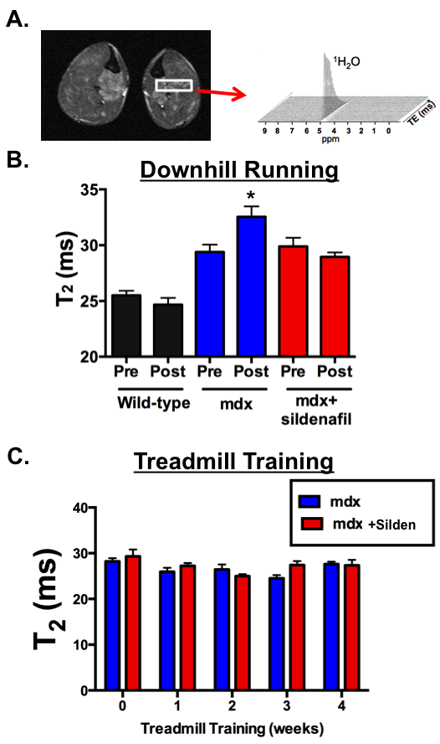

Figure 1. ¹H-MRS relaxometry derived ¹H₂O T₂ values from the medial compartment of the hindlimb (1A.) after downhill running (1B) and during four weeks of endurance training in mdx with and without treatment of sildenafil (C).

Experimental
Dystrophic (mdx) and wild-type mice performed a downhill running protocol (6-12m/min; 30-60min;14º decline) and low-intensity progressive treadmill training five days a week over a four week period (8-12m/min; 25-60min;0º incline). Training was performed in mdx mice with (n=5) and without (n=10) administration of sildenafil citrate (400 mg/L drinking water, ad libitum) and in wild-type (n=5) mice (age 9-17 months). ¹H-MRS single voxel STEAM (10-128 TE’s, 5-300 ms, TR 9 s) was used to acquire data from the medial compartment (MC) of the lower hindlimbs 24 hours after downhill running and at weekly intervals during the training program using a 4.7T Varian/Agilent MR operating system of the Advanced Magnetic Resonance Imaging and Spectroscopy (AMRIS) facility (Fig. 1A).
Results and Discussion
Sildenafil citrate diminished the increase in T₂ of skeletal muscles 24 hours after downhill running in mdx mice, suggesting reduced muscle damage (Fig. 1B). During training, the prescribed distance completed was greater in treated mdx mice (98%) and controls (100%) than untreated mdx mice (60%). At baseline, ¹H₂O T₂ was greater (p<0.05) in the mdx for all groups (28.7±1.6ms) compared to control (22.8±1.6ms) mice. T₂ values were maintained in controls and mdx mice throughout training and were not elevated after four weeks of running compared to baseline (Fig. 1C).
Conclusions
Our findings indicate that treatment with sildenafil reduced muscle damage from downhill running in mdx mice. Furthermore, the progressive low-intensity treadmill training program did not lead to additional muscle damage/ inflammation in mdx mice. In addition, the effects of training were enhanced by sildenafil, as evident by improved performance during training of the treated mice.
Acknowledgements
This research was supported by the Muscular Dystrophy Association (175552). A portion of this work was performed at the National High Magnetic Field Laboratory, which is supported by National Science Foundation Cooperative Agreement No. DMR-1157490, the State of Florida, and the U.S. Department of Energy.
References
1. Tidball & Wehling-Henricks. J Physiol. 592(Pt 21):4627-38, 2014.
2. Kobayashi et al. Nature. 27(456(7221)):511-5, 2008.
3. Mathur et al. Muscle Nerve. 43(6):878-86, 2011.

