MR Microscopy of a Mouse Model of Recessive Polycystic Kidney Disease

Lee, C.H. (UF, Elec.&Comp. Eng.); Yang, C.; Tate, J.M., Schoeb, T.R. (University of Alabama); Flint, J.J.; Blackband, S.J. (UF, Neuroscience, NHMFL) and Guay-Woodford, L.M. (University of Alabama)

Introduction
Polycystic kidney disease (PKD) is a major cause of end-stage renal disease (ESRD) in both children and adults, affecting 12.5 million people world-wide (~600,000 in the US). While current clinical trials are promising, there is no proven therapy for slowing disease progression and PKD patients continue to receive primarily supportive care (1). In an effort to understand disease progression and treatment, a variety of animal models have been developed. Previously in an NHMFL report we described how MRM can be used to image livers and kidneys and detect differences in normal and diseased tissues, and how these studies matured to quantitative volumetrics of normal wild type and mutant isolated mouse kidney and liver – this report repeats the major aspects of this work, that histological confirmation was also achieved, and that the study is finally complete and published.

Experimental
Images were acquired with a Bruker 14.1 T vertical magnet equipped with 3000 mT/m gradients and interfaced with a 10 mm bird cage coil. In order to accommodate the liver samples into the inner diameter of a 10 mm NMR tube, the largest lobe of each liver sample was separated with a scalpel and fine surgical scissors. 2D MSME images both in coronal and sagittal view were acquired with TE =50 ms, TR = 2.5 s, number of averages = 10, FOV = 2mm x 1mm, sampling matrix =256 x 128, slice thickness = 200 µm, and in-plane resolution of 78 µm. Wild type (n=8) and mutant kidneys (n=12) as well as mutant (n=6) and wild type (n=6) livers were scanned. Image segmentation with the biliary trees and the entire volume of livers was performed by using AMIRA software version 3.1.1 (Template Graphics Software, CA, USA) semi-automatically. Additionally histological confirmation of volumes was acquired.

Results and Discussion
The mutant kidney exhibits gross cystic formation and is several times larger than the wild type kidney (data not shown). Figure 1 shows data sets from the livers that have been segmented to isolate the biliary tree. Total wild type liver volumes were larger than the mutants by a factor of 1.7 (519±72mm³ versus 292±119mm³), with the mutant livers exhibiting a much greater variability in volume. After segmentation, the total biliary tree volumes were similarly differentiated (wild type = 87.3±8.5mm³, mutant = 35.0±22.4mm³). The volume fraction of the biliary tree to the total liver volume was 0.17±0.3 in the wild type and 0.11±0.3 in the mutant (p=0.015). The wild type biliary tree exhibits more extensive and finer branching, indicating developmental abnormality in the mutant livers. These data are confirmed by histology.
Figure 1. 3D segmentations of the biliary tree in wild type (left) and mutant (right) liver lobes.

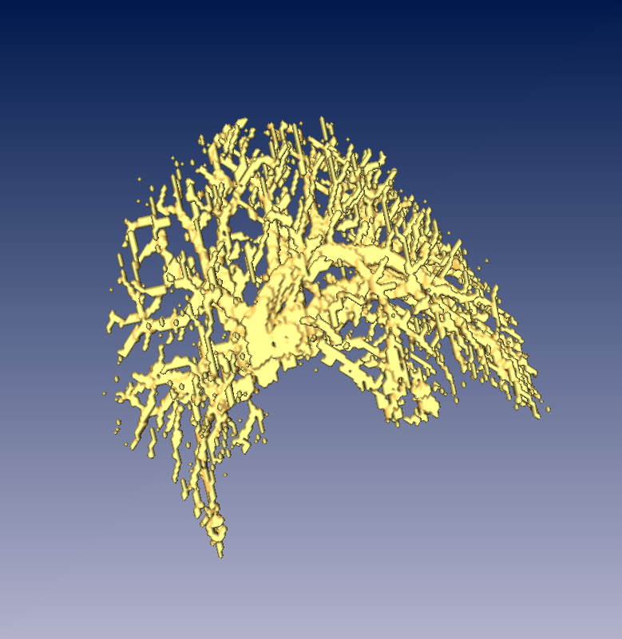

Conclusions
The quantitative MRM volumetric studies illustrate not only a clear difference in the normal and PDK liver volumes, but also a significant difference in the volume fraction of the biliary ducts to total liver volume. These results suggest that MRM may play a role in evaluating genetic models of PKD, quantitating variance for genetic modifier studies and monitoring of potential therapies. This complete work has now been published (2).

Acknowledgements
Funded by the NIH (P41 RR16105 and 1R01EB012874), a Burroughs Wellcome Clinical Scientist Award in Translational Research and performed at the NHMFL, which is supported by National Science Foundation Cooperative Agreement No. DMR-1157490 and the State of Florida.

References
- Cowley BD. Drugs. 64(12):1285-94 (2004). 2. Lee CH, et al, Physiol Rep. 3(8) (2015)

