Quantitative Spectroscopy of Sodium during Migraine Progression

Abad, N.; Grant, S.C. (Florida State U., Chemical & Biomedical Engineering, NHMFL); Rosenberg, J.T. (NHMFL) and Harrington, M.G. (Huntington Medical Research Institutes, Neurosciences)

Introduction
The brain allocates over 50% of its energy reserves on a cellular basis to the regulation of sodium concentrations; therefore, the alteration of sodium concentrations and fluxes related to these distributions are critical. In this study, rat models were used to evaluate in vivo sodium (²³Na) fluxes during the onset and progression of migraine. MR spectroscopy performed at 21.1 T provided the sensitivity and resolution to evaluate the local redistribution of sodium under migraine conditions.

Experimental
All scans were performed using the 21.1-T, 900-MHz ultra-wide bore at the National High Magnetic Field Laboratory, Tallahassee, FL. Animal procedures were approved by the Institutional Animal Care and Use Committee at the Florida State University and the Huntington Medical Research Institutes (HMRI) in Pasadena, CA. After baseline scans, 17 anesthetized Sprague-Dawley male rats were administered in situ an intra-peritoneal injection of either nitroglycerine (NTG, N=7) to induce migraine or saline (N=6) to serve as a control. A voxel selective STEAM sequence was used to acquire the total sodium signal in under 1.2 min from a (4-mm)³ voxel placed in the right cerebral hemisphere, and 14 spectra were acquired from pre injection to ~2.5 h post injection. Chemical Shift Imaging (CSI) with a 3-mm slice thickness also was acquired in 4 min using a 16x16 matrix over a 3.2x3.2-cm FOV at pre-injection and post-injection (~2.5 h after injection) time points.

Results and Discussion
²³Na spectroscopy was collected using both voxel selective and CSI approaches. STEAM voxels demonstrated a trend of initial increase in ²³Na signal following NTG that returned to control levels after 1 h. CSI scans appeared more sensitive to changes mediated via NTG, with a general increasing trend evident for NTG samples compared to controls between pre- and post-injection time points but more intense and localized sodium signal differences identifiable in the ventricles. These results extend the initial findings of a sodium change in migraine [1, 2].

Acknowledgements
This work was supported by the NIH (R01-NS072497 to MGH) and UCGP (to SCG) from the National High Magnetic Field Laboratory, which is funded by the NSF (DMR-1157490) and the State of Florida.

References
[1] Harrington, M.G., et al., Headache, 50(3), 459-478 (2010).
[2] Harrington, M.G., et al., Cephalalgia, 3(12), 1254-1265 (2011).

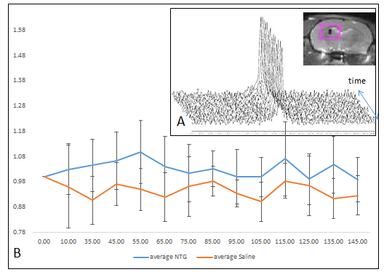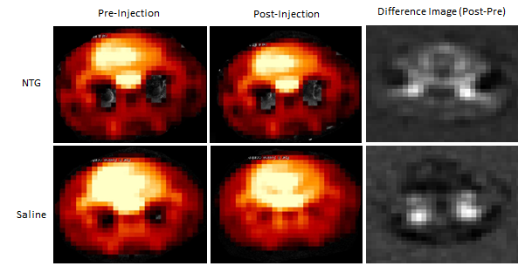
Fig. 2 Representative ²³Na CSI overlaid on reference ¹H scans were used to generate mean difference ²³Na images for all samples. Top Row NTG administered. Bottom Row Saline administered. Yellow arrows indicate the position of ventricles.
Fig. 1 A) Sample time course ²³Na spectra acquired with 14 scans over ~2.5 hr after injection. B) Mean ²³Na SNR normalized to the pre-injection point shows increases in sodium signal following NTG.

