Magnetic Field Measurement in Rat's Spinal Cord:
A Study of Magnetic Anisotropy in White Matter

Banan, G. (UF, Physics) and Mareci, T.H. (UF, Biochemistry and Molecular Biology)

Introduction
Magnetic susceptibility is the degree to which a material can be magnetized in an external magnetic field. Previous studies have reported a significant susceptibility contrast between white matter and grey matter of brain presumably because of dominance of myelin in white matter which can reveal important information about brain functionality and tissue structure. Field inhomogeneities due to magnetic susceptibility distribution can be quantified using phase data from gradient echo MRI.
Furthermore, Recent studies (Li et al., 2012) show that magnetic susceptibility of brain white matter is highly anisotropic and can reveal important information about microstructure of the white matter. One possible source of this anisotropy is believed to be the myelin sheath and the radial alignment of lipid molecules around the axons (Li et al., 2012). In a magnetically anisotropic environment, susceptibility is considered to be a tensor. To investigate the underlying mechanisms of this anisotropy and reconstructing the susceptibility tensor, magnetic field map needs to be calculated. Field calculation has to be done in multiple orientations in order to determine the unknown elements of the susceptibility tensor.
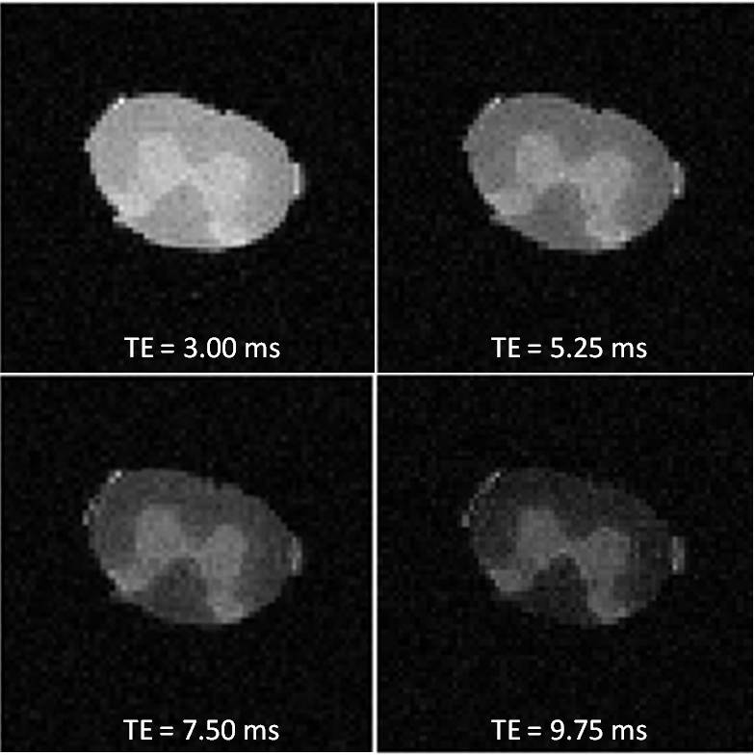
In this study, a rat’s spinal cord was imaged at nine different orientations in order to calculate magnetic field maps at each orientation and reconstruct the susceptibility tensor.
Fig.1 Magnitude images for 0° orientation

Experimental
Spinal cord has a cylindrical structure and white matter fibers aligned largely in the same direction and therefore presents an ideal sample to study magnetic anisotropy of the white matter and validate our quantification models.
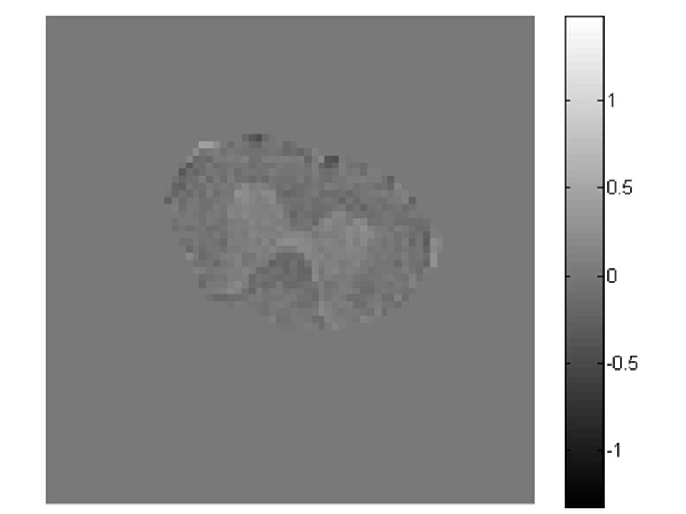
A 2cm section of the rat’s spinal cord was imaged at 9 different orientations. The images were acquired using a 3D multiple GE sequence. Imaging was performed on a Bruker 17.6 T magnet in the McKnight Brain Institute at the National High Magnetic Field Laboratory’s AMRIS Facility. The angle between the long axis of the cord and the main magnetic field was 0, 8, 17, 25, 39, 54, 60, 74, and 85 degrees. Imaging parameters were: TR = 200 ms, four echo times separated by 2.25 ms starting at TE₁ = 3 ms, isotropic resolution = 0.1 mm, and FOV = 20x7x7 mm³. The magnitude image for the 0° orientation is shown in Fig.1.
Fig.2 Phase image for 0° orientation and TE = 3 ms

Results and Discussion
All images were registered to a single frame of reference. The phase data for each orientation and echo time was calculated (Fig.2 shows an example for 0° orientation and TE = 3.00 ms). Magnetic field was calculated for each orientation. These fields show magnetic anisotropy in the spinal cord. The change in field perturbations with orientation is most obvious by comparing the first (0 degree) and the last (85 degree) maps which are shown in Fig.3.

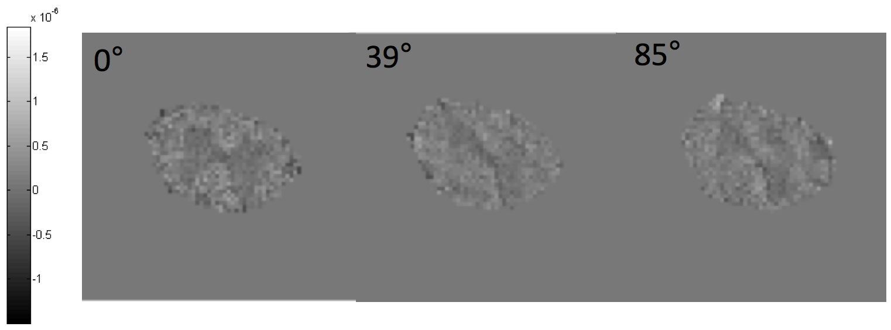
Conclusions
Fig.3 Magnetic field perturbation for different orientations of the spinal cord
The anisotropy seen in the magnetic field of the white matter is believed to result from the myelin sheath and molecular susceptibility anisotropy of lipid molecules and their radial alignment around the axon (Li et al., 2012). This data can be further used to reconstruct the susceptibility tensor.

Acknowledgements
A portion of this work was performed at the National High Magnetic Field Laboratory, which is supported by National Science Foundation Cooperative Agreement No. DMR-1157490 and the State of Florida.
This work was supported by NIH grants R01 NS082386-01A1 and R01 NR014181-01.

References
[1] Li, W., et al., NeuroImage, 59, 2088-2097 (2012).

