Anatomy of the Goliath Grouper Skull

Chapman, F.A. (U Fla, School of Forest Resources and Conservation-Fisheries and Aquatic Sciences);
Frank, L.R. (UC San Diego, Radiology) and Plant, H.D. (U Fla, McKnight Brain Institute)

Introduction
Traditional methods for identification of fish species require study of their skeletons. The skeletons are obtained by boiling and pulling the meat off or using dermestid beetles to clean the skeletons. Boiling is a crude method that requires careful reassembly of hard parts and the beetles require months to clean the skeleton.
The goliath grouper (Epinephelus itajara) is a protected species and requires examination of their skull for its identification. We proposed to study skull morphology to recognize the species utilizing imaging technology instead of the traditional methods. Imaging technology can be a valuable tool for species identification to natural history museums.

Experimental
The fish skull was imaged at 17T at the Advanced Magnetic Resonance Imaging and Spectroscopy
(AMRIS) Facility. The sample was prepared in fluorinert FC-43 to avoid background signal. Zero Echo Time (ZTE) imaging experiments were used to highlight bone and other anatomical features not particularly visible with traditional imaging methods (1).

Results and Discussion
Standard imaging methods do not reflect bone structure very well but the ZTE experiments have been successfully applied to bone and other structures which have in the past required CT to distinguish.
Epinephelus itajara is a species distinguished by its broad head. A distinction between itajara and the other species is obtained with the ratio of head width to head depth (2).
Fig.1 ZTE experiments – TE=0, TR=3ms, Matrix size 256x256x256. Images were rendered in Osirex.
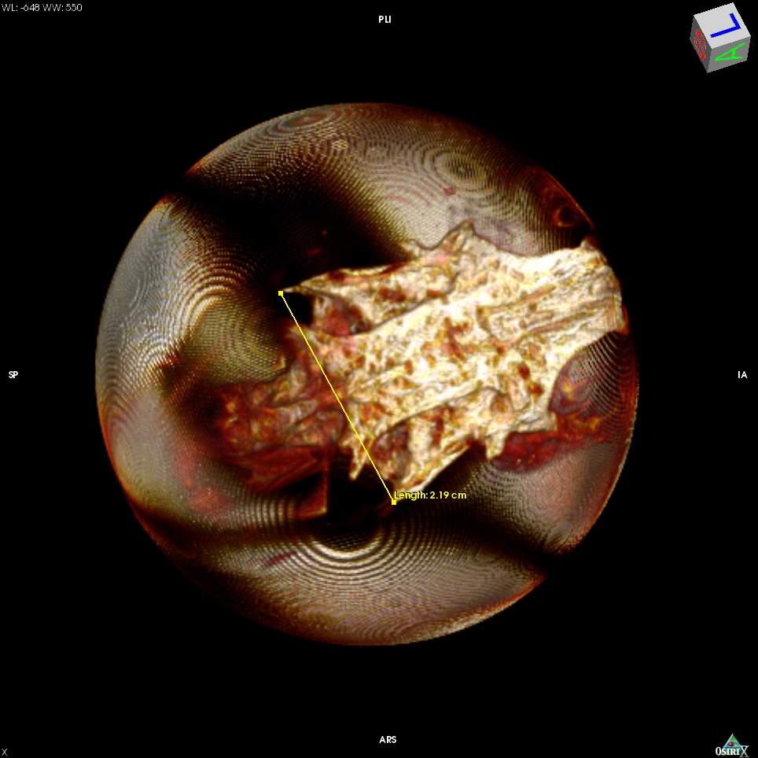
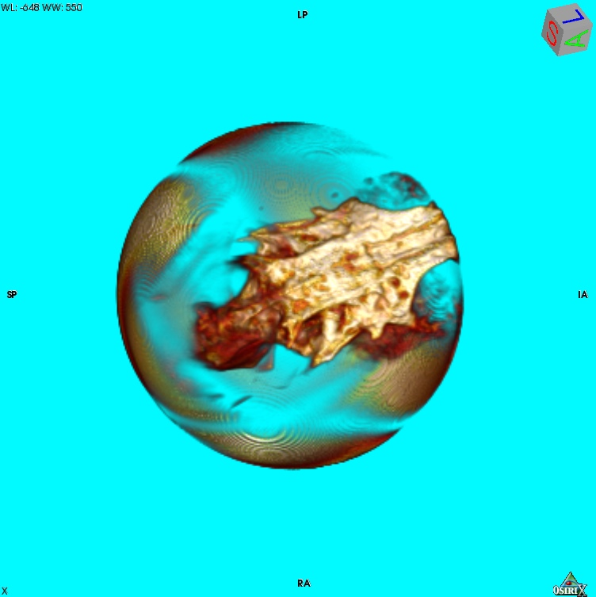
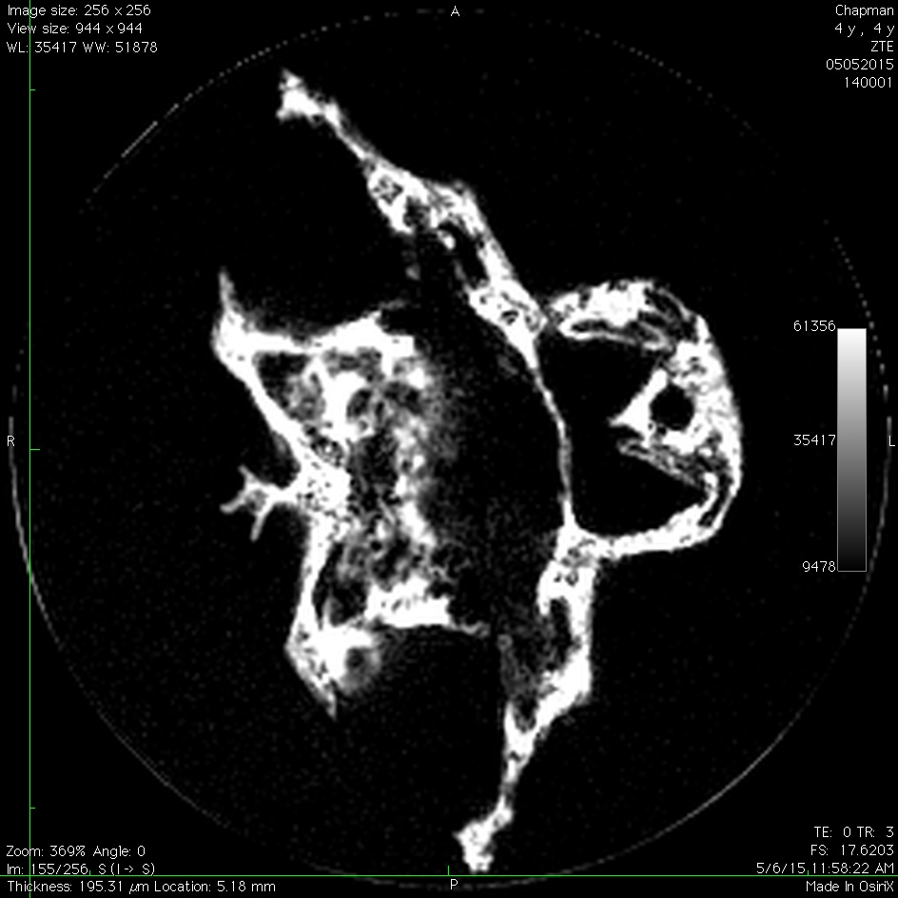

Conclusions
Now that the optimum imaging parameters have been determined using this phantom, the next step is to determine the head width to depth ratio in an intact fish.

Acknowledgements
A portion of this work was performed at the National High Magnetic Field Laboratory, which is supported by National Science Foundation Cooperative Agreement No. DMR-1157490 and the State of Florida.

References
[1] Weiger, M., Bone. May;54(1):44-7 (2013)
[2] Smith, C. L., Bulletin of the American Museum of Natural History. Volume 146: Article 2 (1971)

