Diffusion Tensor Imaging Analysis to Assess Stem Cell Therapy Efficacy in Traumatic Brain Injury

Abad, N.; Ould Ismail, A.; Grant, S.C. (Florida State U., Chemical & Biomedical Engineering, NHMFL); Rosenberg, J.T. (NHMFL); Darkazali, A. and Levenson, C.W. (Florida State U., Neuroscience and Biomedical Sciences)

Introduction
This study employs Diffusion Tensor Imaging (DTI) to probe nondestructively the physiological and potentially synergistic impacts of endogenous neural progenitor cells (NPC) and exogenous mesenchymal stem cells (MSC) in a rodent model of traumatic brain injury (TBI). To evaluate these effects, anisotropy and diffusivity were in rats with and without irradiation to eliminate proliferation of and impacts from NPC.
Experimental
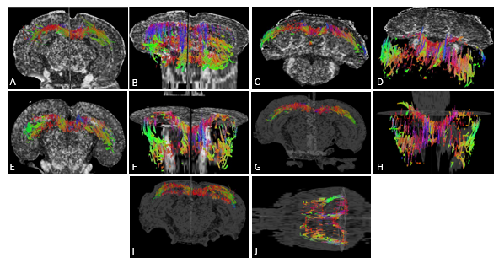
TBI Model and Delivery of hMSC: The TBI rodent model has been described previously [1]. Sprague-Dawley rats (N=25, N=5 per treatment group) were anesthetized and fixed in a stereotaxic frame to perform a 6-mm craniotomy rostral to Bregma. A CCI device was used to deliver a 5-mm diameter cortical. Six hours after TBI, the rats were administered either: an intravenous injection of passage-3 hMSC via the tail vein or a saline injection. Subventricular Zone (SVZ) Irradiation: Targeted irradiation (Irr) was performed under anesthesia on the rats directly after the TBI by making use of a custom-built lead shield, which protected the rest of the brain and exposed only the SVZ. Treatment groups: The following treatment groups were generated and analyzed: (1) TBI/no Irr/saline; (2) TBI/no Irr/hMSC; (3) TBI/Irr/saline; (4) TBI/Irr/hMSC; and (5) Sham. MRI Acquisition: Three weeks post-TBI, N=5 fixed rats in each treatment group were imaged ex vivo at 11.75 T. A high resolution, six-direction DTI (b value = 1000 s/mm²) was acquired and analyzed by anatomical segmentation, a slice-by-slice analysis and tractography for numerous regions, including the Corpus Callosum and Neo-Cortex.
Fig 1. Representative fiber tractography of the entire Corpus Callosum (thresholds: F A=0.581 and angular=45°) to display differences in treatment groups based on tract density. (A and B) Sham; (C and D) TBI/no Irr/hMSC; (E and F) TBI/no Irr/Saline; (G and H) BI/Irr/hMSC; and (I and J) TBI/Irr/Saline.
Results and Discussion
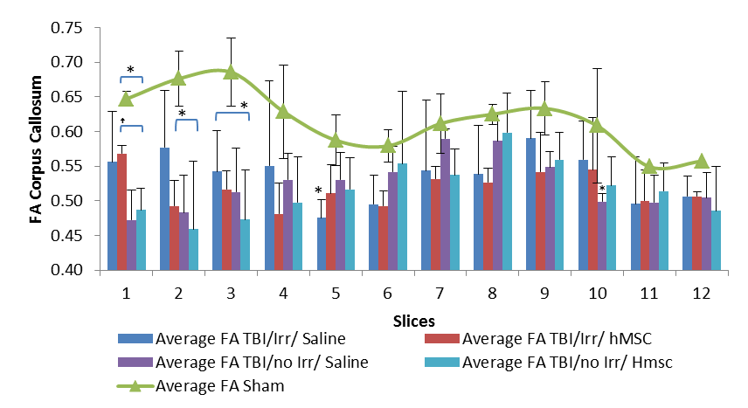
Tractography analysis showed differences between all TBI groups and shams in the Corpus Callosum in the form of reduced tracts in the area adjacent to the injury and surprisingly near the splenium (Fig 1). In close proximity to the initial TBI lesion (low slice number), Corpus Callosum (Fig 2) and Neo-Cortex data suggest differences between irradiation groups without major impact from exogenous hMSC therapy. Interestingly, irradiation appears to increase FA proximal to the injury either because of irradiation damage or reduced infiltration of migrating endogenous cells. Behavior measures (not shown) indicate more significant impacts from endogenous cells over exogenous cells [1]. This study represents the first investigation of the efficacy of MSC treatment in TBI and the potential synergistic effect of MSC and NPC on anisotropy using DTI.

Acknowledgements
This work was supported by the US Army (to CL) and UCGP (to SCG) from the National High Magnetic Field Laboratory, which is funded by the NSF (DMR-1157490) and the State of Florida.
Fig 2. Fractional Anisotropy (FA) values from slice-by-slice analysis of the Corpus Callosum in the TBI (n=5) and Sham (n=3) rats. Statistical significances are *p<0.05 (Tukey’s Posthoc) for comparisons with the Sham and between bracketed groups.
References
[1] Darkazalli, A., et al., J. Neurotrauma, in review (2105).

