EPR Studies of Protein-Protein Interactions Involved in the Assembly of Bacterial Nanoinjectors

De Guzman, R.N. (U. of Kansas, Molecular Biosciences); Kaur P. and Song, L. (FSU, NHMFL)

Introduction

The goal of this project is to use EPR to determine the protein-protein interactions involved in type III secretion system (T3SS), which is essential in the pathogenesis of many bacterial pathogens. The T3SS of Yersinia pestis (the causative agent of bubonic plague) contains a tip protein, LcrV, and a chaperone to the tip protein, LcrG. The binding of LcrV to LcrG is essential in the regulation of type III secretion in Yersinia pestis. The crystal structure of LcrV has been known for over a decade, however, the structure of its chaperone, LcrG, has only recently been determined by NMR in our group, and shows that LcrG lacks a tertiary structure and consists only of secondary alpha helical structures [1]. The current hypothesis is that LcrG is a highly alpha helical protein that forms a coiled coil upon binding to LcrV; however, NMR analysis is insufficient to identify if the two helices are in close contact with each other. Therefore, we performed EPR distance measurements to determine if there is a population of LcrG where the two helices are in a ‘closed’ conformation (Fig. 1). This knowledge is important in developing the mechanism of how LcrG functions in type III secretion.
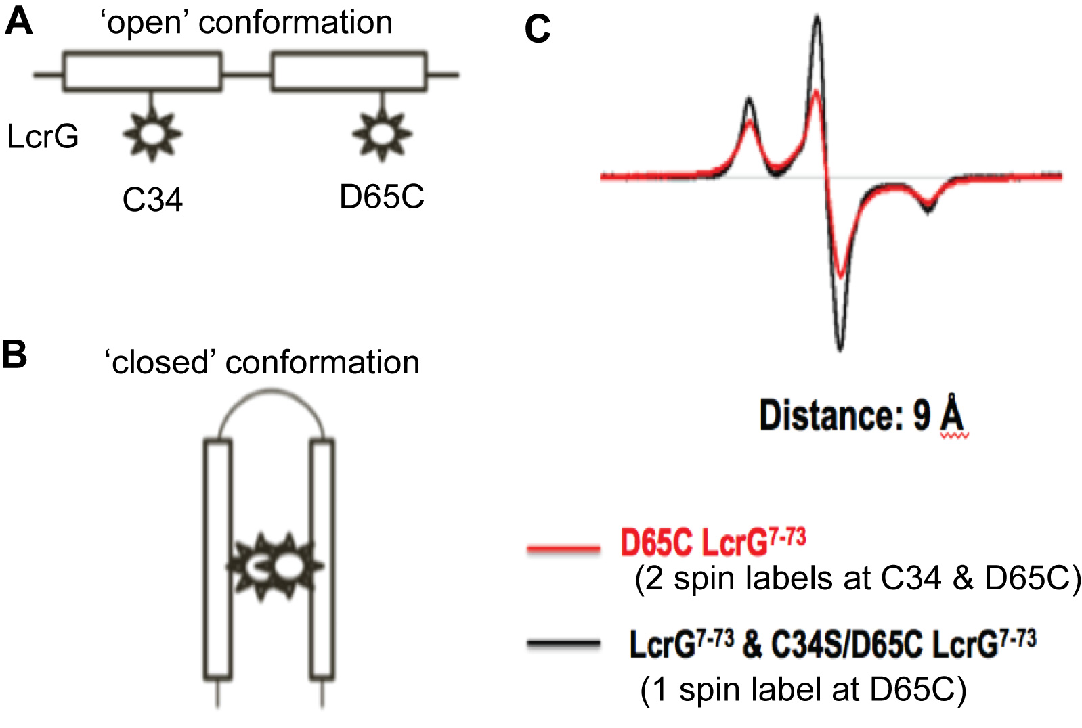
Fig. 1. Models of (A) ‘open’ and (B) ‘closed’ conformations of doubly spin-labeled LcrG. EPR data (C) suggest a population of LcrG in ‘closed’ conformation.

Experimental

Site-directed cysteine mutants of LcrG recombinant proteins were expressed and purified following published methods [1]. MTSL spin labels were attached to the LcrG proteins following published protocols [2]. EPR experiments were carried out at the NHMFL using a Bruker E680 spectrometer.

Results and Discussion

Our preliminary EPR data of two spin labeled sites at C34 and D65C suggest that LcrG may adopt a closed conformation (Fig. 1C). The EPR results show that the spin-spin distance of the two sites is 9 Å, indicating close proximity between the spin labels. These results will be confirmed by mapping EPR distances of other sites within LcrG. Furthermore, EPR distance measurements will be used to determine the conformation of LcrG iin the presence of the tip protein LcrV.

Conclusions

Using NMR, we reported in 2015 that LcrG lacks a tertiary structure and consists only of two alpha helices [2]. However, the EPR results suggest that the tip chaperone protein LcrG may exist in a closed conformation where the two helices are in close contact with each other. The results from EPR will change the way we view the structure of LcrG, and will contribute in developing the mechanism of how LcrG functions and interacts with its cognate tip protein.

Acknowledgements

A portion of this work was performed at the National High Magnetic Field Laboratory, which is supported by National Science Foundation Cooperative Agreement No. DMR-1157490 and the State of Florida. This work was also supported by NIH grant AI074856 (R.N.D.).

References

[1] Chaudhury, S., et al., J. Mol. Biol., 427, 3096-3109 (2015).
[2] Rathinavelan, T., et al., J. Mol. Biol., 426, 2958-2969 (2014).

