Ultrafast Dynamics in Photosynthetic Protein Complexes

Maiuri, M.; Dean J.C. (Princeton U., Chemistry); Bishop, M. (Connecticut U, Chemistry); McGill, S. (MagLab) and Scholes, G.D. (Princeton U., Chemistry)

Introduction
Nature has evolved sophisticated ways to control photosynthetic complexes where position and orientation of individual chromophores in the protein scaffold are finely engineered to funnel the absorbed energy and transfer it to reaction centers via electronic energy transfer (EET). EET is described according to the electronic coupling between chromophores by the Fӧrster model in the weak coupling regime or by the excitonic model where the delocalized excitation is governed by electronic coherence when moving to stronger coupled systems [1]. Furthermore “vibronic” coupling has been recently highlighted to describe the influence of the Franck-Condon active vibrations on coherence. Here we propose a new approach to address the problem of disentangling electronic/vibronic coherences by envisaging that a strong magnetic field will affect the electronic coupling of the chromophores while not interacting with their vibrational structure. We studied photosynthetic phycobiliproteins algae with a tailored apparatus which couples an ultrafast pump-probe system with the high fields of the Split Helix. The proteins studied (namely PC577 and PC645) have different structural arrangements: PC577 is known to have an “open” structure with the main pigments spatially far apart, thus exhibiting a weak electronic coupling, meanwhile PC645 is characterized by a “close” structure, with a stronger electronic coupling. The PC577 is thus expected to display mainly excited state vibrational coherences and show little to no magnetic field effect, while the pigments of PC645 shows several excitonic interactions, which are expected to be modulated by the presence of a high field.
Experimental
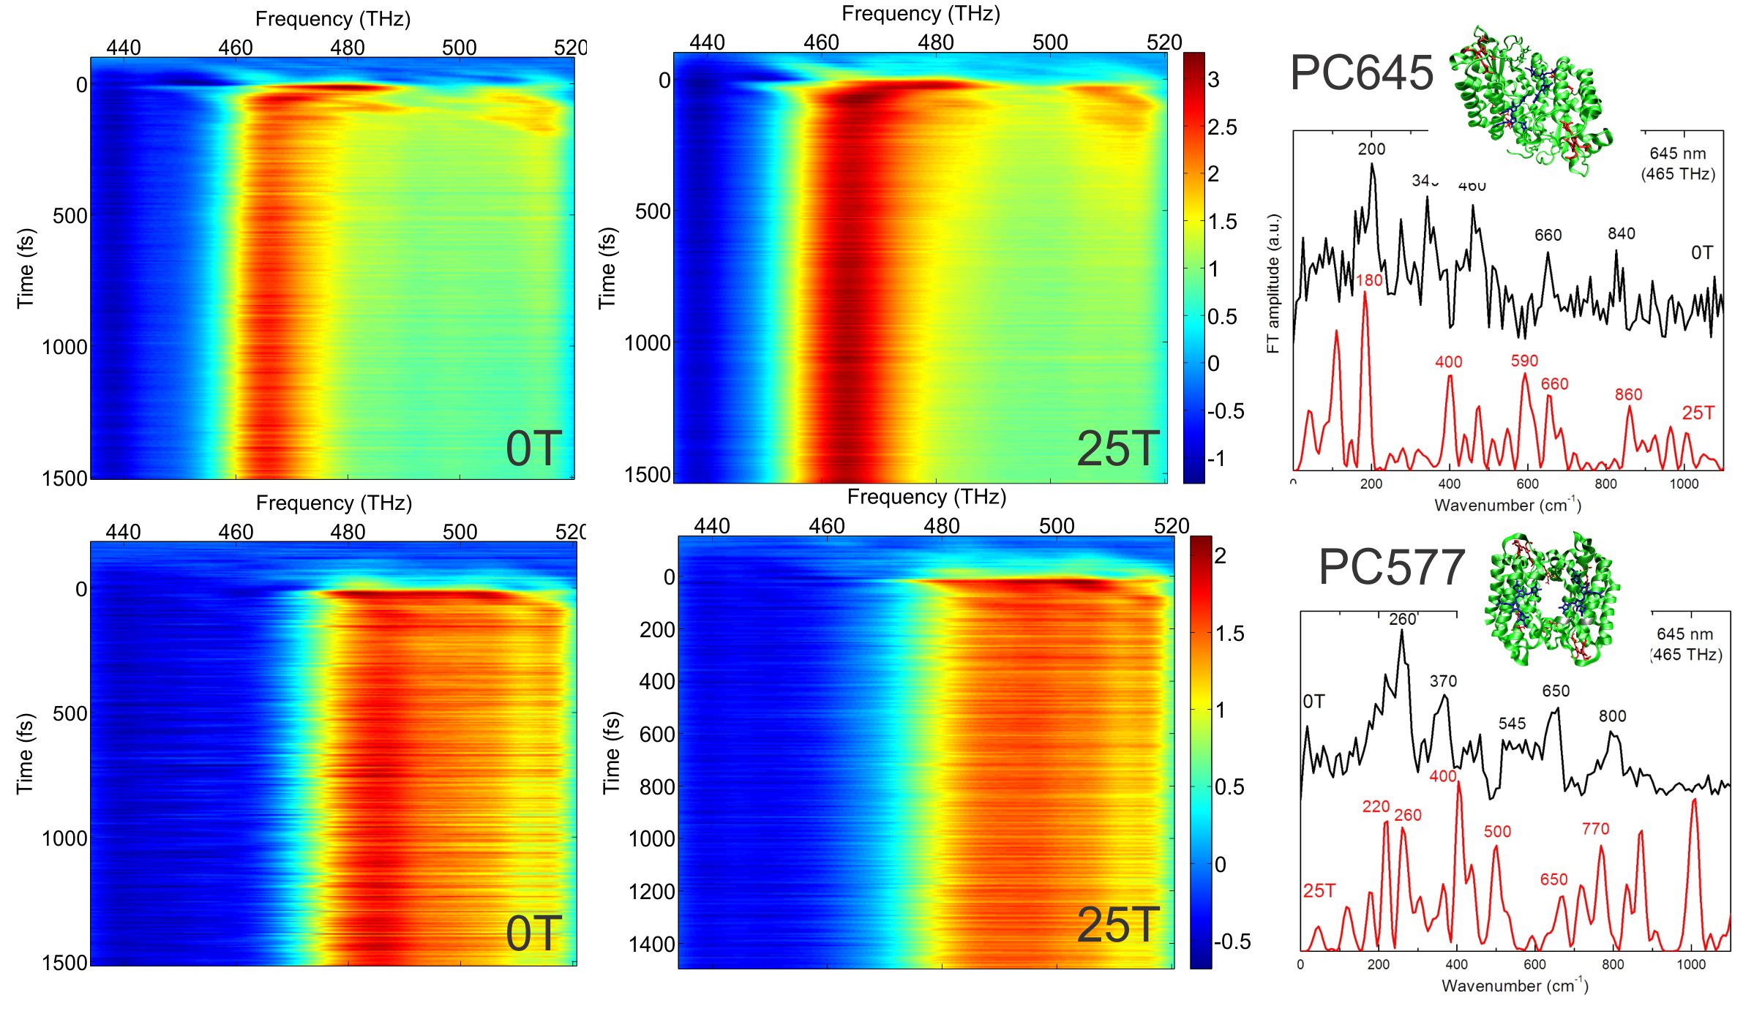
A broadband pump probe set-up [2] was implemented pumped by a home built NOPA delivering broadband pulses in the visible frequency range compressed down to 30fs. Short pulses enabled us to trigger and detect coherent oscillations created in the time domain. By a post-process Fourier analysis of the pump-probe data, we resolved the FT modes forming coherent signals and compared the results in the absence/presence (0/25T) of the external field. We tested our system on a reference dye and found that the fundamental vibrational mode is clearly observed at 0T and 25T, proving no observable effect of magnetic field on a simple non-excitonic system.
Results and Discussion
Fig.1 shows the pump probe maps of PC645 and PC577 at 0T and 25T and the corresponding FT spectra at selected probe frequency. For both the proteins, the 0T field experiment matches the coherence frequencies measured previously in the Scholes’s group [2]. Interestingly for PC645 we observe within the experimental noise that the main modes undergo a change in amplitude and shift in frequency (around 600 cm⁻¹) at 25T pointing towards a potential effect of the magnetic field, while the position of frequencies of these coherences seem to be less sensitive to the effect of the 25T field for the PC577, following the hypothesis that the vibrational coherences will not be perturbed by the magnetic field.
Fig.1 Pump-Probe maps of PC645 (first raw) and PC577 (second raw) at 0Tand 25T and corresponding Fourier analysis at selected probe frequencies.
Conclusions
Our results point toward the direction of a detectable change of an excitonically-coupled system under the effect of a strong magnetic field. Nevertheless we suffered non-negligible uncertainty in the observation of the coherent modes in the frequency domain that pushes us to repeat and improve our results during the next magnet time.
Acknowledgements
A portion of this work was performed at the National High Magnetic Field Laboratory, which is supported by National Science Foundation Cooperative Agreement No. DMR-1157490 and the State of Florida.
References
[1] Chenu, A., et al, Ann. Rev. 66, 69-96 (2015).
[2] McClure, S., et al JPCB 118, 1296-1308 (2014).

