Global Patters of Soil Organic Matter Composition

Normand, A.E. (UF, Soil and Water Science); Turner, B.L. (STRI); Lamit, J. (MTU, Forest and Environmental Science); Baisier, B. (UF, Wildlife Ecology); Lilleskov, E. (Forest Service, Northern Research Station); Grover, S.P. (La Trobe U, Animal, Plant, and Soil Science); Smith, A.N. (UF, Chemistry); Cheesman, A.W. (James Cook U, Marine and Environmental Sciences) and Reddy, K.R. (UF, Soil and Water Science)

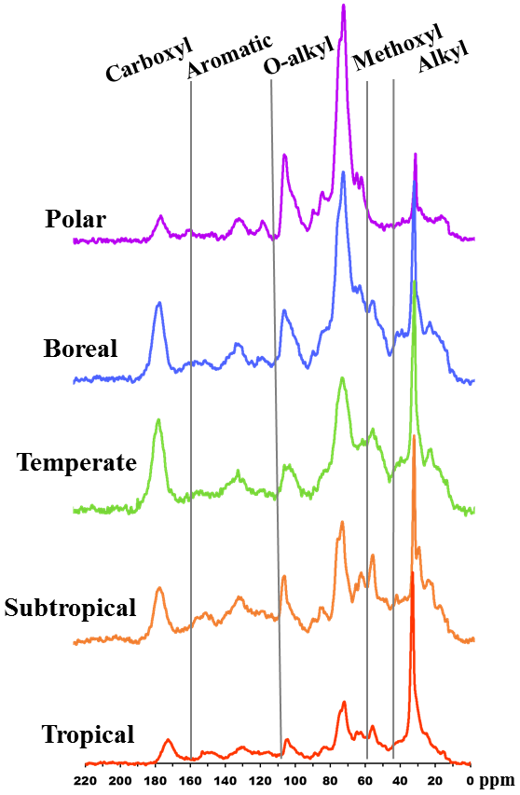
Introduction
Climate change will inevitably dictate the fate of peatland soil organic matter (SOM) stability which stores ~462 Pg carbon (C) – more C than any other terrestrial ecosystem¹. Destabilization of this large and potentially vulnerable pool of C could have a major impact on climate through microbial respiration producing greenhouse gasses (GHG). The stability of SOM is dependent on its chemical composition, yet a holistic understanding of peatland SOM chemical composition across the globe is lacking. ¹³C Solid State NMR analysis may provide clarity about the response of SOM from climatic change by differentiating carbon functional groups varying in molecular stability from peat across the globe.

Experimental
Peat soil samples from top soil (0-20 cm) were collected from 80 peatlands across climate zones, vegetation material, chemical properties, and land use. CPTOSS ¹³C Solid State NMR sprectra of dried, ground samples were obtained using a Bruker Avance II 500 MHz Spectrometer with a 3.2 mm H/C/N MAS probe at the AMRIS Facility. Spectra peaks were integrated to determine percent of C functional groups: carboxyl, aromatic, O-alkyl, methoxyl, and alkyl (Fig. 1).
Fig.1 ¹³C ssNMR spectra of peat across climate zones.

Results and Discussion
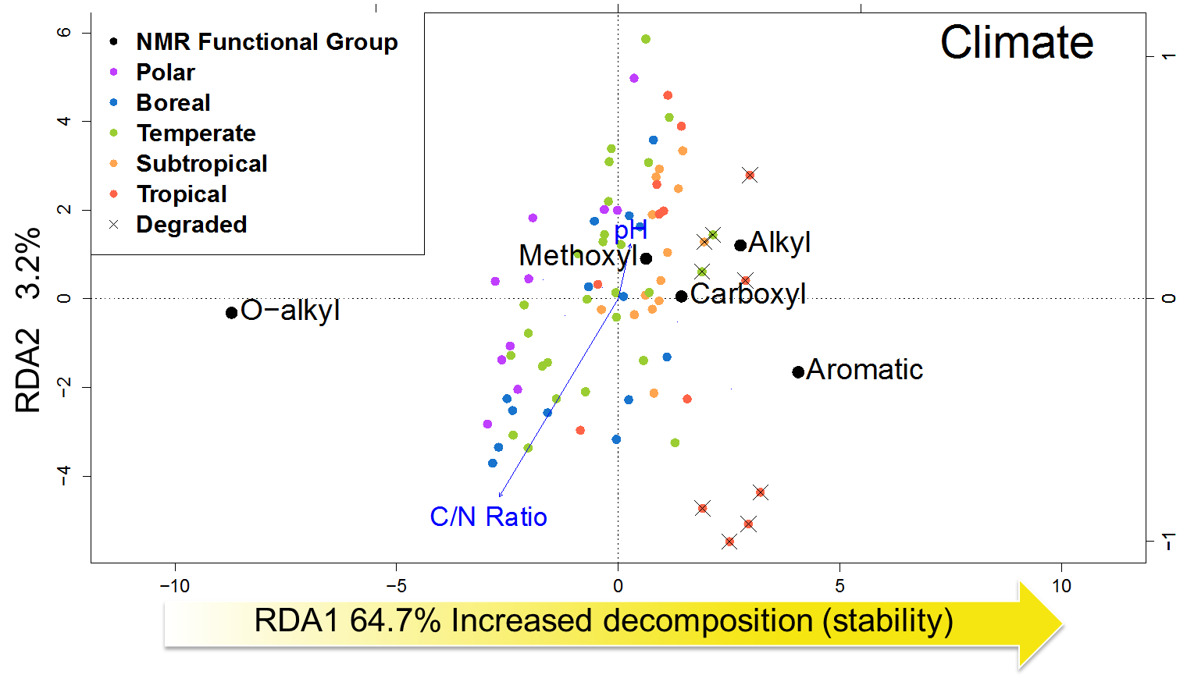
Redundancy analysis (RDA) was used to determine the key explanatory drivers of SOM chemical composition (Fig.1). RDA axis 1 represented increased decomposition (or stability). Long term degraded sites had the most decomposed peat. Polar, boreal, and moss sites had more potentially labile SOM compared to tropical, subtropical, and shrub/forested sites. Explanation of variance quantified the influence of the 5 variables on SOM chemical composition. Land use accounted for the most variation (16%). C/N ratio (7%), climate (6%), and vegetation (2%) also were strong explanatory variables with significant shared variance. pH was not a significant driver explaining only 0.1% of variation.

Conclusion and Future Research
Change in climate may result in more decomposed SOM due to temperature increases or vegetation community shifts.
Management of peatlands should be a priority as peat SOM composition is drastically changed due long term disturbance. Future research will determine how SOM composition from contrasting peatlands affects GHG production.

Acknowledgements
A portion of this work was performed at the National High Magnetic Field Laboratory, which is supported by National Science Foundation Cooperative Agreement No. DMR-1157490. This material is based upon work supported by the NSF GRFP under Grant No. DGE-1315138, and NSF GROW and GRIP travel awards.
Fig.2 RDA revealed patterns of climate, vegetation, chemical properties, and land use affecting NMR functional groups.

References
[1] Bridgham, S.D., et al., Wetlands, 26, 889-916 (2006).

