Characterization of Disinfection Byproducts from Chromatographically Isolated NOM through High Resolution Mass Spectrometry

Harris, B.D.; Brown, T.A.; McGehee, J.L.; Houserova, D.; Jackson, B.A.; Buchel, B.C. (Univ. S. Alabama, Chemistry); Krajewsk, L.C. (FSU, Chemistry); Whelton, A.J. (Purdue U., Engineering) and Stenson, A.C. (USA, Chemistry)

Results and Discussion
As levels of natural organic matter (NOM) in surface water rise, the minimization of potentially harmful disinfection by-products (DBPs) becomes increasingly critical. Here, we introduce the advantage that chromatographic prefractionation brings to investigating compositional changes to NOM caused by chlorination. Fractionation reduces complexity, making it easier to observe changes and attribute them to specific components. Under the conditions tested (0.1−0.4 g of Cl to g of C without further additives), the differences between highly and less oxidized NOM were striking. Highly oxidized NOM formed more diverse Cl-containing DBP, had a higher propensity to react with multiple Cl, and tended to transform so drastically as to no longer be amenable to electrospray-ionization mass spectral detection. Less-oxidized material tended to incorporate one Cl and retain its
humic-like composition. N-containing, lipidlike, and condensed aromatic structure (CAS)-like NOM were selectively enriched in mass spectra, suggesting that such components do not react as extensively with NaOCl as their counterparts. Carbohydrate-like NOM, conversely, was selectively removed from spectra by chlorination.

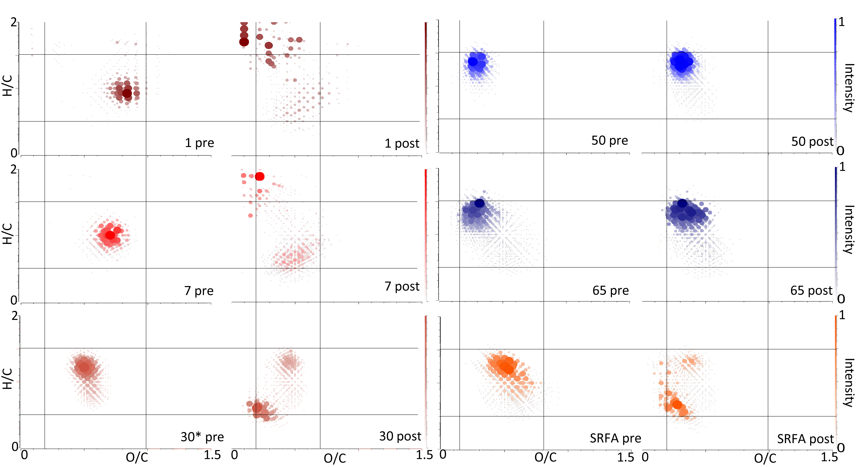

Figure 1. van Krevelen plots of all formulae assigned for fractions 1, 7 30, 50 and 65 pre-chlorination (left) and post-chlorination (right). Red corresponds to early eluting compounds, whereas blue for late-eluting compounds. HPLC-fractionation prior to chlorination reveals differences between pre and post chlorination spectra not accessible from bulk measurements of whole water and avails detail as to which components are relatively inert, and thus selectively enriched or highly reactive, and thus substantially converted.

Acknowledgements
Funding was provided by the NSF CHE 1039944, the Center for Environmental Resiliency (University of South Alabama), the State of Florida, and the University of South Alabama, and the National Science Foundation Cooperative Agreement No. DMR-1157490.

Reference Harris, B.D., et al. Environ. Sci. Techn., 49, 14239-14248 (2015).

