**HFEPR and 57Fe Mössbauer Spectroscopic Investigation of the Tetrahedral, *S* = 2, [Fe{(EPiPr2)2N}2], E = S, Se, Complexes**

Levesanos, N.; Ferentinos, E.; Kyritsis, P. (U. of Athens, Greece, Chemistry); Stoian, S.A. and Krzystek, J. (NHMFL)

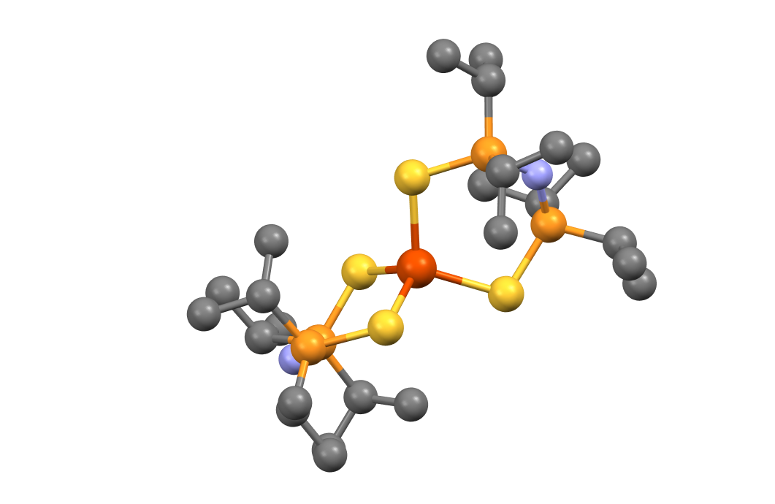

**Fig. 1**. X-ray crystal structure of **1**.

**Introduction**

Owing to their similitude with the local iron sites of enzyme-based iron-sulfur clusters, iron-containing complexes enclosing a tetrahedral FeIIS4, *S* = 2 site are of high interest in bioinorganic chemistry. Up to date, only four such systems have been studied by high frequency/field EPR.1-4 Furthermore, no such investigations have been ever reported for a Se-based analog. In this study we have performed a detailed HFEPR and Mössbauer spectroscopic investigation of the [Fe{(EPiPr2)2N}2], E = S (**1**), Se (**2**) series of analogous complexes.

**Experimental**

HFEPR experiments were performed using the EMR Facility and in particular its15/17 T superconducting magnet. Field- and temperature-dependent 57Fe Mössbauer spectra were recorded using a constant acceleration spectrometer fitted with an 8 T superconducting magnet that is part of the user program at the NHMFL.



**Fig. 3**. Field- and temperature-dependent 57Fe Mössbauer spectra recorded for **1**. The solid red lines overlaid over the experimental data are simulations obtained using a standard *S* = 2 spin Hamiltonian.

**Results and Discussion**

The high-field EPR and field-dependent Mössbauer spectra recorded for **1** - **2** were successfully analyzed in the framework of an *S* = 2 spin Hamiltonian. This study allowed us to establish that at low temperature the magnetic properties of the S and Se containing complexes are similar. This observation is further corroborated by the fact that the parameters which describe the electronic ground state of these complexes are also rather similar. Furthermore, a theoretical analysis of the parameters obtained from this spectroscopic investigation allowed us to determine that many of the essential spectroscopic parameters are in fact determined by the nature of the ancillary substituents present in the second coordination sphere of the iron ions.



**Fig. 2**. Field vs. frequency map of EPR resonances observed for **1**. Squares: experimental resonances. Curves: simulations using best-fitted parameters: *D* = −4.53, *E* = −0.88 cm–1, ***g*** = [2.094, 2.057, 2.19].

**Acknowledgements**

A portion of this work was performed at the National High Magnetic Field Laboratory, which is supported by National Science Foundation Cooperative Agreement No. DMR-1157490, the State of Florida, and the U.S. Department of Energy. PK thanks the Fulbright Foundation in Greece and the NHMFL for a Visiting Scientist grant enabling him to join the NHMFL for a two-month stay in 2013 and pursue the reported project. We thank Dr. A. Ozarowski for his EPR simulation and fit program SPIN.

**References**

[1] Knapp, M.J,. *et al.*, Inorg. Chem., **39**, 281-288 (2000).

[2] Barra, A.L., *et al.*, Appl. Magn. Reson., **30**, 385-397 (2006).

[3] Mathies, G., *et al.*, J. Magn. Reson., **224**, 94-100 (2012).

[4] Zadrozny, J.M,. *et al.*, Chem. Sci., doi: 10.1039/C5SC02477C (2016).