Solid-State NMR Studies of a New Ionic Conductor: Na-doped SrSiO₃

Chien, P.-H. (Florida State U., Chemistry & Biochemistry); Jee, Y. (U. of South Carolina, Mechanical Engineering); Hung, I., Gan, Z. (NHMFL); Huang, K. (U. of South Carolina, Mechanical Engineering); Hu, Y.-Y. (Florida State U., Chemistry & Biochemistry)

Introduction
Solid-state electrolytes play a pivotal role in solid-oxide fuel cells (SOFCs), batteries, and ion exchange membranes. Recently, a novel ionic conductor, Sr_{1–x}Na_{x}SiO_{3–0.5x} (SNS), has been proposed as a suitable solid-state oxide-ion electrolyte for SOFCs.¹ The ionic conductivity of SNS with an apparent composition of Sr_{0.55}Na_{0.45}SiO_{2.78} (x=0.45, SNS45) was found to be the highest among all chemically stable solid oxide-ion electrolytes ¹ at intermediate temperatures (σ₀ ≈ 0.01 S/cm at 500 ºC). The origin of this high ionic conductivity in SNS has been the topic of major debates since the birth of SNS in 2013. In this abstract, high-resolution and high-temperature solid-state ²⁹Si, ²³Na, and ¹⁷O NMR studies of SNS samples reveal that SNS is a Na-ion conductor rather than an oxide conductor as proposed before.
Experimental
²⁹Si NMR spectra were acquired on a Bruker DRX-300 spectrometer at a Larmor frequency of 59.6 MHz using a Bruker 4-mm MAS probe spinning at 10 kHz. ²³Na and ¹⁷O NMR spectra were acquired on a Bruker DRX-830 spectrometer with a home-built 3.2-mm low-γ and high-sensitivity MAS probe spinning at 18 kHz at the Larmor frequency of 219.6 MHz for ²³Na and 112.6 MHz for ¹⁷O. A rotor-synchronized spin-echo pulse sequence was employed for all experiments. The MQMAS spectrum of ¹⁷O-enriched SNS45 was collected using a shifted-echo sequence using a home-built 4-mm single channel probe with a spinning speed of 10 kHz.
Results and Discussion
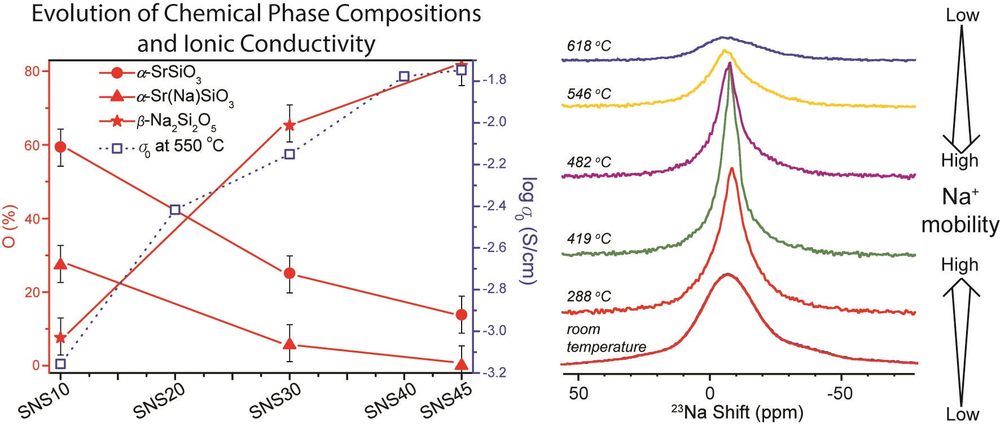
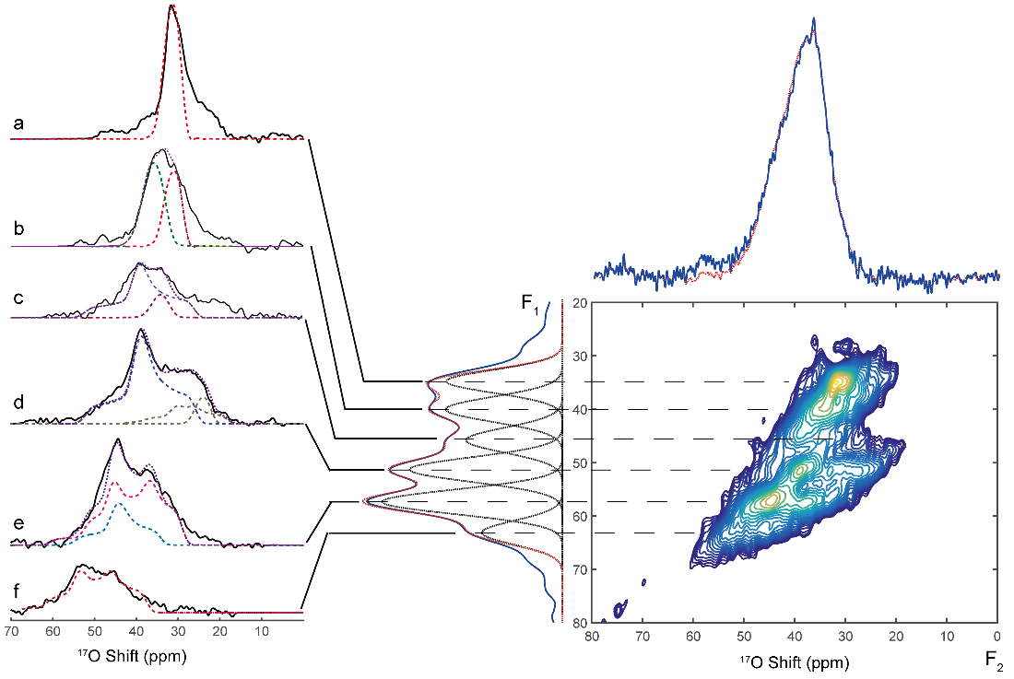
²⁹Si, ²³Na, and ¹⁷O NMR showed that the amount of the α-SrSiO₃ phase decreased gradually as Na-doping level was increased. The expected phase with Na-doped into the α-SrSiO₃ structure, i.e., Sr(Na)SiO₃, peaked at 10% Na doping, but vanished gradually with more Na doped. Also, β-Na₂Si₂O₅ became the dominated phase with > 20% Na content. Sr(Na)SiO₃ and β-Na₂Si₂O₅ were spatially separated and large C_{Q}s shown in ²³Na and ¹⁷O NMR indicate disordered structural properties of the β-Na₂Si₂O₅ phase. Structural fusion of silicate framework was suggested by gradually decreased ratio of non-bridging oxygen to bridging oxygen observed in ¹⁷O NMR. Most importantly, variable high-temperature ²³Na and ¹⁷O MAS NMR show changes in ²³Na ion dynamics with temperature but no significant motions were observed of oxide ions.
Figure 1 Phase evolutions correlated with ionic conductivity and ion dynamics.

Figure 2 MQMAS ¹⁷O NMR of Sr_{0.55}Na_{0.45}SiO_{2.78}
Conclusions
Phase evolutions and ion dynamics of SNS samples with varying Na doping contents have been investigated using advanced solid-state NMR techniques. ²⁹Si, ²³Na, and ¹⁷O NMR spectra indicate amorphous β-Na₂Si₂O₅ phase dominates in SNS after Na-doping level reaches 20% and beyond. Variable high-temperature NMR results clearly showed that Na ion motions changed as the temperature increased to about 400ºC as seen by narrowed spectral linewidth whereas no oxide ion motions were shown.
Acknowledgements
Hu and Chien acknowledge support from the National Science Foundation under Grant No. 1508404. Huang acknowledges ARPA-E, U.S. DOE for support under Award number DE-AR0000492. A portion of this work was performed at the National High Magnetic Field Laboratory, which is supported by National Science Foundation Cooperative Agreement No. DMR-1157490 and the State of Florida.
References
[1] Singh, P., et al., J. Am. Chem. Soc., 135, 10149-10154 (2013).

