Structure and Topology of Binary Si-Se Glass Networks: Results from Two-Dimensional ²⁹Si and ⁷⁷Se MATPASS/CPMG NMR Spectroscopy

Marple, M.A.T.; Kaseman, D.C.; Sen, S. (U. of California-Davis, Materials Science); Hung, I. and Gan, Z. (NHMFL)

Introduction
A wide range of inorganic glasses in the AX₂ family are characterized by predominantly corner-sharing tetrahedral networks, such as SiO₂ and GeSe₂. In contrast, amorphous SiSe₂ is characterized by three different types of tetrahedral environments which are (i) entirely corner-sharing (E⁰) and (ii) singly (E¹) and (iii) doubly edge-sharing (E²). The compositional variation of the relative fractions of these environments as well as the degree of randomness in the connectivity between the Se-Se chain and the SiSe₄ tetrahedral units in binary Si_{x}Se_{100-x} glasses remain largely unknown. In this project, the structural speciation and local site symmetry of Si_{x}Se_{100-x} glasses with Se contents ranging between 67 and 95 atom% are investigated using two-dimensional ²⁹Si and ⁷⁷Se MATPASS/CPMG NMR spectroscopy. Here we report the first results on the amorphous SiSe₂ alloy.
Experimental
The Si_{x}Se_{100-x} glasses were synthesized from constituent elements using the conventional melt-quenching method. The ²⁹Si and ⁷⁷Se MATPASS/CPMG NMR measurements were carried out at NHMFL using a 19.6T narrow bore magnet equipped with a Bruker DRX console at a resonance frequency of 165.2 MHz and 158.6 MHz for ²⁹Si and ⁷⁷Se, respectively. Crushed glass samples were packed into 3.2 mm zirconia rotors and spun at 5 kHz and 10 kHz for ²⁹Si and ⁷⁷Se, respectively. The MATPASS/CPMG experiment uses a series of 5 MAT π-pulses (4 μs) followed by CPMG pulses for data acquisition. 16 hypercomplex t₁ points were acquired with 36 transients per point and 64 CPMG echoes per transient. The recycle delay was 120 s for ²⁹Si and 60 s for ⁷⁷Se.
Results and Discussion
The ²⁹Si and ⁷⁷Se MATPASS/CPMG NMR spectra for the SiSe₂ alloy are shown in Fig. 1. Three different Si sites, E⁰, E¹, and E², are clearly resolved with isotropic chemical shift decreasing and anisotropy increasing with increasing degree of edge-sharing (Fig. 1: left). Similarly two distinct Ge-Se-Ge sites can be seen in the ⁷⁷Se spectra (Fig. 1: right) in edge- and corner- sharing environments, again distinguishable by their anisotropy and isotropic shifts. Full analyses of these results are currently underway. However, it is clear that they provide important constraints on the compositional variation of Se and Si speciation and the connectivity between the chain and tetrahedral units at an unprecedented level of details.
Conclusions
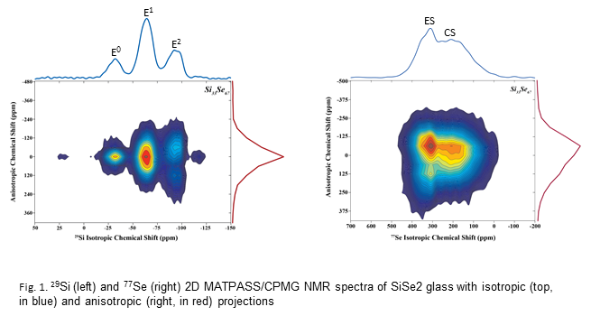
The multi-nuclear isotropic-anisotropic chemical shift correlation MATPASS spectra offer unique insight into the structure and connectivity of binary Si_{x}Se_{100-x} glasses. Full structural analyses of these results and their topological implications are being developed.
Acknowledgements
A portion of this work was performed at the National High Magnetic Field Laboratory, which is supported by National Science Foundation Cooperative Agreement No. DMR-1157490 and the State of Florida. MM, DK, and SS were supported by a grant from the National Science Foundation (DMR-1104869).

