EPR and NMR Spectroscopy of Small Molecules in Low Viscosity Solvents

Wi, S. (NHMFL); Frydman, L. (NHMFL; Weizmann Institute of Science); Akinfaderin, A. (Florida State U., Physics); van Tol, J., Dubroca, T. (NHMFL) and Hill, S. (Florida State U., Physics)

Introduction
It has been proposed recently by the PIs of this project that Overhauser dynamic nuclear polarization (ODNP) NMR spectroscopy at high field is a promising option to enhance NMR signals in the liquid state when a low viscous solvent system is employed. In an effort to develop the ODNP NMR spectroscopy at high field we have investigated the diffusive characteristics of CO₂ and small organic molecules in supercritical fluid (SF) CO₂ (η = 0.03 cP).
Experimental
SF-CO₂ solutions in various temperature, pressure, and composition were prepared in a 5 mm high-pressure zirconia cell, employing Daedalus Xtreme-10 syringe pump system. A pulsed-field gradient DOSY sequence¹ was utilized for diffusion measurements.
Results and Discussion
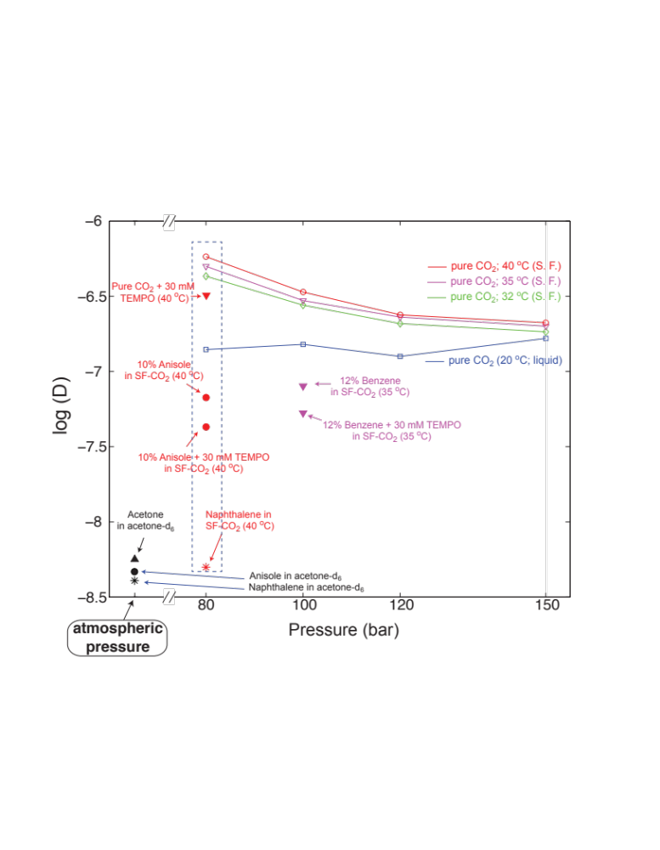
Fig. 1 shows diffusion coefficients of CO₂ and solute molecules measured in liquid and SF phases. Noticeably, the diffusion coefficient of CO₂ in the SF-CO₂ phase at every pressure and temperature we tested were in the 10⁻⁷ m²/s range; this is to be compared with the self-diffusion coefficient of water, ≈ 2. x 10⁻⁹ m²/s. The diffusion coefficient of CO₂ becomes larger as the SF’s temperature increases or pressure decreases. Even with 30 mM TEMPO in the solution, the diffusion coefficient of CO₂ is still closer to that of pure SF-CO₂.
Fig. 1. Experimental diffusion coefficients measured on pure liquid-CO₂, pure SF-CO₂, and small organic molecules dissolved in SF-CO₂ – with and without 30 mM TEMPO. Variable-temperature and pressure experiments were carried out using ¹H and ¹³C NMR, with the setup illustrated in Figures 5 and 9. Also included for comparison are diffusion data measured on solutions of acetone-d₆, at 25 ºC and atmospheric pressure.
We also monitored the diffusions of added solutes in SF-CO₂ phase with and without TEMPO. For instance, anisole molecules in SF-CO₂ (10 w/v %; 80 bar; 40 ºC) diffuse at 6.7 10⁻⁸ m²/s without TEMPO and at 4.3 10⁻⁸ m²/s with 30 mM TEMPO. Benzenes in SF-CO₂ (12 w/v %; 100 bar; 35 ºC) diffuse at 8.0 10⁻⁸ m²/s without TEMPO and at 5.3 10⁻⁸ m²/s with 30 mM TEMPO. When these solute molecules are dissolved in acetone-d₆, their diffusion coefficients (measured at 25 ºC; atmospheric pressure) are ca. an order of magnitude slower: D(acetone) = 5.6 10⁻⁹ m²/s; D(naphthalene) = 4.1 10⁻⁹ m²/s; D (anisole) = 4.7 10⁻⁹ m²/s.
Conclusions
CO₂ and solute molecules in SF-CO₂ phase diffuse an order of magnitude faster than those dissolved in organic solvents.
Acknowledgements
A portion of this work was performed at the National High Magnetic Field Laboratory, which is supported by National Science Foundation Cooperative Agreement No. DMR-1157490 and the State of Florida.
References
[1] Stejskal, E.O., et al., J. Chem. Phys., 42, 288 (1965).

