Record Zero-Field Splitting in a Polymeric Chain Containing Six-Coordinate Ni(II) Ions

Manson, J.L. (Eastern Washington U., Chemistry); Blackmore, W.J.A.; Brambleby, J.; Goddard, P.A. (U. Warwick, UK, Physics) and Ozarowski, A. (NHMFL, Tallahassee)

Introduction
While much attention has been paid to low-dimensional antiferromagnetic S = 1 Ni(II) coordination polymers, challenges persist in extracting the anisotropy parameters D and E of such compounds, especially when magnetic interactions (J) co-exist [1,2]. To this end, we have designed a molecule-based coordination polymer that exhibits negligible J, thus facilitating determination of D and E by high-field/frequency ESR [3]. The tetragonal compound, Ni(SiF₆)(vinim)₄ (vinim = 1-vinylimidazole) [4], forms parallel 1D Ni-F-Si-F-Ni chains with large interchain spacings ensured by bulky vinim ligands (Fig. 1a). Near-octahedral NiN₄F₂ sites exhibit Ni-N and Ni-F bond lengths of 2.06 and 2.10 Å, respectively. It serves as a basis for which to compare parameters against more complicated examples such as [Ni(HF₂)(pyz)₂]SbF₆ (pyz = pyrazine) that has Ni-F-H-F-Ni chains and J_{1D} ~ D ~ T_{N} [1].

Experiment Details
High-field, high-frequency ESR spectra at temperatures ranging from 5 to 20 K were recorded on a home-built spectrometer at the EMR facility of the NHMFL, Tallahassee, with the microwave frequencies ν = 197 − 658 GHz. The instrument is a transmission-type device and uses no resonance cavity. The microwaves were generated by a phase-locked Virginia Diodes source, generating frequency of 13(1) GHz, and equipped with a cascade of frequency multipliers to generate higher harmonic frequencies. An Oxford Instruments superconducting magnet capable of reaching a field of 17 T was employed.
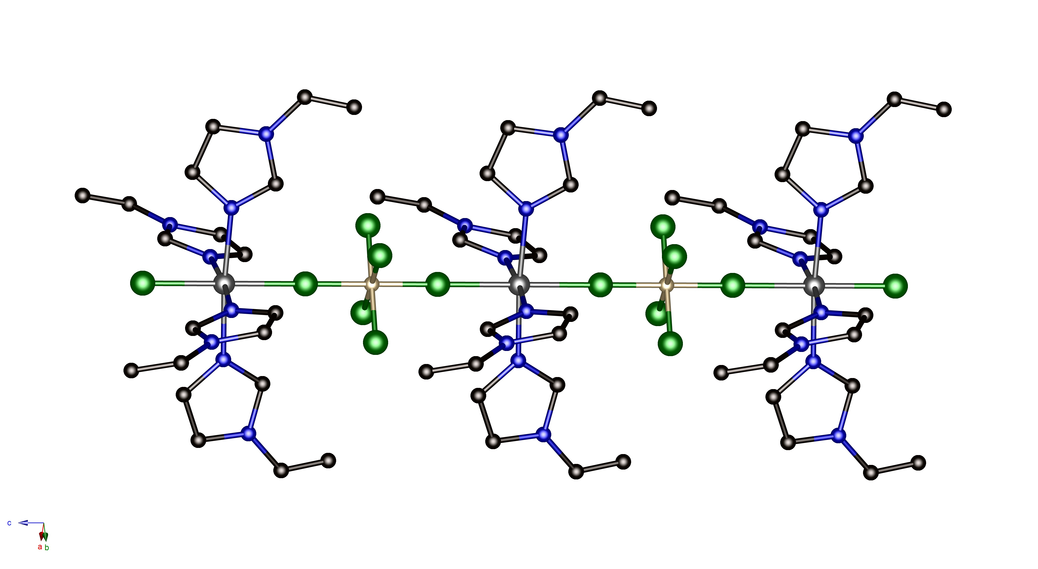
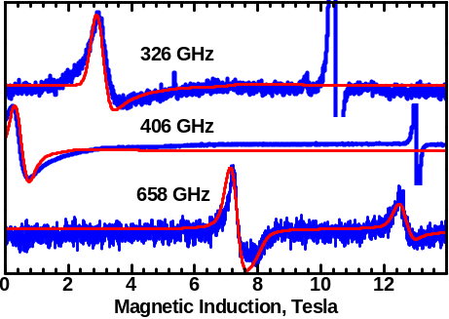
Fig. 1. (a) 1D chain and (b) transmission
ESR spectra for Ni(SiF₆)(vinim)₄ at 5 K.
(a)
Si
F
Ni
C
N
c
(b)
Results and Discussion
Continuous-wave ESR spectra recorded on a powder sample of Ni(SiF₆)(1-vinim)₄ are shown in Fig. 1b along with a simulation (red) based on the Hamiltonian:
Ĥ = μ_{B}B {g} Ŝ + D { Ŝ_{z}² – S(S+1)/3 } + E ( Ŝ_{x}² – Ŝ_{y}²) [1]
The simulations gave an anisotropic g-matrix with g_{x} = g_{y} = 2.26, g_{z} = 2.15, and D = +14 cm⁻¹. The simulation captures the majority of resonances as shown collectively in Fig. 2. The values of g and D are also consistent with susceptibility and magnetization measurements. A positive-D denotes easy-plane anisotropy with m_{s} = 0 being the ground state. While a large negative-D value of –22.3 cm⁻¹ has been found in Ni(CH₃CO₂)₂(im)₄ (im = imidazole) [5], the D found for Ni(SiF₆)(vinim)₄ is the largest positive-value observed thus far. Notably, a tetrahedral NiSe₄ coordination complex features D = +45 cm⁻¹ [6]. We attribute the large-D to a stark difference in orbital reduction factors for ionic SiF₆²⁻ as compared to coordinate covalent vinim ligands. Combined with a very small intrachain J, the enormous D/J ratio puts this material well inside the so-called large-D (i.e., quantum paramagnetic) phase [7].
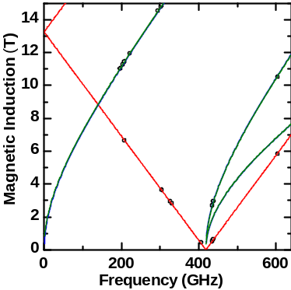
Acknowledgements
Fig.2 Resonance field vs. frequency dependence for Ni(SiF₆)(vinim)₄ obtained at 5 K.
Work at EWU was supported by the NSF under grant no. DMR-1306158. This work was performed at the National High Magnetic Field Laboratory, which is supported by NSF Cooperative Agreement No. DMR-1157490 and the State of Florida. WJAB, JB and PAG acknowledge the EPSRC for funding.

References
[1] Manson, J.L., et al., Inorg. Chem. 50, 5990 (2011).
[2] Manson, J.L., et al., Dalton Trans. 41, 7235 (2012).
[3] Krzystek, J., et al., Coord. Chem. Rev. 250, 2308 (2006).
[4] Manson, J.L., et al., to be published.
[5] Boča, R., et al., Chem. Phys. Lett. 373, 402 (2003).
[6] Jiang, S.-D., et al., J. Am. Chem. Soc., 137, 12923-12928 (2015).
[7] Wierschem, K., et al., P. Mod. Phys. Lett. B 28, 1430017 (2014).

